PICKING THE BEST FEATURES OUT OF ALL OF THEM

Comparing with the original dataset

Random forest - $b – feature 1 and 2

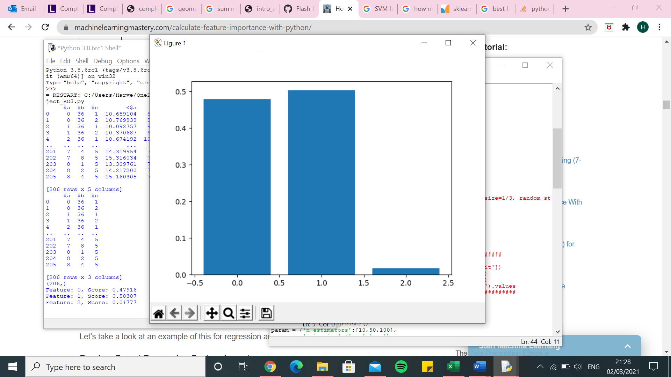

Random forest -$a

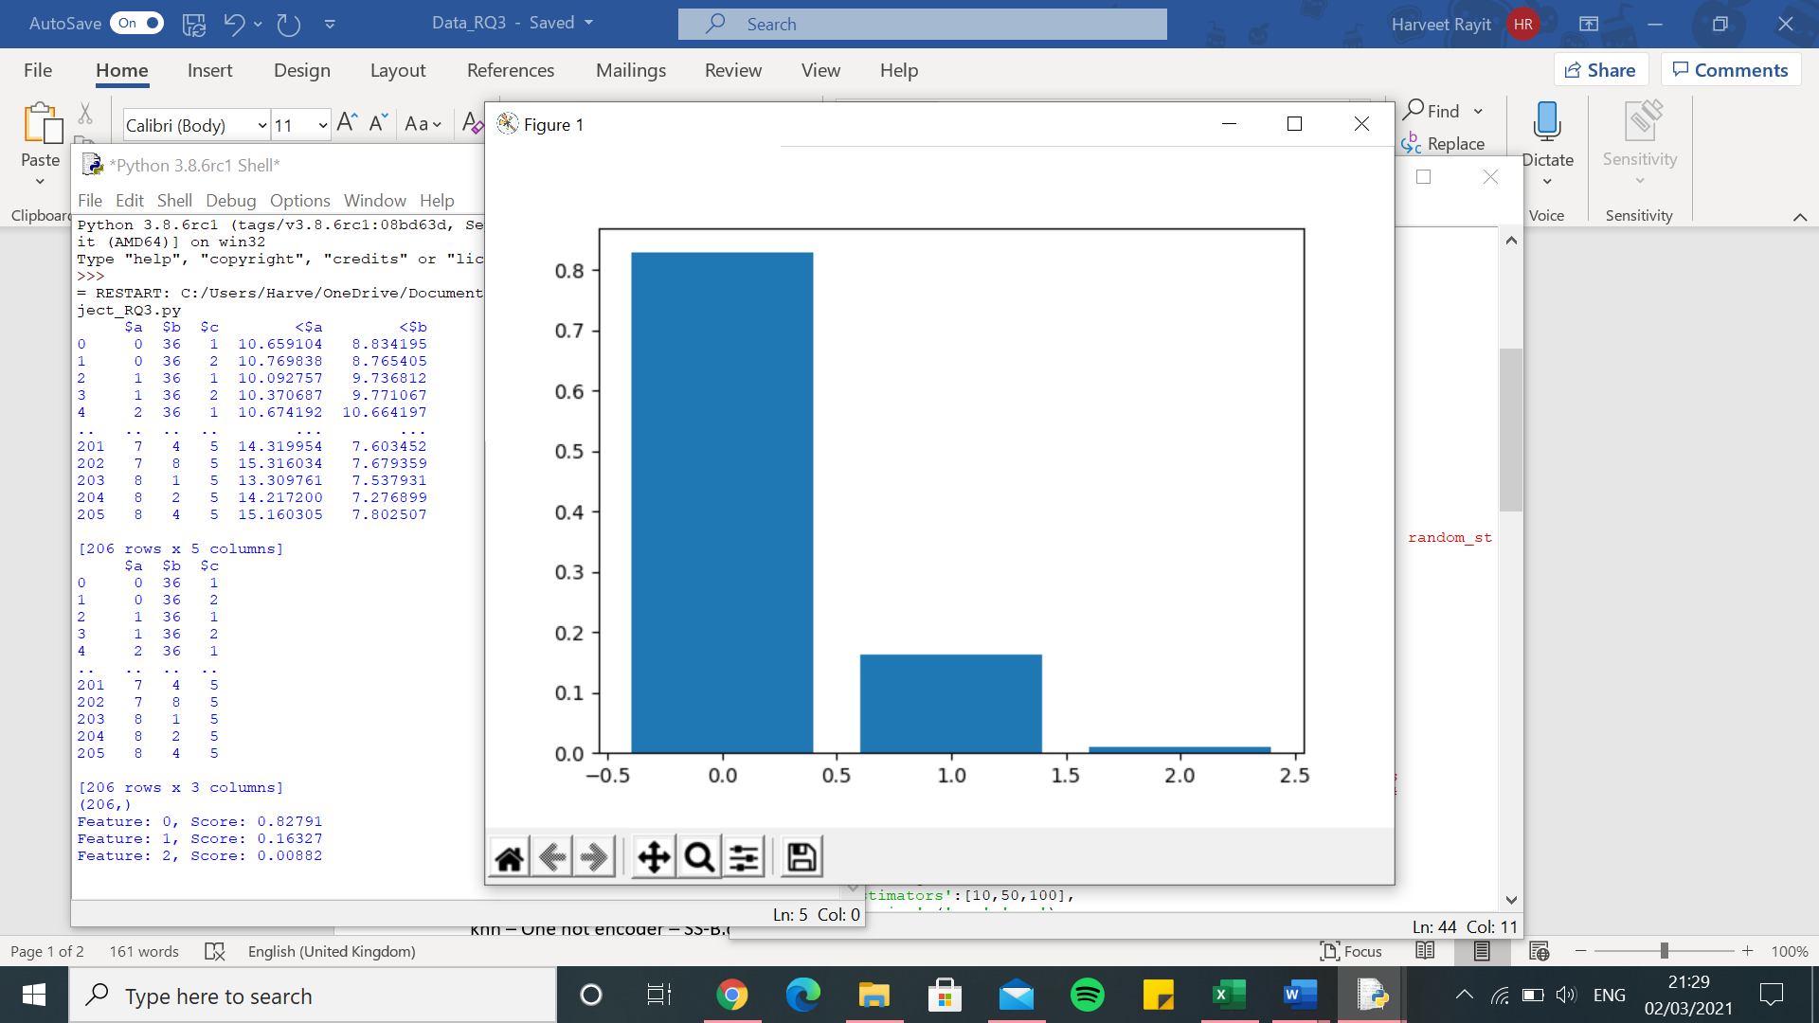

Random Forest – One hot encoder – SS-B.csv -$b

[1.9760510281325094, 2.455123624457421, 1.7094316993571304, 1.7261098198232114, 2.4116316128243764, 2.3628535382403495, 1.9922604647370923, 2.277924039145457, 2.323149042292561, 1.31605535526095, 2.138406176861625, 1.6829512044371788, 2.660960896588365, 1.9401997353208276, 2.172298604780779, 2.278476009950897, 1.484336333914477, 2.1287491364057067, 2.4616373058075443, 1.927959766738488, 2.2304813660053515, 2.5404793515379223, 1.9640440728255002, 1.9233795340370266, 2.0667353421939723, 2.172121989730418, 2.3031873574811788, 2.4247527472441837, 2.0258895972539857, 2.315935573858749, 2.364233551184607, 1.876356750916499, 1.7967440751013712, 2.56469962264018, 2.0761064652638046, 1.879193651562018, 2.068386519830267, 1.8627638077706816, 2.013584195063947, 2.0639626889316074, 2.0218932174136737, 2.546481893283986, 1.6577264068234765, 1.5971148141357927, 2.419182577495022, 1.865544900014112, 2.2416607309892287, 2.0800099631930573, 1.9540294783171417, 1.9941876843849353]

0.0 7.556929455863566e-10

Execution time: 58.95668864250183 seconds

knn – One hot encoder – SS-B.csv -$b

[2.4769207407256575, 2.1764130258239076, 1.8847549719471064, 1.9066985397959204, 2.7936589054899614, 2.581999696756691, 2.0319923384506864, 2.2518647287401317, 2.4278832882857024, 1.7451709874514199, 2.1616464688790673, 1.779803095352926, 2.4570276521182914, 1.8761038705073714, 2.445978351455916, 2.6283833443702997, 1.260877045692992, 2.184184225660515, 3.19313397154464, 2.172632171671953, 2.206005584491274, 2.861380939818374, 2.470693667667343, 2.4157963540531298, 2.2257707636723323, 2.232682922689236, 2.5833868706021907, 1.9959417259129348, 2.453521538076899, 2.5298815597686444, 2.7850401997654872, 1.9503468806457736, 1.8970847546626404, 3.004930827716702, 2.002028509907328, 1.8146386450177405, 1.973229743280457, 1.8528125010506307, 2.0210350197260487, 2.1274670190837925, 2.7382864144532477, 2.7177130028786642, 2.2850019205201075, 1.839561668874366, 3.317359842507638, 2.046872445271079, 2.250618228750562, 1.726072215397812, 1.93594071983824, 2.4180665470577467]

0.0 7.556929455863566e-10

Execution time: 3.924583911895752 seconds

SVR – One hot encoder – SS-B.csv -$b

[2.2430415465136724, 2.367971250692026, 1.7764174894052829, 1.752450028640449, 2.8507008383926737, 2.389388974495274, 1.992257995353576, 2.3505818889049506, 2.372568105018089, 2.0184181067546247, 2.141895814677732, 1.6358608610065535, 2.5694164081683226, 1.8344490443525332, 2.3116324010471487, 2.4909237096791426, 1.4677481216297408, 2.1359234268637715, 2.9791108606106547, 2.0996923603120647, 2.002860693571219, 2.5322068746140043, 2.4221431718329076, 1.977238784690193, 1.962598490520231, 2.0109592262901472, 2.485106189619397, 2.320986980073555, 2.1632089130454095, 2.353506091810678, 2.480564425057816, 1.9836595186159798, 1.9660924878389936, 2.91966574842577, 1.747837021227488, 1.8032098876204727, 2.0953520218792323, 1.6416454945619776, 2.052909189114607, 2.7242778772543175, 2.4237074727954324, 2.6466393943863196, 2.1761456036933255, 1.6233456924412264, 2.8437947464099764, 1.8442834751192447, 2.1859173049196725, 1.9931261007249839, 2.009663990302262, 2.1633787638033577]

0.0 7.556929455863566e-10

Execution time: 4.131968975067139 seconds

Decision tree – One hot encoder – SS-B.csv -$b

[2.4963243249407507, 2.741693921909165, 1.8349099102195898, 2.121860767335779, 2.3057303945668624, 2.4165249509375766, 2.6199846498946555, 2.3812778500302594, 2.1535656352111943, 1.5326304704360114, 2.76437481194772, 1.849342309910618, 3.28646984873534, 1.9310261989641144, 2.3244832056456546, 2.391170063480966, 1.9559773505612048, 2.64163606182059, 2.644323022202751, 1.9105865677394576, 2.750094395194795, 3.6087896949403055, 2.437802389796415, 1.6747592718730064, 2.0383681776995974, 2.509406825263934, 2.4741028392438955, 2.359204008477683, 2.392958711324958, 3.210060750022116, 2.9767505872139397, 1.9299444140283544, 2.1147479520281207, 2.395266939032408, 2.617168309223086, 1.9782615971600648, 2.546201099434739, 2.3594622122812643, 2.6391471610389323, 3.271562257732415, 2.908886707442673, 2.7061582411337906, 1.8953268434610626, 2.0608925541765912, 2.460034814918769, 2.2941938371393187, 2.323771152941111, 2.7235227274876106, 2.2741292231112564, 2.0073056043442246]

0.0 7.556929455863566e-10

Execution time: 2.862623453140259 seconds

Linear regression – One hot encoder – SS-B.csv -$b

[0.8674336271581595, 2.449755099802728, 1.424590929577083, 1.8198912583073368, 1.9528720337961998, 2.0123217426983513, 2.038310485795121, 1.868162619913519, 2.2625223520870987, 1.184210794819434, 1.7072600353307943, 1.851725090821313, 1.9894945707105058, 1.7660570505023911, 2.004209203568487, 2.2937969009552646, 1.02965518893968, 2.216178945473061, 2.2687020683642194, 1.9597842331647302, 2.2586361198174365, 1.8279582346372605, 1.869363506005145, 1.8539272200523793, 1.7755258087993648, 1.92605621181547, 1.7565733457128174, 2.138131713559459, 2.161292115076259, 1.8281326287714434, 1.8261476317810865, 1.981142573353562, 1.7662624668632045, 1.8923262478867637, 1.7681805882068347, 1.6699267262532533, 1.63399978002384, 2.0601674734473163, 1.888376449855591, 1.5919109064228472, 1.6956095912788804, 2.168229057242361, 1.1280414242580366, 1.6340358373883412, 2.4287753095471665, 1.4828858107272687, 1.8948229098914555, 1.3836806485011433, 1.8210637356877823, 1.8252678082258027]

0.0 7.556929455863566e-10

Execution time: 5.873900651931763 seconds

Kernel ridge – One hot encoder – SS-B.csv -$b

[3.6067965487193123, 5.7330888399711375, 6.050671672736157, 5.272398802768038, 6.332765522894965, 5.901990234787511, 5.839919741419318, 5.823249365175887, 5.822738971281295, 4.732854338347796, 5.609925936386546, 5.800176778514714, 4.970084467769513, 5.981982885406133, 5.907779732894863, 6.499606855409336, 6.360706117658038, 6.4878325629215015, 4.785021390635487, 5.357705973853955, 6.335211905227409, 5.289782095235831, 5.5577943530571, 7.151239379496415, 4.8449882025831865, 5.872207420989704, 6.9553059075864, 5.981740937052481, 6.522020191611389, 6.538480966166274, 6.199303285950049, 5.394681215847705, 6.369182311685105, 5.562588769287495, 6.82541936266922, 4.080000955223793, 5.0318142200648195, 6.250415957485733, 6.611774384368005, 5.454288574903297, 5.545291318617539, 5.936818043375582, 5.123664101604154, 5.038121240252309, 6.582004598755365, 4.297986610367223, 5.469328893869983, 6.727991575735451, 4.69660568934475, 4.836152024046556]

0.0 7.556929455863566e-10

Execution time: 5.561173677444458 seconds

Random Forest – One hot encoder – SS-B.csv -$a

[1.3681481671307643, 2.8200505295466334, 1.730017851979889, 1.4398235107010497, 1.7262999207565524, 2.108257931198731, 1.805946962420205, 1.5986134104282161, 1.3342408746526122, 1.9541940763227224, 1.5889158775837846, 1.9711454353959301, 1.920585773479048, 1.9737022385410465, 1.3354466431778789, 2.312486661780596, 1.6946247087576964, 1.591184007121733, 2.3306814433840906, 1.8662959214500892, 1.8780803306565328, 2.0001509431069926, 1.6607525627139827, 1.4219315516942383, 1.5028940049810546, 1.8278590504777885, 2.229843178987596, 2.2501215044334337, 1.9690893840306698, 2.3016331339891485, 1.747829774758551, 1.6298756150912632, 1.2079563526713548, 1.4684032043740505, 2.8898924952535117, 2.0344831431792576, 1.821689683100844, 2.350275102308834, 1.9102722892596065, 1.4181232576958458, 1.4256783096219703, 1.8263397011685965, 1.2728032985448858, 1.424439413815503, 2.437547920020231, 1.1968280285375559, 1.5119965150888819, 2.1959042334810195, 1.0243890414366674, 2.1779167620342585]

0.0 7.556929455863566e-10

Execution time: 56.860650062561035 seconds

knn – One hot encoder – SS-B.csv -$a

[2.038300457543301, 2.287703698418072, 2.0076556678403334, 1.757809047678942, 2.2274222224437428, 2.460126396264636, 2.176028152966651, 2.286805752100195, 2.004516020391007, 1.9123658992680503, 1.5756681913419206, 2.1923116326915943, 1.967338137301496, 1.7530313660336692, 1.708584220335349, 2.6033332554384723, 1.6528436807835718, 1.8703675335008432, 3.0916149379691094, 2.324165543038553, 2.3767927330105, 2.087832890085485, 2.5317549761726954, 1.7684936127695947, 1.8110667651666323, 2.7174144380707417, 2.3611552136545852, 1.9114496652625184, 2.168702624643022, 2.1110229050782863, 2.444201046285833, 1.6480203050638833, 1.4931265344427795, 2.093881550002382, 2.98562848929469, 2.191418588304999, 1.967611280063488, 1.9642892434883312, 1.8751793232817802, 2.1777048668056143, 2.6216501405767585, 2.284076629116951, 2.404870858721253, 1.520262764978561, 2.923467399695723, 1.821834615088677, 1.6499051702084055, 1.8263890250729358, 1.3705782392421695, 2.016193660570496]

0.0 7.556929455863566e-10

Execution time: 5.3786962032318115 seconds

SVR – One hot encoder – SS-B.csv -$a

[1.7020228345596422, 2.445185728605545, 1.6171282018340347, 1.348653987896983, 1.910424144712057, 1.7957674543295394, 1.7166692588047334, 1.7521092592413263, 1.3047858818652662, 1.6563048656072827, 1.5274531022121018, 1.875200503879949, 2.2243185443326268, 1.761077734129112, 1.3999348883309168, 2.4482194963817494, 1.5025529576314045, 1.5604969003851739, 2.3026824998835913, 1.8997307150483442, 1.991055142516894, 1.9977234963682378, 1.710161362150283, 1.5296978890635102, 1.5826213530756257, 1.9237273210166697, 1.957317998681032, 2.0208551041144833, 2.0368401584342575, 2.0213189015620068, 1.8037460808973436, 1.7236377957786462, 1.413875916968673, 1.3421951933798715, 2.288039675227793, 2.1313552881970934, 1.845458992957885, 2.1084556810398896, 1.9238620282459438, 1.6354821510489046, 1.665737063384688, 1.9984688955881904, 1.5744948416262046, 1.5086712319561848, 2.1026875144032435, 1.2947041267676647, 1.6804573060292691, 2.0317661456591147, 1.2327908726211338, 2.0928908875874366]

0.0 7.556929455863566e-10

Execution time: 3.4410860538482666 seconds

Decision tree – One hot encoder – SS-B.csv -$a

[1.459639784063479, 3.3721834939610305, 2.0886936824066566, 1.5220908620399338, 2.034169725935042, 2.359213522168878, 2.075375588083999, 1.4813836877253437, 1.2280103591713185, 2.081884572639712, 1.749778167416362, 1.9380856982801058, 1.778515309845914, 2.4760159920589158, 1.5181001166599801, 2.1053601897039194, 1.4678205107536872, 1.5548044509361536, 2.31452501175358, 2.2414799219982418, 1.565758415155454, 2.6758026607869003, 1.6607480412709632, 1.6497533821998018, 1.3725355325322934, 2.189464982035558, 2.2977039650085653, 2.435529794238361, 2.2430313397261017, 2.758726207304869, 2.0711773869911307, 1.5387029949164677, 1.6450729248616622, 1.7898886323290446, 2.904506330160307, 2.3608505197846497, 2.458919122021732, 2.2936603049243334, 1.6705570689165086, 1.5880866583689968, 1.7751126364405425, 1.7969393578016337, 1.3670617898231168, 1.4400554106351207, 3.4139093696991667, 1.2047205060769888, 1.4940785420743787, 1.9978580604950407, 0.8315484121636405, 2.3114514641780395]

0.0 7.556929455863566e-10

Execution time: 4.50746488571167 seconds

Linear regression – One hot encoder – SS-B.csv -$a

[1.459639784063479, 2.2817617426731496, 1.4978053068559039, 1.3920891093248051, 1.9834006928979986, 1.826245063797243, 1.7619909489196, 1.5098258164090137, 1.2236716912104912, 1.531400220714931, 1.640663412012729, 1.878785824309306, 1.689653560286841, 1.989910798437621, 1.3288090500202177, 2.3797219477151184, 1.2311860877017295, 1.4020685816990777, 2.079973319341722, 1.7804913993133877, 1.8167337599835716, 2.0248136219187036, 1.6506781437739575, 1.3609761974456447, 1.4241302094475534, 1.7643932246108323, 1.7167691307565947, 1.9766878186929437, 1.928506302372007, 2.078531253409748, 1.6775707490209177, 1.7307228181637613, 1.0575394011956745, 1.2608928019457404, 2.1801288965861336, 1.8311221310527455, 1.8139536208464486, 1.9213892993779753, 1.8856267341338555, 1.2130827276078586, 1.762281009372919, 1.7046429989222247, 1.0640783217200018, 1.3206592490453102, 2.26939805611726, 1.2047205060769886, 1.3762494986559624, 1.378008367614444, 0.9677971366758057, 2.056238894065468]

0.0 7.556929455863566e-10

Execution time: 4.233680725097656 seconds

Kernel ridge – One hot encoder – SS-B.csv -$a

[4.503279463553722, 8.145732599318595, 7.848222974910159, 6.870132375344322, 7.587353082708898, 8.279648405180135, 8.094478862516025, 7.399752356254172, 5.946797567874371, 6.696124701469732, 6.936076871888029, 9.824610785136, 6.926123744771406, 7.4263702325681775, 7.372981050859882, 9.880278695487945, 7.919670873748257, 8.239834271240946, 6.76057586580916, 8.006732710916792, 8.10273163777314, 8.194744867590066, 6.7653037017287705, 8.936980263886163, 7.087338286282295, 8.869416911766594, 8.349048800458956, 8.503657132586143, 8.37627757816643, 9.874065459359782, 7.781129042904746, 6.960218095354886, 8.053332888233198, 5.446358985739288, 11.032008063058804, 7.599212140205003, 6.538462898153313, 9.057040054237644, 9.985792352722957, 6.438024745642844, 6.007219813016151, 7.787812460922491, 6.775162293656013, 6.59969178978209, 8.652709206148895, 4.442621339965456, 6.616338196564593, 7.930887335935557, 5.394805232989544, 7.3238555751907315]

0.0 7.556929455863566e-10

Execution time: 4.515061855316162 seconds

Random Forest – Integer encoder – SS-B.csv -$b

[1.2469438603052432, 1.4126100160718977, 0.8248607049064788, 1.0815170845587734, 1.6420467022320298, 1.2932295293030183, 0.9539629608726897, 1.4344870926310413, 1.7077903482801033, 0.7202695627400959, 1.0330003453163954, 0.8198289654355247, 1.4970468521828666, 1.153512182848819, 1.3324182260980095, 1.5383805097645977, 0.6913184070919695, 1.4974681277356137, 1.536784135153423, 1.4795033414801038, 1.4556203674801582, 1.8944353669852743, 0.9319114491946808, 1.7076223189871618, 1.4808832050404142, 1.192962834934828, 1.2906223163234003, 1.4272372825362325, 1.4647289648781308, 1.8329955015876558, 1.6225328653537394, 1.3612444273775, 1.4869943980377214, 1.6234109276968995, 1.0728931049759534, 0.8282053415514231, 1.190064142348121, 1.440747621944931, 1.4988779569262118, 1.1964596184187544, 1.5393732071699808, 1.3743672847940929, 1.176258338571292, 1.3551362555972317, 1.2040071063902373, 1.0674659305009169, 1.1604843645032732, 0.8013781149236484, 1.4755457126711726, 1.676930939270233]

0.0 7.556929455863566e-10

Execution time: 42.54574108123779 seconds

knn – Integer encoder – SS-B.csv -$b

[1.6002681660827927, 1.5397669277950052, 1.1487897788216395, 1.4109113437673866, 2.1433555684572863, 1.8143135747947303, 1.3351044818153144, 1.6012736887297359, 1.3829782534325739, 1.0249636120456276, 1.0748216854066646, 1.143227889159417, 1.4482700465589204, 1.2764904241523365, 1.8001074495086293, 1.5986321845089437, 1.230230699775518, 1.851445139901601, 1.7360639472246684, 1.5555449997169972, 1.43292990441222, 1.5059986027673053, 1.8607202580736966, 1.8470410056860265, 1.7167388482395278, 1.4821440677734874, 1.5798884562090112, 1.290255491507515, 1.4159798248215523, 1.8060311500494053, 1.9170278331053898, 1.3478152805486863, 1.3636547642315824, 1.6655316113105971, 1.106429044071678, 1.4790571299203805, 1.2494257241567348, 1.1066270727547758, 1.7277901611212585, 1.434015738824754, 2.046014304683898, 1.7097368007595855, 1.2414437687817634, 1.5347065045151862, 1.9007358492202788, 1.3638197987632392, 1.3027959725494318, 1.4315507716423987, 1.6060506286382328, 1.8743667324432103]

0.0 7.556929455863566e-10

Execution time: 1.8404066562652588 seconds

SVR – Integer encoder – SS-B.csv -$b

[1.5635678879214525, 1.2440999524124658, 1.132096595382499, 1.3483254844655308, 2.302365448453209, 1.7989464197928735, 1.326289339021609, 1.6623791566349866, 1.4970485042860358, 1.223681294308196, 1.0575433642916858, 1.0034628602232014, 1.496184233883752, 1.1479554580124052, 1.705715588458003, 1.5972827376368035, 0.779876732107092, 1.6099858201054542, 2.243247126587231, 1.8244561422930514, 1.4047322651140117, 1.4974478238214513, 1.944683736519377, 1.6791136790861978, 1.4217582502769681, 1.1996769422594737, 1.2085727406620714, 1.3000286076630074, 1.6135329044159477, 1.7459576120167368, 1.9022732975159726, 1.3309924464503131, 1.4563566919526467, 1.886609101739605, 1.0197413329998766, 1.3400630685003267, 1.0379254323241633, 1.0364475794022867, 1.5862471064030328, 1.0440257797014239, 1.9372119170162352, 1.8237399007884276, 1.1059880806574558, 1.428479621438301, 1.8827638076165791, 1.212632908558918, 1.2315781965447865, 1.0294288037683643, 1.8640776092568605, 1.6373713013617797]

0.0 7.556929455863566e-10

Execution time: 2.7678394317626953 seconds

Decision tree – Integer encoder – SS-B.csv -$b

[1.4775628262968823, 1.2678919996786047, 0.973423181679833, 1.3885543011713313, 1.9340536362987537, 1.88057094879834, 0.9929732404104701, 1.7026136166399102, 2.0658158235335757, 0.8025822056373045, 1.5733024206814537, 0.5648729583542014, 1.4068541308478952, 1.7159782289549599, 1.6247140658302113, 1.804104914679267, 0.8990522286642348, 1.806276456201443, 1.6421947312965468, 1.9660218922194725, 1.6027346039813117, 2.057050301349372, 1.4520714095633862, 1.7953919913682492, 1.720139568843435, 1.3797589008768365, 1.1037585997940542, 1.6315410542187478, 1.5863651854447591, 2.9288514880521146, 1.6469442076170282, 1.631984297368639, 1.8543681033718917, 1.5607746659847541, 1.1908858115716021, 1.1232477098079283, 1.5164003344734045, 1.6766340717568067, 1.63362626458928, 1.8628765372314144, 2.306411590722719, 1.4240277100051628, 1.730723901549602, 1.1544260382210334, 1.2340687544755458, 1.1358036709330763, 1.5680901506504792, 1.583564780911703, 1.8573835105268661, 1.5333343005819484]

0.0 7.556929455863566e-10

Execution time: 3.578551769256592 seconds

Linear regression – Integer encoder – SS-B.csv -$b

[0.7862877356730972, 0.9314456359254101, 0.8278292013260788, 0.8628106096107608, 1.4656926100754648, 1.2564717704519588, 0.7379726048775639, 0.9335871228958239, 1.2135215630377556, 0.6559116523335528, 1.0094895684269274, 0.6972006857418866, 0.9738320683883074, 0.7385231397836927, 1.1200310171938155, 0.7857411241052911, 0.5471956340468236, 1.307020528255963, 1.0209086020784002, 0.8582646221309242, 1.2146323322225565, 1.2284247229015628, 0.7698171439727788, 1.0201212845155778, 0.7964640991110015, 0.6984828160758387, 0.8115762841599516, 1.0183162617794035, 1.1305906544039004, 1.3614498985780126, 0.8971462505823974, 1.0720192849283927, 1.2985368533393702, 0.8717579765978254, 0.60631191886811, 0.9561010240004226, 0.5637771927200463, 0.8836304074198675, 1.1367116935975716, 0.9752356915052881, 1.0537291155185513, 1.0949084400936382, 0.7012669849628403, 1.4558702740679306, 0.9069062216653122, 0.5987851473550174, 0.904768583498728, 0.690167060702204, 1.1831691274606764, 1.0427449361533343]

0.0 7.556929455863566e-10

Execution time: 3.4164838790893555 seconds

Kernel ridge – Integer encoder – SS-B.csv -$b

[2.4506025315493685, 2.035722123627369, 2.1745547069602957, 2.00839153321028, 1.8523739499020373, 1.8404759471639325, 2.2849996387327067, 2.3292770032373253, 2.168266651444057, 1.7569810115166786, 2.0354527137635596, 2.0312271465502003, 1.914718421105963, 2.739296247135646, 2.0210361000189216, 2.076676858424649, 1.848647800645869, 1.8582544181676148, 2.6523404328500297, 2.0328044615319114, 2.7298434305031, 2.028381296734869, 2.038076900636937, 1.7716711408589685, 1.9916242884915072, 1.7263877064247064, 2.5986183480328706, 2.0828367868478894, 2.2255046901543714, 1.7994026136651273, 1.9929581584241476, 2.187512796313029, 1.9774929932565228, 2.1279037484620345, 1.8350870291414914, 2.3657700329828386, 2.517160770491096, 1.8418471568917543, 2.1338241665699225, 1.9199361014905247, 2.3212882067410283, 1.9695056800935857, 2.172307075441907, 1.681597270595476, 2.2819226358533924, 2.0335773112844073, 2.1597952146494714, 1.9867917437490716, 3.2612764091762085, 1.858638480123183]

0.0 7.556929455863566e-10

Execution time: 2.8427164554595947 seconds

Random Forest – Integer encoder – SS-B.csv -$a

[1.345952400703752, 0.9639417919777907, 0.7620382894985182, 1.0635942014607371, 1.2990153725140394, 1.5965345278236585, 0.8481358505672081, 1.0216988071714284, 1.1478883633605919, 0.6591666723442752, 1.0906434826584885, 0.7182134981810268, 1.3591201702038844, 1.5404841279708346, 1.1806002238740974, 1.0006720968931284, 0.7659883990826155, 0.6973905973914644, 1.5910110909829538, 1.3343508552444097, 1.2013394528620576, 1.741623587798979, 1.7164400103185014, 1.0848984726339008, 1.0247561529856664, 1.0362896917007167, 1.0805094665059576, 1.2497905621260672, 0.9552755914329775, 1.29955867317249, 1.1977376017574701, 1.379161544067065, 0.7291340926784073, 0.7961008489353483, 0.6781593019555032, 0.7348684902738528, 1.1896531164633197, 1.3831012596238887, 1.4615313738500992, 1.2098249834037709, 1.5718802379873653, 1.2937094648686276, 1.0237836620078298, 0.8333569126997895, 1.3706379791699312, 1.0569879964256899, 0.8600128855424436, 0.7506223070294227, 0.6318993880831544, 1.5535881883198244]

0.0 7.556929455863566e-10

Execution time: 55.49784064292908 seconds

knn – Integer encoder – SS-B.csv -$a

[1.5351249529625273, 1.0438498791951034, 0.8238893414850907, 0.9621035910552104, 1.6137192674275407, 1.5334474783406442, 0.9983059070433166, 1.3504185574966059, 1.1460617918442695, 0.7158017418522041, 1.087212523435825, 0.8438223142399452, 1.7032562494827315, 1.5479574923347632, 0.9291095241979459, 1.2722532487473546, 0.7061986446779156, 0.8936344053556672, 1.8125171481160514, 1.1278466717202085, 1.549407671856529, 1.273680800615407, 1.6065247502573183, 1.0252566533204197, 1.1604931365396116, 1.007060189945296, 1.2744478158031611, 1.1833211268943882, 0.8940090338470955, 1.3242021856010593, 1.210153941770783, 1.468366044465656, 0.8343608406910649, 0.9189106288492209, 0.7045423285156975, 1.0379478900202097, 0.9789690099651256, 1.2213608168687755, 1.3442204200215178, 1.1862360387459467, 1.5507947134156126, 1.2038491143032541, 1.1532123960485687, 0.9767908419346069, 1.3529342198909011, 1.133675802990082, 0.918884614852436, 0.9385591072106807, 0.8092148736456587, 1.3729849829475143]

0.0 7.556929455863566e-10

Execution time: 4.784328937530518 seconds

SVR – Integer encoder – SS-B.csv -$a

[1.5112637682874235, 1.075080328635088, 1.0066127662000819, 1.1868700962533416, 1.3429881950311928, 1.4549543410349175, 1.3223451022445913, 1.6728273608572042, 1.084757513068815, 0.760913061598285, 1.23836458981317, 1.0585554075476582, 1.5504157320658736, 1.5054119650746858, 1.0589320589254652, 1.706942804713308, 0.7981545017362586, 0.6327234086113359, 1.7948268624748156, 1.2333625680524807, 1.5066321751186178, 1.2220628375724967, 1.4828475233891276, 1.1246094856615882, 1.3495554389269027, 1.0896379754085974, 1.6129258162063567, 1.32159623947499, 1.1679039089414978, 1.040147174752838, 1.5997052997123629, 1.7208527646898046, 0.7181815057344216, 0.8010332452781729, 0.8495042326077373, 1.4163448940601586, 1.0832880296208365, 1.1996958669571314, 1.5537291362781336, 1.256451853189971, 1.567101205200828, 1.217061990354484, 1.0109328746426467, 1.0779597501922529, 1.3492303747612786, 1.016125390087734, 0.9367369639940785, 1.0308403490479856, 0.8738506737413131, 1.597454627879432]

0.0 7.556929455863566e-10

Execution time: 4.081827878952026 seconds

Decision tree – Integer encoder – SS-B.csv -$a

[1.459639784063479, 0.9682082794424873, 0.9067051777550663, 1.327191619937186, 1.5298105895005807, 1.847803797629427, 0.8316501775062298, 0.9879766268578001, 1.2531876267712692, 0.624998286965286, 1.0669520765605702, 0.7075113437919658, 1.5035243213804927, 1.7943723373455012, 1.3153698634549176, 1.0892227172613274, 0.8941609912087719, 0.717546595231865, 1.4591222057190674, 1.5757345284388875, 1.1341888416876873, 2.133341989870183, 1.8464447076371846, 1.1008540739707366, 1.0250299690098674, 1.022439437468345, 1.1247106670829705, 1.2809503069573254, 1.0991437963002604, 1.729898640684399, 1.288064700704161, 1.4631401509636146, 0.7917345216207209, 0.8087904911866174, 0.8518505487490272, 0.8631085379320399, 1.292783752699675, 1.702999144293114, 1.467186287225527, 1.2033723349608483, 1.7738377946981383, 1.4841555899246464, 1.0802317674302164, 0.9100265065347775, 1.3535262882816768, 1.2047205060769888, 0.9216228822266085, 0.7453737633493679, 0.7283680666278468, 1.8048055717986646]

0.0 7.556929455863566e-10

Execution time: 2.8694026470184326 seconds

Linear regression – Integer encoder – SS-B.csv -$a

[1.0949922831908958, 0.7487779683939323, 0.5923590497142441, 0.8727618504886258, 1.4670826626261582, 1.4841740062619353, 0.6232513674882921, 1.031599672511317, 1.0931171469248164, 0.5574563102675621, 0.9404345408906597, 0.578431259165007, 1.1993951290372629, 1.3119865902696677, 1.1696451602890836, 0.8060211066555978, 0.8762653615190849, 0.7640498306580917, 1.204809124734163, 1.1222828110794967, 1.082021835509404, 1.347799121309405, 1.4821467199140046, 0.9212452359602055, 1.0792660997633374, 0.7923641729275206, 0.6762999881245962, 0.9199750755284113, 0.9099508447662682, 1.1197357379294042, 1.2412060645363823, 1.282921308938314, 0.7885354329549132, 0.7909797609074418, 0.6407665067408967, 0.9115127995814954, 0.8674921473648984, 0.9858962443940877, 1.2367799451057484, 1.4035413968228163, 1.3953952332478146, 1.0783689613245857, 1.0265551654432306, 0.7690342246218186, 1.484428689633898, 0.893985120239268, 0.6670758961768146, 1.0521877219974676, 0.5881739809386817, 1.1736544158828224]

0.0 7.556929455863566e-10

Execution time: 2.4621613025665283 seconds

Kernel ridge – Integer encoder – SS-B.csv -$a

[5.946061726559543, 5.7175354661133655, 5.345982706418359, 5.536500931427378, 4.438798580559425, 6.495833084200428, 5.449676051060323, 5.745345221259793, 5.447968492396328, 5.623074674202428, 5.341278202069796, 4.935769265060699, 4.817590136282311, 5.51831764156283, 6.07486973437963, 5.828024412028684, 5.490325947151194, 5.304764901013437, 6.097150993167731, 5.933039313003478, 5.52759270729872, 5.831069152911418, 5.234531442923516, 5.0007050568043425, 5.35309015384529, 5.411911218815851, 7.71890255920466, 5.700820161449945, 4.640939106505691, 5.752270984143233, 5.68380279058489, 4.941566819328401, 5.255641696910622, 5.667291978541819, 5.010459580300961, 4.6680224344200525, 5.4141485444372135, 5.369976583403783, 6.363385100721768, 6.566757916838319, 5.6594343678232315, 5.2707023616710424, 6.370529992726024, 4.244215937862258, 5.50729825513364, 4.804315633231059, 5.108317740845214, 7.392221075331647, 4.752980981739752, 5.722819629927023]

0.0 7.556929455863566e-10

Execution time: 3.531325578689575 seconds

Random forest - $throughput

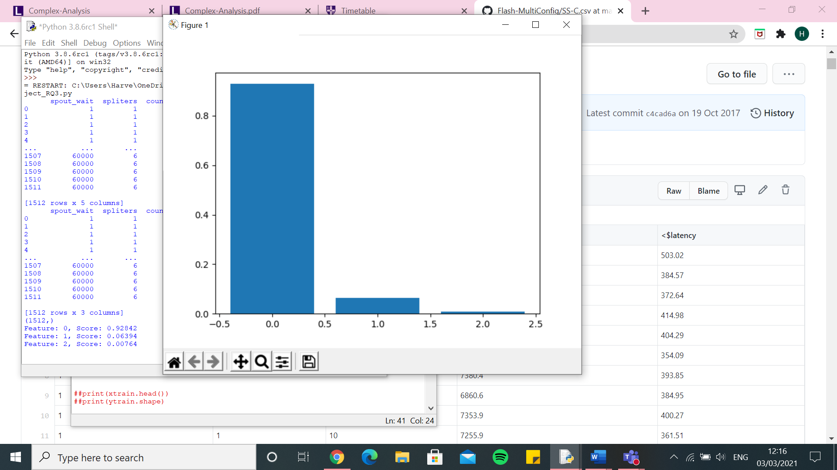

Random forest - $latency

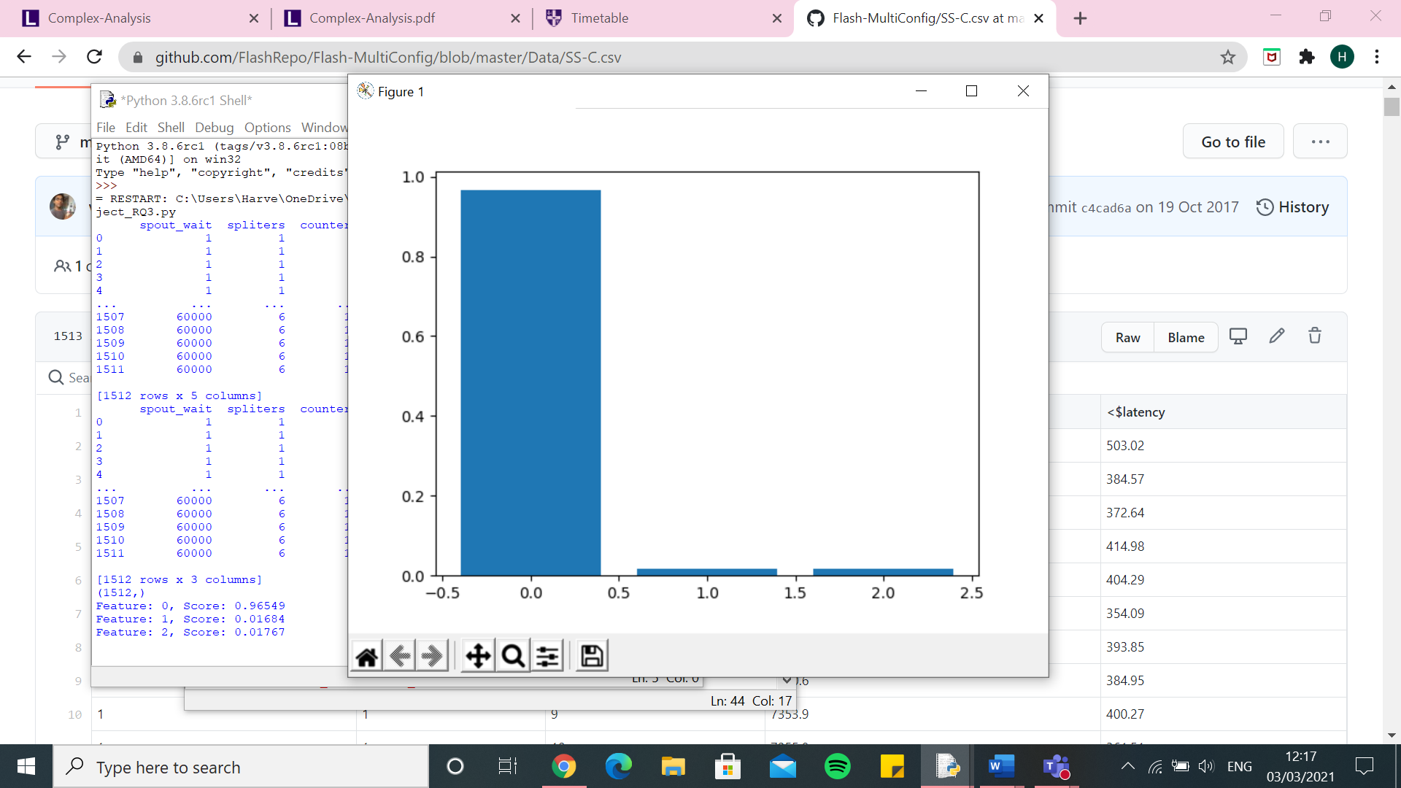

Random Forest – One hot encoder – SS-C.csv - $throughput

[3844.854715798241, 4087.508769810599, 3649.9248010718247, 4269.532374470393, 3498.2343286615264, 3793.406059391726, 3627.327459210667, 3936.1039153888446, 4167.95772866568, 5159.756978684181, 3593.237622595034, 3952.9435474707934, 4037.3760343015124, 4116.471603168036, 3747.359914463127, 3775.9966303958345, 4109.923116053536, 3464.828397767117, 4257.13146347524, 3787.7002432036006, 3819.469583322383, 3897.4538391108727, 3933.4453861083575, 4008.602503438975, 4372.38498625726, 3933.5699469756864, 4162.767833390518, 3655.357040964488, 3958.425888056888, 3889.8097654354206, 4098.801115456455, 4183.063904900022, 3397.9455894015837, 4106.065760511052, 3812.0967670230225, 3915.802664223428, 3935.5501773769806, 4133.352621019432, 3756.7617065799386, 3862.1644702346016, 3986.388546918817, 3905.7416352861997, 4099.9153308362265, 3884.8625544233046, 4725.04245407025, 3820.923554192257, 3576.5851582641426, 3721.661963578796, 3933.69196314334, 3806.8054198688237]

0.0 7.556929455863566e-10

Execution time: 53.32111382484436 seconds

knn – One hot encoder – SS-C.csv - $throughput

[2760.840207058804, 3163.429979463809, 3063.3767703722465, 3185.0500380251237, 2820.0731497318316, 3002.6590738127975, 3202.7817392319466, 3414.8908574999036, 3947.1228286621254, 4183.518178785942, 3205.1808359469687, 3199.84737333252, 3355.3326396246416, 5117.671148695675, 2722.4798341832466, 3511.190657123429, 3023.3710052317692, 2968.7027539023084, 3099.398793344514, 3040.902991915569, 3026.056694571532, 3209.8698076016467, 2762.695428767429, 3219.9572514242077, 3524.3102532179378, 3131.437208709878, 3277.278501846852, 3411.788232324385, 3404.6030219595973, 2916.0338101026177, 3432.3460384020445, 3923.743533894171, 3449.900020930063, 3300.4217864813577, 3018.051059140014, 2955.8405553780945, 2872.116419502206, 3608.2662464004206, 3233.6466070317906, 3113.371470408191, 2763.6406334305993, 3087.7722677978663, 4498.38070658949, 3192.010077832375, 3949.6616177144033, 3019.1754250342033, 3136.9142908653243, 3455.8394965674784, 3013.1886948637934, 3245.839719144721]

0.0 7.556929455863566e-10

Execution time: 4.897657871246338 seconds

SVR – One hot encoder – SS-C.csv - $throughput

[3700.104542792902, 3760.5248482132015, 3628.9835900437106, 4275.642401857999, 3191.0036159668184, 3372.842412409222, 3494.8406379862777, 3670.180510624968, 3964.1161768805046, 4548.8764686344575, 3447.040933920464, 3687.089153946504, 3662.852348502866, 4201.3986946954865, 3228.8780077340216, 4025.470346122602, 4121.263454506299, 3544.987638996832, 3867.557049918663, 3535.880190150673, 3545.3153333262485, 3739.914103662728, 3733.2680454606384, 4026.801755206174, 3852.037889212399, 3975.896933037321, 3789.1425860738846, 3323.9929760163836, 3729.215811834972, 3642.4685827802605, 3994.924996005936, 4072.6637996672107, 3547.023604319668, 3961.510806340524, 3864.7686511114207, 3823.272450599372, 3542.607435124116, 3551.117891835659, 3322.2164642008174, 3676.8719671177746, 3648.7846199777487, 3938.470006852598, 3912.258558736482, 3621.3253182948383, 4018.1204251815643, 3343.394275274807, 3517.159459486358, 3721.861719146593, 3790.5834811321397, 3753.707271707477]

0.0 7.556929455863566e-10

Execution time: 7.529186248779297 seconds

Decision Tree – One hot encoder – SS-C.csv - $throughput

[3771.2815591511107, 4182.748066289775, 3514.2200526629317, 4489.850958277257, 3874.967117151068, 4234.0623814876335, 3246.989875837239, 4283.854239787215, 4556.139334061794, 5161.495174381902, 3249.0795205605023, 4089.9702916168935, 4149.570158224584, 4305.425206717264, 3919.485887477668, 3772.1238145770003, 4750.914536478461, 3150.2894614681263, 4240.430632251972, 3914.4299611378824, 3289.975898026952, 4494.263450522342, 4177.112782910604, 4331.110853781992, 4599.203944140505, 3820.9239646064993, 4502.920979582197, 4115.395486661032, 4142.108103887381, 4027.9068029064965, 4064.7779481432053, 4301.747203591662, 3489.8984021535516, 4037.383328699871, 3362.1311138781753, 4127.35600859585, 4158.187733061972, 4522.016641904963, 4269.6927778416575, 4373.78338362537, 4142.6715209919, 4150.563920029858, 4468.407577354698, 4127.6278438844065, 5008.342314481711, 4077.628931605179, 3859.875635199912, 3797.0573269414913, 3893.655069945109, 3437.3198667265633]

0.0 7.556929455863566e-10

Execution time: 2.503241539001465 seconds

Linear Regression – One hot encoder – SS-C.csv - $throughput

[3470.1099220449796, 3542.35978211806, 3194.3370551740745, 3756.552120413786, 3543.319756719323, 3633.6796371552546, 3444.397989890484, 3748.0131796137007, 3866.5464118950736, 4212.075547241493, 3372.7361424718156, 3535.228981723831, 3822.281221598846, 3477.3398735634332, 3530.3602371486777, 3498.430579093294, 3827.552341886637, 3345.9769081047393, 3936.0573389937376, 3357.855497308092, 3581.904451623935, 3822.0078923025576, 3517.6046227090515, 3542.89242358667, 3896.439260851542, 3622.163253525483, 4088.196475024851, 3619.3556071182506, 3630.342633554221, 3379.12173341601, 3638.260268259377, 3691.521999736641, 3251.916438359482, 3898.8622929840726, 3582.1061015598702, 3549.7029724843555, 3814.155889596577, 3992.4059885665865, 3752.715013262559, 3591.4338974793845, 3585.523148105869, 3600.020536631621, 3735.4180097175513, 3465.368790783303, 4078.964619512367, 3621.741442561883, 3551.0070690779635, 3424.504377070193, 3515.4855549562967, 3718.546191371333]

0.0 7.556929455863566e-10

Execution time: 3.1321113109588623 seconds

Kernel Ridge – One hot encoder – SS-C.csv - $throughput

[6106.246145291914, 6413.83274097358, 6434.22921500414, 6318.972546284028, 6601.7323564387225, 6348.96069679471, 6633.396427990667, 6242.222507418159, 6177.626005598321, 6765.787714289111, 6488.057059488572, 6514.068390912395, 6264.911529628967, 6359.025138292321, 6370.999353220978, 6680.631035292108, 6745.186211592669, 6610.566170773664, 6387.321261588127, 7228.484936736765, 7063.963229765594, 5908.278110625181, 6545.8017922455465, 6347.98331729509, 6492.6870008799515, 6387.818146521169, 7619.089799095243, 6783.1283733709615, 6417.576255318535, 6655.1245451381255, 6763.4779182098055, 6196.535008553061, 6411.408317100617, 6498.780395216714, 6586.271769341899, 6477.696196771498, 6495.46615089316, 6518.14016418833, 6149.230777405313, 6644.077412983943, 6807.223955058534, 7345.166228980094, 5920.014856189081, 6562.355439008692, 6453.777160984796, 6534.809116686226, 6874.976870449752, 6626.522846764799, 6516.714518311604, 6566.141777505407]

0.0 7.556929455863566e-10

Execution time: 9.739714860916138 seconds

Random Forest – One hot encoder – SS-C.csv - $latency

[9260.726377561781, 11502.843812577154, 9193.32940678804, 10273.84859565417, 10604.30803520127, 10657.84900273244, 10635.954844000487, 13608.78453499972, 13226.155405792593, 11685.165531525034, 8827.580545519944, 11320.08121328059, 11168.303313282478, 13711.470812491403, 10178.601328873689, 13907.760903529928, 12240.858276767003, 9661.268773257418, 8831.386453748946, 10002.933064508028, 13179.122792897624, 10538.73255227533, 9557.635664904212, 12843.179025727863, 14442.77607389465, 10016.68144481638, 10923.68773412277, 8792.851923358905, 8191.201527428002, 11398.093256165357, 13091.256871555512, 10929.21537330921, 9025.81761259378, 9276.63370769421, 13178.608565009437, 12497.822975056946, 11422.563801402952, 9045.871985533682, 9953.061616594789, 11982.406229751834, 11630.633903913447, 12000.316844714249, 14322.711592021935, 10207.996769978552, 12411.141612626756, 9201.355917288067, 9879.204041877363, 8534.679560689909, 11401.206559842172, 10757.216968475206]

0.0 7.556929455863566e-10

Execution time: 44.24172878265381 seconds

knn – One hot encoder – SS-C.csv - $latency

[9225.686191127043, 11474.05837973269, 9166.78532458906, 10214.138985792264, 10577.742426152314, 10633.509631048677, 10602.812669300394, 13588.659837290936, 13181.174303158414, 11626.06023080493, 8814.005884575361, 11283.584537363044, 11141.70996000987, 13689.87336422477, 10146.41115850344, 13888.077522728137, 12176.919777758652, 9632.78938828768, 8787.225072297848, 9983.443469437605, 13147.061109593837, 10496.249037927171, 9506.176391126552, 12817.239076975118, 14389.756950064115, 9985.2061848363, 10888.032689280304, 8777.122149801467, 8162.982113144848, 11370.044609372562, 13062.451728080932, 10895.532284291197, 9004.263388473457, 9248.138666511995, 13147.793712774848, 12460.523273006786, 11380.434024693386, 9022.98943076686, 9935.101539370688, 11948.042463608832, 11588.577065548396, 11964.071617719708, 14281.403106272106, 10181.023208804814, 12382.67379387187, 9174.64577667358, 9861.778829165027, 8520.86964192632, 11363.062618790338, 10727.071804348881]

0.0 7.556929455863566e-10

Execution time: 1.2716083526611328 seconds

SVR – One hot encoder – SS-C.csv - $latency

[9256.576981352671, 11483.402159124698, 9181.87895696133, 10263.937661212814, 10591.197692045076, 10642.568774420924, 10627.062360885902, 13594.363131817921, 13209.971249117472, 11670.1179983458, 8822.476601876233, 11302.104760952507, 11152.847130581607, 13939.668716729477, 10165.297992777902, 13900.314985772382, 12226.825956642868, 9651.569575020812, 8819.38864059985, 9991.368367183728, 13161.431199908338, 10519.608509819165, 9540.988052296078, 12832.87511994752, 14423.502458184672, 10007.195640184584, 10912.399596896672, 8782.643957918339, 8180.3143701228355, 11381.242525592508, 13080.978372783156, 10917.777954121066, 9017.206995017576, 9269.540373009324, 13168.579033853004, 12481.665258724672, 11407.693161892506, 9028.344960436549, 9943.729580734725, 11970.180694343331, 11619.16860061148, 11995.295744076422, 14304.597834795282, 10196.596870280508, 12388.396358724543, 9190.661463360284, 9868.729663411488, 8525.865826233488, 11386.476586230146, 10742.887809379734]

0.0 7.556929455863566e-10

Execution time: 4.583745718002319 seconds

Decision Tree – One hot encoder – SS-C.csv - $latency

[9261.082486332492, 11497.487921788346, 9192.207036682756, 10273.109048091288, 10607.895837744367, 10656.569614118145, 10640.167252122896, 13610.359749610823, 13233.585696008895, 11686.629602355028, 8833.308062168804, 11316.789021889444, 11166.675402716388, 13705.96784278192, 10178.95719946702, 13911.898943552658, 12242.18592783596, 9625.674764527108, 8832.551335186588, 10003.107787365623, 13177.461512650687, 10544.357253181644, 9557.991176765561, 12840.960617004983, 14445.397654112669, 10015.207839872923, 10923.937128483307, 8795.698584572325, 8190.349869761156, 11400.205618741498, 13087.906787434167, 10929.007009289704, 9026.523241375435, 9276.425099828217, 13142.2705221753, 12501.437987599014, 11424.736663667318, 9048.399424513276, 9958.04161701612, 11993.337076083519, 11631.539139996616, 12005.815908906263, 14314.024381767653, 10211.818186301864, 12410.105315321704, 9200.891011837664, 9882.637144594375, 8535.502824608626, 11399.597500227537, 10762.928542000263]

0.0 7.556929455863566e-10

Execution time: 1.0481958389282227 seconds

Linear Regression – One hot encoder – SS-C.csv - $latency

[9668.35195912646, 11805.274344689431, 9616.159499284742, 10588.790574635648, 11069.268866269504, 11114.67494403897, 11101.967164023054, 13913.737814214397, 13514.287933899992, 12219.992193721706, 9258.761882620294, 11725.2454359886, 11516.875113683564, 13851.755424255734, 10656.61351897883, 14286.186945141264, 12585.362412272916, 10163.504275790749, 9183.79295876742, 10701.418867574752, 13638.269459314113, 10831.062251561998, 10051.864895654227, 13197.828597223328, 14763.390477666446, 10453.939082159117, 11482.475526145281, 9265.965433772759, 8573.244717481142, 11824.570814367176, 13468.037699162556, 11272.829273926447, 9452.38584485649, 9707.911106472851, 13593.598047559382, 12810.370490669993, 11845.03310397878, 9449.597890437304, 10311.126609720217, 12412.642882528044, 12052.195494604823, 12490.732740932868, 14583.79319931243, 10645.776092192902, 12786.66737544052, 9723.603701720573, 10505.066244745594, 8967.23303185511, 11755.038665768592, 11137.394528394207]

0.0 7.556929455863566e-10

Execution time: 1.3884327411651611 seconds

Kernel Ridge – One hot encoder – SS-C.csv - $latency

[9334.355429554504, 11600.260365841006, 9276.702159681607, 10372.224934907164, 10698.889529014898, 10744.18391805332, 10733.520990957059, 13724.660071701552, 13338.175987017152, 11783.784150014544, 8926.936138722409, 11422.097081111791, 11267.137237937919, 13811.953953941502, 10255.508358069479, 14010.804904570721, 12345.542673558215, 9750.182356524452, 8921.392856152352, 10085.727692682784, 13284.211792456512, 10645.015539231195, 9648.2958368651, 12945.559782324442, 14550.685951842906, 10111.860043709858, 11021.266898225289, 8871.169360185593, 8273.149731030438, 11494.03864635066, 13188.962017855458, 11030.62111542238, 9113.632190744054, 9362.747460800572, 13280.57992625058, 12598.81034034473, 11520.104447711296, 9146.806699467666, 10055.542922399914, 12090.017124196638, 11720.491945141372, 12100.737899182379, 14438.427462508174, 10300.566110706095, 12518.32373655586, 9277.868996325666, 9974.582579826912, 8621.25736102043, 11504.639825407286, 10854.281718210736]

0.0 7.556929455863566e-10

Execution time: 7.560913324356079 seconds

Random Forest – Integer encoder – SS-C.csv - $throughput

[2549.8038842676747, 1780.9152027915852, 1833.441996544134, 1805.2378140298777, 2831.0110715638125, 2627.165017395476, 1839.8854804573148, 2193.1780189805136, 1858.220846844049, 1714.4236859461969, 2364.371150702704, 1929.7187808911508, 3118.166011033283, 1558.0992378690166, 2547.019952488338, 1848.6607664538262, 1834.7678836918901, 1827.1843689480115, 2765.864452390481, 2072.5727837524983, 2376.2619545531475, 1873.6842059430328, 2057.5148704677104, 1888.7884624418832, 1736.2258760394898, 1742.125346449745, 2673.0180435438033, 2611.569932929057, 2511.7017334198476, 1925.7028754643827, 1878.7067499114635, 1616.8718489856824, 2305.0261618991376, 2985.697334052895, 1826.2410373926855, 2058.565610567328, 3295.570845342971, 3095.908326720137, 2765.7348340057542, 2276.922098029916, 2198.047591502961, 1813.3872713899702, 1907.0044524380482, 2304.0310042252063, 1808.6761777761155, 2629.059887373762, 1939.6408262718314, 2060.577744376276, 1901.256535681039, 1648.5807148302422]

0.0 7.556929455863566e-10

Execution time: 29.595672369003296 seconds

knn - Integer encoder – SS-C.csv - $throughput

[2385.238686796107, 1799.525970060003, 2153.3135451337066, 1920.4139092091855, 2795.7290482192575, 2358.034614554338, 2280.808681790255, 1984.559785037224, 1915.678632041224, 2002.413836114333, 2792.691821313194, 2297.759643672248, 2893.8658271511104, 1538.470275984127, 2437.928980285771, 2533.6050382685407, 2171.799486709807, 2025.2085447789555, 2633.8365921163104, 2491.75848938506, 2535.451682349637, 1921.37301867996, 2055.8678646500275, 2091.4587628260774, 1759.1706519218214, 1880.2687008112248, 2822.0105299820907, 2220.3478928925047, 2336.525955070451, 1973.704335529534, 2320.5612424215283, 1706.8794386268407, 2269.156119629714, 3087.6848386032534, 2034.1428712369182, 1850.8849369553864, 3406.137834673659, 2895.717177148998, 2578.2565234844387, 2200.634312916038, 2358.261677100373, 2600.920303400216, 1898.3363470085035, 2800.95098723559, 2117.0591740782984, 2475.2704718874693, 2306.9901493887705, 2697.896547103965, 1774.7626438341008, 1865.7182292433995]

0.0 7.556929455863566e-10

Execution time: 1.0669684410095215 seconds

SVR - Integer encoder – SS-C.csv - $throughput

[3672.195772697074, 3754.714174240215, 3622.207178722799, 4261.868093653387, 3183.800105670922, 3361.480443588412, 3485.8142069291484, 3667.0395633969124, 3958.272831561854, 4521.921117514866, 3444.1057160947057, 3679.046283766785, 3665.3914127858434, 4181.436025026139, 3222.7065635397526, 4010.149882219524, 4099.892998592441, 3543.7494601113453, 3845.0733777438654, 3524.307875568606, 3527.47723317669, 3735.7535152805663, 3727.103659227761, 4013.989489487525, 3847.1140313095134, 3951.695892057191, 3777.7340098479494, 3321.187573512585, 3704.5200241502644, 3634.063577356804, 3977.0739888347534, 4053.2864651181176, 3533.902882107065, 3943.338044791171, 3847.1400231698044, 3807.888169241832, 3538.1651162937146, 3548.8248277039324, 3319.7693932595425, 3658.630460047385, 3630.7949362622535, 3915.931669975494, 3901.8107824768304, 3600.6225975733964, 4008.137636488778, 3329.9836968298637, 3510.21071063812, 3697.7091586218858, 3787.766897137326, 3735.7418921206863]

0.0 7.556929455863566e-10

Execution time: 5.365940570831299 seconds

Decision Tree – Integer encoder – SS-C.csv - $throughput

[2544.148447149961, 1786.370350085885, 1789.7573297810975, 1811.2175776231531, 2835.1940704471494, 2662.8942008546555, 1781.3405281113821, 2240.2542569282973, 1900.370295146079, 1888.1900895541444, 2025.2768758368525, 1885.0168330902284, 3124.5570524750337, 1778.227865038674, 2566.1816573463484, 1718.0713598555358, 1899.8315134593627, 1825.6849156605183, 2846.512196931908, 1960.2832137436094, 2049.8032014649984, 1884.4009186485769, 2019.222495224994, 1868.3336074631243, 1870.6343432922383, 1738.5524892013477, 2710.6867839135575, 2682.5194680392033, 2516.6299160883777, 1951.3800336892723, 1858.7299348099423, 1629.9965763877447, 1989.6023221922917, 2945.354410083993, 1813.7262893019183, 2078.7477300415662, 3363.073570956024, 3099.706104876715, 2760.0692713558146, 2306.7517616982113, 2195.033586056523, 1651.4623312815907, 1924.0331320243245, 2052.2426774672995, 1825.9917249368443, 2668.7264944809845, 1913.1990925223522, 1852.1152739733056, 1897.718895699824, 1585.7543992083004]

0.0 7.556929455863566e-10

Execution time: 0.9490954875946045 seconds

Linear Regression – Integer encoder – SS-C.csv - $throughput

[2732.8415076091574, 2688.35040642683, 2983.837318594461, 3027.6251845201373, 3039.3609355408157, 3015.7686037665494, 3028.9008536417227, 3258.361001458695, 3026.259980756122, 3169.2108864127813, 3188.6060504458164, 3073.2546262896476, 3314.2048221293453, 2906.0151367103113, 2763.81251556325, 3105.483597148291, 3166.7474536270724, 3331.436262617162, 2851.2256809321057, 3007.402997036976, 3036.999568202463, 3165.092134364474, 2972.0737691040695, 3205.309236267185, 3044.6021925956825, 2979.6092133683655, 3254.596072276048, 3148.2384890643684, 2821.7994797677175, 2972.7242873844875, 3044.7601470449717, 2783.228549508173, 3115.6174744772065, 3053.259435704013, 3029.3512155387252, 2995.0682967728035, 3265.705270363891, 3496.2584330034874, 2965.154490052515, 3500.0098858765678, 2737.3825281345767, 3098.5152255340245, 2898.0437607886074, 3280.6656323139, 3141.065390443147, 2873.6296175549396, 3239.540147466185, 3030.563821534317, 3006.8984370177454, 3024.6076935462747]

0.0 7.556929455863566e-10

Execution time: 0.9412951469421387 seconds

Kernel Ridge – Integer encoder – SS-C.csv - $throughput

[7742.499698713278, 7561.5507347209395, 7533.627197257852, 8224.615628979804, 7500.457260977139, 7663.553189863863, 7810.358777920345, 7728.944850118481, 7597.995065269347, 7902.655285121548, 7824.398375598274, 8020.489989125794, 7975.981528537651, 7053.164969027134, 7529.9392641061995, 8508.516952765505, 8142.665089405386, 7405.72426324528, 8141.891013890189, 7525.414079404133, 7660.820449831536, 7667.798226746944, 7355.464960939819, 8011.9250283593665, 7643.552827780017, 8409.710626979428, 8339.304303249442, 7702.603412820377, 7691.030461714627, 7521.276309747445, 8219.90742385634, 7627.561619840666, 7703.587590977567, 8549.521073972397, 7847.926800740813, 7863.035310075462, 7853.444459356341, 7836.315145534224, 7481.018787334775, 7498.6349979447095, 7973.86853414228, 8370.428112320718, 7292.547594030979, 8055.957359078767, 7489.116858213123, 7504.234719764679, 7651.384473492031, 8120.137159790569, 7769.400538797595, 7408.480676811039]

0.0 7.556929455863566e-10

Execution time: 6.640007972717285 seconds

Random Forest – Integer encoder – SS-C.csv - $latency

[9228.190235182905, 11275.67588078173, 9016.624002281547, 10026.172542075938, 10577.918279967322, 10609.85784080101, 10446.155501477442, 13360.477139858815, 12981.037100711645, 11593.69784159998, 8701.409649960682, 11104.226391770728, 11127.84550184366, 11243.107572233439, 10140.75525691402, 13663.51856276047, 11994.795675840352, 9465.301785624637, 8789.928648744502, 9844.077602724263, 13009.078105459104, 10326.823206552885, 9342.795093362236, 12604.342466471278, 14194.133214022355, 9802.154655477992, 10879.874751218853, 8764.749826609666, 8152.6575242711215, 11170.886811329201, 12871.584582380927, 10702.899898026584, 8869.391719733425, 9239.525766240953, 12950.356203060508, 12248.790515893548, 11393.413342175192, 8999.816396892382, 9927.07364931533, 11774.637930898469, 11561.61793874245, 11779.721698467401, 14076.810335714223, 10059.325470235923, 12262.015108735804, 9161.465648061607, 9680.366837699028, 8374.919009665196, 11181.341759116596, 10539.090782992269]

0.0 7.556929455863566e-10

Execution time: 26.17325186729431 seconds

knn – Integer encoder – SS-C.csv - $latency

[9222.6999494846, 11272.680243045967, 9073.946393594773, 10024.653544585872, 10576.610338575989, 10599.179078956704, 10524.976686619792, 13359.441636682224, 13033.550293678276, 11726.5501404563, 8766.428106120706, 11162.887234257447, 11110.905820901167, 11723.642265447985, 10139.951043054325, 13774.167112972385, 12054.35272267278, 9522.23176766071, 8775.029611351269, 9897.952167704463, 13067.153314136218, 10372.050645940017, 9340.48111832578, 12645.010899864888, 14212.287609703513, 9800.638588040756, 10874.185573688925, 8749.21851004701, 8135.68574309214, 11207.46768022628, 12948.391883470662, 10724.177046361388, 8932.040698178802, 9238.230640067219, 12984.733139625863, 12250.723365278634, 11390.201944812132, 8981.185654354233, 9913.974668053293, 11776.348749637575, 11570.968874533553, 11884.110653861342, 14091.785975003591, 10129.005960753846, 12360.24116313741, 9155.472177803727, 9735.344555996622, 8458.798876626544, 11177.321115596078, 10535.998224490215]

0.0 7.556929455863566e-10

Execution time: 0.9784295558929443 seconds

SVR – Integer encoder – SS-C.csv - $latency

[9249.98648531873, 11484.007975336806, 9180.966193412678, 10257.784701786659, 10591.891129525415, 10644.173251626642, 10629.036758709877, 13593.906733065747, 13209.655848916098, 11661.296063997606, 8822.986653024771, 11304.170103943192, 11154.657195278074, 13938.404464604459, 10167.631504143463, 13895.785729076984, 12224.14474916065, 9650.905502412143, 8816.85222705293, 9990.286180179128, 13164.4635274202, 10522.127548496204, 9541.294772469593, 12830.298885092978, 14423.674646887073, 10005.917427981201, 10911.16006812765, 8782.257117022275, 8176.335244693435, 11383.5094853633, 13076.265481550041, 10914.045589259176, 9017.824196000753, 9265.672615010499, 13167.862662638758, 12481.756259755084, 11409.281841794378, 9030.125721008826, 9945.25919528803, 11969.020571619441, 11618.027724283986, 11990.999431374303, 14304.106680960967, 10195.819390863711, 12390.140181290322, 9189.232384201214, 9869.87728838554, 8524.512891448998, 11385.815512515686, 10743.580301636883]

0.0 7.556929455863566e-10

Execution time: 5.389117240905762 seconds

Decision Tree – Integer encoder – SS-C.csv - $latency

[9228.356654043546, 11275.400566208007, 8993.254180416741, 10024.042085640196, 10577.32491791767, 10609.832460205716, 10425.085481652764, 13360.885689775683, 12981.468391931643, 11592.340562614861, 8637.487292710772, 11094.452175921699, 11127.99137171689, 11219.364200463768, 10140.042508074419, 13639.528452837483, 11991.817127194063, 9461.75532797079, 8791.166038908847, 9823.38185317514, 12906.080027157119, 10322.77794245885, 9343.298755271564, 12603.041811669762, 14194.776426463712, 9800.285689240767, 10880.282526331972, 8765.457246868313, 8151.425826115442, 11166.78537060741, 12841.046951051294, 10702.660491113238, 8814.62946057683, 9239.659288563353, 12941.631172634916, 12250.743834747296, 11393.428739375426, 8999.752300643324, 9926.137779519318, 11774.050459850041, 11562.003428965942, 11750.735467936469, 14075.798899585696, 9985.15244130476, 12263.01700201954, 9162.014757257715, 9667.635641510056, 8323.504831839457, 11177.29857307404, 10538.501468307397]

0.0 7.556929455863566e-10

Execution time: 0.9517467021942139 seconds

Linear Regression – Integer encoder – SS-C.csv - $latency

[10364.658143083327, 13671.33111608241, 10519.150034186052, 11885.408053441537, 12662.693777271228, 12216.013507390719, 12238.252542769502, 16273.464829468585, 15890.207467221708, 13747.814139866008, 10215.633512023016, 13160.212522421058, 13041.422288781667, 16565.149205976464, 11592.574571482079, 16271.813546713129, 14796.992567616819, 11158.86164979901, 10117.526773614225, 11486.582810634365, 15660.730091238296, 12609.449476327352, 10995.673394792464, 15311.776937855164, 17443.84241575753, 11346.26826346414, 12675.716056199657, 9861.889934172546, 9409.652119179975, 13545.757275757525, 15262.153814141942, 12682.937446731445, 10279.952969429096, 10409.22158261966, 15510.30750262633, 14844.189087970577, 13328.112998140945, 10929.256912217086, 11766.95752263991, 14298.830500280363, 13556.622337946214, 14001.640469740729, 17381.039138002878, 11868.594308187687, 14780.744763032139, 10431.896800200448, 11313.276703103238, 9693.776208970214, 13416.07827423849, 12739.32842893897]

0.0 7.556929455863566e-10

Execution time: 0.9007761478424072 seconds

Kernel Ridge – Integer encoder – SS-C.csv - $latency

[9870.775110920036, 12742.380098523985, 9918.583791750509, 11329.717889932765, 11566.912339055809, 11518.140456774152, 11593.5250660589, 15299.343948316087, 14829.627325877544, 12940.810127025925, 9566.364489342355, 12493.062391799269, 12313.532991371882, 15370.165897591542, 10855.885926354, 15531.178056375578, 13661.231983555917, 10432.15712740288, 9586.089851655264, 10771.296441642366, 14752.855315400773, 11599.964151768296, 10392.834589133066, 14277.177756836929, 16218.79128655584, 10924.97318611954, 11982.839765741606, 9368.908491833468, 8803.090606915088, 12534.35084908412, 14585.824567883914, 12066.231140891292, 9718.84008760676, 10004.375772975864, 14591.055454933292, 13917.853751640341, 12465.524425069041, 9902.336691263487, 10887.09331660232, 13267.724079572843, 12747.23439375208, 13261.788518942472, 16149.287200470646, 11137.116780609847, 13841.322233226721, 9818.938056710149, 10704.37533082354, 9188.99054386791, 12714.264365297899, 11773.753733399375]

0.0 7.556929455863566e-10

Execution time: 7.308629512786865 seconds

Random forest – SS-D -$throughput

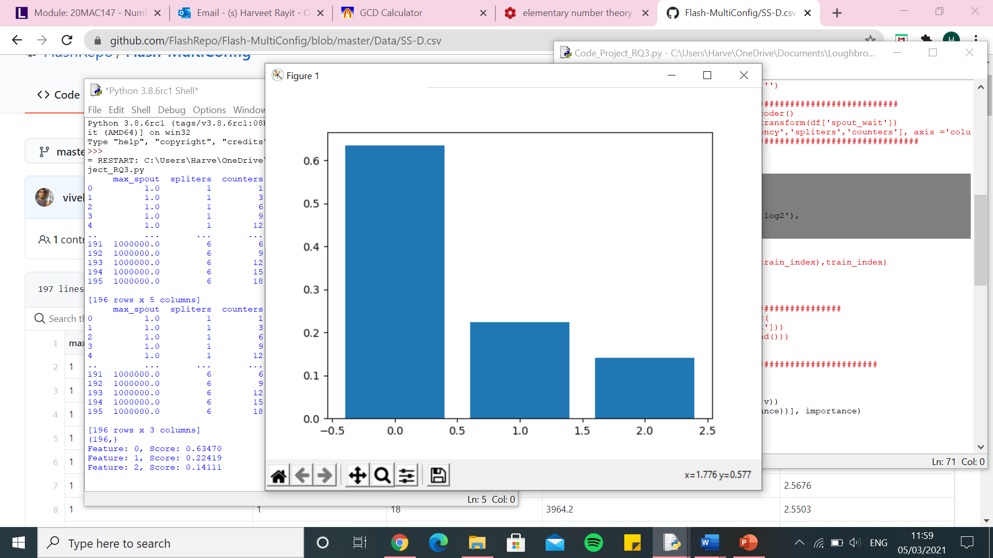

Random forest SS-D - $latency

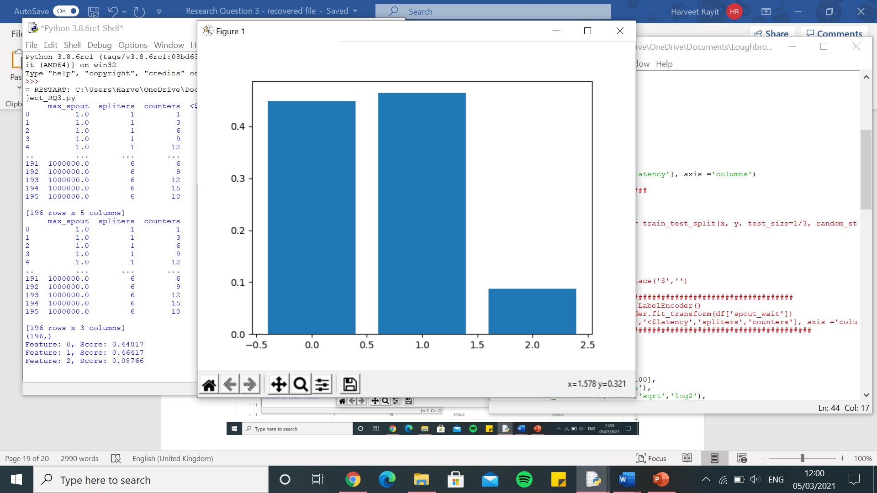

Random Forest – One hot encoder – SS-D.csv - $throughput

[13708.52920875496, 12742.164741821192, 13795.970852284701, 10285.105980397808, 13406.499291211683, 11788.663642234183, 12122.179509212405, 9030.90841005781, 12155.185925718975, 9490.068809860135, 12904.064898284742, 9433.084229253163, 13742.205721233835, 9670.333237014582, 10214.173552003016, 7968.538064694649, 12837.700500882236, 11463.686146477592, 10714.197389550678, 10924.171719736141, 11746.633550446204, 3490.7062763015997, 10408.271046965388, 7598.593877180393, 11420.64043186805, 10445.451393927036, 11959.127936737621, 11915.177679355485, 12643.698405468967, 11598.233638468842, 7969.466312315621, 10211.637019989796, 10083.754842790986, 8715.172581208455, 9387.589224384177, 14626.206971491118, 16364.006478486242, 11741.795966995387, 9474.462110764074, 10496.773416197515, 3496.923327142772, 10568.368550508058, 12460.358818409553, 13287.168230912192, 12106.36595677383, 11558.093111063854, 10293.3088273845, 11805.662204465847, 11450.585267113835, 8658.001566115674]

0.0 7.556929455863566e-10

Execution time: 27.734678268432617 seconds

knn – One hot encoder – SS-D.csv - $throughput

[14750.365759044078, 15289.126705496295, 17485.753170867418, 11271.174668965077, 13022.755576763313, 15717.054790417315, 14722.106507464781, 10321.620087288418, 15918.217334303023, 9050.669591060507, 18834.387962885863, 11359.388090021399, 20130.746941221532, 8876.937789742586, 10549.107138526939, 7912.58705317041, 15705.558574330502, 23505.71880290143, 13097.459110890655, 11994.540070753244, 14341.592253144698, 5475.737852859649, 12949.366945224774, 7446.6791477181305, 24130.17053939404, 10638.246191123797, 14335.058885006734, 13910.060626473502, 14249.657315740687, 13486.144554748735, 7898.71453587101, 9933.783227275499, 10489.438444244763, 7893.841532546749, 18238.156169082995, 13740.043653177381, 18315.441734479566, 16209.21498082917, 16653.8006878942, 15795.400282827179, 6599.563920387468, 9560.111387817611, 14382.800956918649, 22452.22144236512, 11514.49069071229, 16306.275307040538, 12147.617871006643, 12048.22257078699, 11967.017162381644, 9625.917153054752]

0.0 7.556929455863566e-10

Execution time: 1.5432288646697998 seconds

SVR – One hot encoder – SS-D.csv - $throughput

[14436.490351534292, 12998.960168325468, 14129.495313828656, 10386.49276843675, 11959.364278751858, 11140.742854091608, 12781.646366958405, 9088.858885826388, 12896.231134069962, 9379.526075353439, 13325.75788965229, 8941.317453103606, 14114.922913295266, 8349.605157793336, 9678.67689253064, 7775.800999558142, 11871.149514777757, 22145.780516308696, 10459.740300670624, 10630.14783337899, 11602.931181116808, 10574.799241565546, 11336.595211648219, 7683.353905595732, 18414.997813724607, 9570.780301674065, 13977.191936584264, 11150.870339690322, 11375.224943468054, 12348.725468814579, 7193.425754439912, 10525.45104630811, 11790.845736019743, 8762.896069493128, 12226.587934721592, 14002.694185486067, 13970.754110861759, 12340.44354511196, 13089.764274971945, 13019.884128072403, 9380.576532709347, 9606.687324492297, 14033.466663200623, 16402.20853461521, 11904.833556151598, 13340.120047476488, 10693.291598668528, 10126.76396461262, 11316.007648881188, 8771.824824370844]

0.0 7.556929455863566e-10

Execution time: 1.5103912353515625 seconds

Decision Tree – One hot encoder – SS-D.csv - $throughput

[13719.10913880441, 14300.179231613769, 13801.522991257965, 11973.596276149543, 15958.067189940015, 11030.726934913448, 12394.949404868088, 8930.971647609756, 12014.433469217653, 9997.585983842491, 13046.33125968753, 9619.977536200384, 13452.84149212434, 10949.899769389063, 9818.73373190745, 7858.445396411112, 12166.40001762836, 11250.343443051335, 10294.796408942673, 11373.800880279838, 11008.346310925355, 4223.603868201022, 10346.611884090365, 7634.394208131337, 11246.379360522884, 10116.923071452138, 11465.447187229895, 13907.421978116956, 13046.325411186288, 11828.82682363339, 7625.873167393139, 9836.853858540228, 9912.892154404255, 9001.60667132062, 12889.417742058471, 14502.756160677032, 17789.838962127258, 11204.87053418973, 10722.404268400564, 10433.681949145328, 3279.9943365720073, 10852.119447462786, 12927.961875540304, 13330.157527267926, 13791.261446423641, 12064.067789960562, 10411.457579083373, 12460.554653371139, 11259.361834338113, 9707.310929998504]

0.0 7.556929455863566e-10

Execution time: 1.2558252811431885 seconds

Linear Regression – One hot encoder – SS-D.csv - $throughput

[14544.570912191744, 13673.628769134548, 15009.109288863834, 11306.151672175029, 15023.032449499631, 12014.145198957884, 14128.953385063363, 8447.816594731086, 13721.139252033183, 10991.288583120016, 14702.399606414898, 9844.297156091156, 15536.706724542546, 11355.571701596293, 10497.909093867793, 8506.993337401587, 13193.063358258427, 12669.947781560151, 11153.628875235212, 12252.525532999738, 12056.326343669372, 3887.5901712290038, 11265.805479713772, 7584.978971127932, 12619.935309378212, 10864.460802375292, 13059.896245307062, 13730.17034935369, 14835.85008963811, 13547.728030771204, 8230.95506887331, 10407.402027782806, 10678.27482325408, 9535.373195574954, 11073.443618717474, 16424.610979350684, 17724.115864058116, 12778.081279352718, 10837.394986087953, 11689.002003318896, 3329.281315436645, 11111.012308484318, 13981.28892547399, 14086.663857165335, 11369.327074823897, 12425.076079077406, 12124.053345967925, 12149.965859687578, 11512.048303568845, 9413.25192560222]

0.0 7.556929455863566e-10

Execution time: 1.4404053688049316 seconds

Kernel Ridge – One hot encoder – SS-D.csv - $throughput

[21094.13425670748, 15568.915806143272, 23655.058936435773, 13850.65943662496, 16709.117041124584, 21587.10033956622, 18933.60496813972, 15236.213074168463, 19338.16710982795, 15813.432125135772, 22760.251117079093, 15103.723667544082, 22104.50452287667, 16027.936853995916, 13996.927720556489, 17244.919763976868, 18019.970443340346, 17000.488669616534, 18694.34925273141, 17795.46863181814, 15880.680472637296, 12901.242108198729, 18855.783408499265, 14217.944423883762, 15136.969759521444, 12533.939169885454, 20856.833140146333, 18933.330358469, 19277.000079369744, 18893.609592761364, 16356.61295684409, 16793.265336436874, 16610.860071125757, 11416.909096111565, 16471.85565638317, 21309.011101801054, 19706.700275747786, 16802.88584234019, 16974.01018463692, 19948.273555610613, 10594.965133895439, 15537.045235054347, 19568.607282833134, 17354.914280460303, 16397.524362865945, 14610.463436404063, 21571.49076626248, 12891.075409506517, 16609.96915775916, 16446.401107224996]

0.0 7.556929455863566e-10

Execution time: 1.4273278713226318 seconds

Random Forest – One hot encoder – SS-D.csv - $latency

[16278.631490596275, 23064.52746135269, 24561.993773943548, 11267.950773827011, 16793.9636689179, 23591.17384285259, 33312.78718560521, 9215.362714002686, 20639.86032374531, 26077.321351085346, 38088.28187337518, 4754.5349382086815, 28826.34126158399, 12246.229449292308, 6741.005071073811, 12205.918781012586, 17944.070920546066, 22536.54076267683, 26950.719624669164, 12333.588692999327, 23828.92272781878, 1379.2019981713622, 21982.45408222102, 20061.42277144248, 22396.377875400503, 20590.836283326786, 25206.658356628628, 20286.643910525683, 21141.038219303286, 29042.905747063076, 2874.221173946166, 12287.790740820026, 14543.03609791417, 8692.07265499893, 24676.861869028326, 23109.96362905634, 31039.0786588908, 15147.512171288245, 20789.871154864602, 29478.294024248476, 1022.1526478277744, 9227.74079751272, 29234.790694507137, 32371.115045122868, 22775.641772795632, 32420.822069858263, 20701.14711571765, 6871.943957212558, 34306.73533239842, 14715.426419565003]

0.0 7.556929455863566e-10

Execution time: 30.1607723236084 seconds

knn – One hot encoder – SS-D.csv - $latency

[16875.320067708766, 31112.13305749795, 28084.186206177168, 11774.07707037893, 20310.981248806107, 23452.980136631293, 34729.62974197589, 8775.5663212434, 26226.46342736446, 25659.58088595751, 38269.854334611795, 4653.170970265927, 30164.875888764185, 14480.262963508754, 6692.967462286151, 13566.385399750878, 17098.122313127213, 42921.519766745056, 26590.225268946502, 13760.92213077299, 22867.65661962303, 1647.2701083288193, 24018.286019915202, 21020.218949966067, 31804.52895307995, 19375.043585282787, 25736.091240188172, 18838.8689844232, 23936.469053499983, 30290.371169780374, 2821.908794465574, 11861.687018613604, 12112.923505897248, 9352.749419228308, 31031.27335927733, 31830.289221772902, 23704.706009087047, 17771.884050551504, 37677.60529712528, 38537.21630931522, 1195.6625182394048, 9395.583203352613, 30859.793761485933, 31979.046428212634, 26325.19559172461, 32461.790456768962, 24418.53371654422, 7686.517287708498, 32569.44293236388, 15371.184630251364]

0.0 7.556929455863566e-10

Execution time: 1.3546736240386963 seconds

SVR – One hot encoder – SS-D.csv - $latency

[16085.031860722494, 28720.270879004584, 24309.421180958714, 11795.10309182233, 19098.977941599085, 25445.773746538875, 33054.73351601233, 8122.097222541652, 20590.490282878538, 24540.36465549929, 33537.013169322614, 4598.313817258054, 28731.373212596838, 14825.485899840001, 6732.76307130868, 12276.414831551541, 16277.177958357486, 39878.037413666265, 26578.384097695103, 12359.387570769837, 20924.10002846699, 1608.4890253932924, 22875.83432325935, 18725.8751076317, 33708.1996844912, 15918.664135274912, 24806.239094586675, 18922.518621908075, 20763.463174778353, 30378.67156939999, 2645.685174132546, 12816.757130165857, 12371.32768217609, 8675.088076258824, 28988.921579632093, 28046.258059961667, 19454.703754695423, 15539.055708995222, 34239.709003824224, 35163.447598615145, 1326.598972583438, 9507.798174945448, 27848.155066861742, 34833.8157273187, 21677.883575512442, 31451.250296841983, 20709.06507661366, 6894.721884189978, 27057.233880199485, 14860.37659966034]

0.0 7.556929455863566e-10

Execution time: 1.4512054920196533 seconds

Decision Tree – One hot encoder – SS-D.csv - $latency

[16901.95402336868, 23478.6058782187, 24329.43222600366, 15820.43575837862, 18713.577181087174, 25451.583546802893, 33179.46436325984, 11322.744327233464, 20606.822964898463, 29275.01038804166, 40346.0407736348, 4677.8159638785755, 28745.42233975629, 19241.63342248881, 6749.837581333293, 12280.468581312447, 19148.24919221148, 20091.308926896516, 31226.535873534085, 12377.428306910762, 24609.593780717903, 1175.8779646389103, 24129.49238304082, 18809.506109911847, 37686.330074943624, 16023.098529836769, 25034.449816274093, 21056.58222498591, 19717.98301129158, 31832.499859783533, 4428.8820051797, 16599.85939613512, 17029.05946214945, 8680.990500047108, 31304.281570887866, 21941.010311375794, 35218.965381349335, 14272.157932162843, 20152.40140833962, 30718.30253412432, 1143.4960547340486, 9188.19473100473, 30547.293920964785, 38228.43525876455, 31482.350364072136, 34811.98654342326, 20718.26807357631, 6902.229928158933, 53384.12064303941, 14928.578898126678]

0.0 7.556929455863566e-10

Execution time: 1.2017171382904053 seconds

Linear Regression – One hot encoder – SS-D.csv - $latency

[18162.84364230318, 29541.735673368574, 28694.046472122438, 18336.572834561444, 20723.687726780725, 25782.539146222425, 32495.375052056315, 10498.441228235268, 23766.11207545872, 24684.81372918027, 35170.96257155714, 6327.812596252597, 42016.35808273527, 19934.518534913735, 6813.934829071034, 13676.375151274895, 21586.080310457335, 23473.95647919139, 24813.828289693083, 14196.863262950554, 28710.421439685055, 1147.7734969986698, 26718.537740001913, 22069.308632903943, 36002.973453398896, 35507.935505344416, 25972.610365169832, 25072.904185639465, 20690.29735226824, 31220.930106292213, 4217.530558557622, 15383.465897188868, 16795.631250615384, 10456.601342721904, 35787.82119867221, 25409.242957337647, 41827.577764945396, 21333.089617706908, 33471.08006737067, 38843.09725270869, 1326.106781790913, 11075.105215978174, 31212.804954237243, 28914.855746855465, 28725.15465482651, 38162.79242307847, 23846.9987619826, 7633.375500063817, 39641.084769829016, 17661.864436308064]

0.0 7.556929455863566e-10

Execution time: 1.4806716442108154 seconds

Kernel Ridge – One hot encoder – SS-D.csv - $latency

[15716.410898227563, 20338.90188603069, 25287.971531740397, 10737.638434504823, 16716.53758061726, 22660.371578825518, 31706.201335354228, 8976.591314658192, 21910.70609774004, 25956.67295911993, 30379.295068073454, 4747.986242024167, 30928.35799482726, 13196.504171915025, 6957.627991814823, 12633.420495098206, 17638.38238904165, 24820.6562522523, 23790.942319823473, 12943.490618513928, 22864.570397434334, 1331.4138144964093, 22895.682207297352, 20550.719496421872, 26290.126870060976, 20558.151581466605, 24409.647417433578, 19004.82032625303, 19034.265120781398, 29152.002637868136, 2845.7663183768095, 11267.075892217437, 13235.155415500567, 9128.26925751607, 24111.481951437945, 23463.62139869694, 25876.570695328024, 16306.668174377304, 26318.24240510209, 30026.770882717454, 971.0391552152203, 9365.856177361318, 28195.038334484732, 25940.27754092013, 22158.651166744025, 27008.078711611015, 21497.498942061935, 7174.251663339783, 32008.00538541411, 15047.478946806037]

0.0 7.556929455863566e-10

Execution time: 1.4028260707855225 seconds

Random Forest – Integer encoder – SS-D.csv - $throughput

[10088.46575138713, 12284.721251171415, 14308.159126822144, 9954.659200661517, 12039.500479408998, 10888.32116451011, 10791.386604671257, 8112.774643231785, 10891.471077163582, 9623.040870174516, 13581.45791786671, 7922.60977371339, 10915.281802871057, 9501.615027913762, 9203.937018055218, 7572.575466538663, 10493.119053993509, 10792.41712681481, 10480.623727524293, 10504.589702166015, 8521.958160013091, 4488.30688713145, 9432.788657231484, 7699.456153264581, 10897.443024434635, 10152.243903049375, 10348.524437792046, 10726.635252934537, 12720.168891461353, 11768.828195466935, 7418.768832956064, 9130.876076199682, 12324.01931062784, 8873.361121752305, 8030.805380006467, 12287.101630303798, 16670.085861310803, 9298.47233081277, 8781.490239490377, 10651.360022561403, 4746.1500631154595, 8104.807744923965, 11790.812719171023, 14118.012281762258, 10068.283766419181, 11134.069794014324, 11871.221041762934, 9826.239154928573, 11273.816156232873, 8557.112618857962]

0.0 7.556929455863566e-10

Execution time: 27.436981439590454 seconds

knn - Integer encoder – SS-D.csv - $throughput

[9942.450290546089, 11764.664440846582, 13492.59405834623, 9625.084612236922, 10887.05126585615, 10445.365146981698, 11452.191615804144, 7500.709653491392, 11034.054324224477, 9691.74390625449, 13146.14718929086, 8434.48436773938, 13029.085893556, 8365.546889650432, 9163.381967337169, 7908.563138011861, 9029.063369179143, 13649.998993137422, 11643.197006269369, 10596.714290761125, 10236.334554749565, 5292.512807442226, 9059.207417159627, 7380.824973842695, 11144.899612448737, 9869.263673998177, 11353.94444018002, 10503.840984754603, 12881.760946957034, 11997.61780951009, 7426.527336307326, 9346.427843049985, 10560.495319506561, 7944.647884174603, 8305.516814277122, 11963.8487287528, 13246.146412531098, 10947.575373049986, 10255.228810744096, 11222.371187235085, 5455.569428613295, 8573.488477059966, 12531.709838707566, 16165.200541684597, 9446.11712162622, 11317.120799876619, 10925.498866592581, 9185.326753928905, 11049.298525934622, 8781.251243771105]

0.0 7.556929455863566e-10

Execution time: 1.2938642501831055 seconds

SVR - Integer encoder – SS-D.csv - $throughput

[14434.288817190352, 12999.803174739634, 14129.662501021236, 10385.526107206297, 11959.677523177486, 11140.713496017921, 12780.817045936663, 9087.797790629747, 12894.905534995012, 9379.555255376663, 13326.65115054556, 8939.979564492927, 14114.508885642746, 8348.582458721105, 9677.723013578583, 7774.991151237961, 11869.837497259694, 22143.812177120213, 10459.194963463531, 10629.847598532233, 11602.819261782091, 10573.469464752388, 11334.93771770106, 7683.256690854443, 18413.504807214213, 9570.784102378433, 13977.798506046984, 11150.685098217778, 11375.460293421287, 12347.607525929143, 7193.52226145367, 10524.396928559003, 11789.317109942414, 8762.557877299698, 12225.888843912076, 14002.350967102575, 13969.999666373096, 12339.305955676886, 13089.62470182687, 13020.3106036997, 9379.727040874892, 9606.157311892375, 14032.897793367916, 16402.61744669115, 11904.25064089086, 13339.785370818416, 10692.60187001996, 10126.837157698777, 11316.316197475642, 8771.255085947989]

0.0 7.556929455863566e-10

Execution time: 1.2924504280090332 seconds

Decision Tree – Integer encoder – SS-D.csv - $throughput

[10038.962173079446, 13742.883621943312, 14677.3734960388, 10970.167711444627, 14171.582187607883, 10955.388659924392, 10822.087051305001, 8122.144404577881, 10980.531466087994, 9697.288010795039, 13419.99215624305, 8253.854387799678, 9989.500002541732, 10779.488096222894, 9568.577224421728, 7137.582959622956, 10969.209552217873, 12336.225132724481, 10078.978824683632, 10513.006674660079, 7870.230830925173, 4715.467877821234, 10070.376654442143, 7958.859475637476, 10970.946479771646, 10759.913394900073, 10065.186052245423, 11348.095032660536, 13043.568715509178, 11806.69503068997, 7651.158391620622, 9065.77673398432, 12970.427254514376, 9155.731539849172, 10217.880852585089, 12445.341104280724, 17507.41601262012, 9251.291963566882, 9429.339803190629, 10469.953040951847, 4703.531067447566, 8708.377261558264, 11838.681852607157, 13740.269273272186, 10129.445895303892, 11384.420289841899, 11906.828136144579, 10157.500205816861, 11120.847978798374, 9135.043347259814]

0.0 7.556929455863566e-10

Execution time: 1.1203858852386475 seconds

Linear Regression – Integer encoder – SS-D.csv - $throughput

[7478.938877273596, 10827.397901731694, 11581.730299370005, 8960.799859575623, 9370.478436122576, 8554.398465427535, 9526.76136595068, 8687.381993039273, 8016.908897832469, 8821.383842448733, 11744.215106565394, 6645.608905476067, 9503.255768005149, 8953.407364987857, 10235.874920478558, 6750.10550055571, 7426.21506852426, 13088.68678049496, 10329.816696850588, 7335.880769708933, 7211.352678661689, 9461.132380853742, 7882.070662654033, 10606.548754465057, 9507.897612333729, 9108.872667102516, 10167.503956831099, 8719.433812350075, 10835.606468434686, 9415.8599722999, 6179.768164836673, 8645.945161965874, 10500.36612000651, 7992.367049972352, 6476.681294181175, 9310.875941740307, 13523.399110232389, 8564.83209451243, 8208.667663711758, 8881.978563697381, 4412.186801095841, 8219.61090529129, 10903.222123840103, 12052.70108924121, 7797.401856872801, 9531.69752816929, 7441.276607596297, 6949.249292703332, 9771.776646957958, 8305.049137020664]

0.0 7.556929455863566e-10

Execution time: 1.1807341575622559 seconds

Kernel Ridge – Integer encoder – SS-D.csv - $throughput

[7283.152964921655, 11141.159244229231, 11549.29639892891, 9098.912248905657, 10418.632886838695, 10305.987344194118, 9360.023800106585, 10830.712241962883, 9143.86743654045, 9580.660202657815, 10833.371519043243, 8349.738007906459, 9793.893426060506, 10659.858770647847, 13031.781990052024, 8047.615760311328, 8836.549207720383, 12208.991999223526, 10798.12589309114, 8893.3717493256, 7591.004604999325, 11994.895971987948, 9349.303515940059, 11759.430971686861, 10094.560658553368, 10866.09564384663, 11205.423543608242, 9393.456471139727, 10074.30667717419, 9478.59973792978, 9414.780290320808, 8510.422826150741, 10886.38482460751, 11514.418715648206, 7176.984044382935, 10234.071475467199, 13949.413582233597, 9149.63717808107, 9080.445070770898, 9929.992887102508, 6079.930515858272, 9219.853606413979, 10617.88941188867, 12121.887834077077, 8414.629440002594, 10923.781614278449, 8834.664273121056, 7947.562134126583, 10831.483335351937, 10335.535272362957]

0.0 7.556929455863566e-10

Execution time: 1.2510058879852295 seconds

Random Forest – Integer encoder – SS-D.csv - $latency

[12888.08369997612, 21593.940646776584, 19114.589869215233, 11918.024536517401, 13079.456335819621, 19981.19217559443, 23478.131638327697, 8696.812447146807, 19807.868545379675, 21510.245707294478, 24412.130488970353, 5335.667477470852, 23410.603977777733, 13431.211508537792, 6210.76476921692, 10942.700381881868, 14874.562307294565, 20595.83233652671, 19199.06867075546, 11586.996547300214, 16166.981233215525, 1406.261539096649, 15547.277189063849, 17666.21663149276, 27345.36819031541, 16959.34981036927, 18895.34444433457, 14340.049801725014, 15488.55442185504, 24081.097573267896, 2787.501966413177, 11326.243904821218, 12874.619802000094, 8514.339733350875, 23970.80452507306, 19043.896192053096, 29626.03731432591, 9710.789920890018, 19694.072402723497, 27506.30226023513, 1162.6553755377884, 7593.4035177948535, 21029.28573140874, 25978.692931143443, 28613.322014543734, 25551.480883157757, 20319.776467422373, 6370.06522114868, 32709.442854862333, 17356.746124995057]

0.0 7.556929455863566e-10

Execution time: 26.24461579322815 seconds

knn – Integer encoder – SS-D.csv - $latency

[14193.35999551781, 22830.568214340095, 21637.196191336356, 9357.267052061898, 15782.263747614645, 21545.095971632425, 27532.346245004184, 8279.054281401195, 20187.35467895268, 15097.683815188315, 22344.174738835063, 4419.361892923621, 28723.89777774804, 11970.418732044356, 6449.890599470441, 12246.769003309957, 13849.21477329127, 22386.466508153815, 21437.701863931557, 12039.003185894235, 16135.483826705431, 1258.3326343497956, 16852.437097630744, 18236.843351475447, 24288.01249633354, 16823.852047923265, 20787.726289983377, 13995.223558865531, 15394.182559100072, 27285.480916437336, 2682.474326206, 11126.199520439506, 12046.137128132157, 8554.853648879045, 20849.94848576101, 23337.47651666082, 21380.14345235638, 12077.250216785591, 24690.506105227567, 26425.040862227783, 976.2081494977581, 7920.912962245373, 20807.456646922426, 24669.446290105596, 21116.291858794695, 23867.13580126366, 20817.072001084125, 6646.043310982067, 28843.457690267554, 15842.192035419472]

0.0 7.556929455863566e-10

Execution time: 1.2314121723175049 seconds

SVR – Integer encoder – SS-D.csv - $latency

[16083.982736662361, 28719.204297404096, 24308.24470216221, 11793.825924720808, 19097.628085534514, 25444.423280659434, 33053.796866743905, 8121.154450258438, 20590.15752837212, 24539.686079792322, 33536.02193410279, 4596.437985014136, 28729.80124766956, 14824.253030442826, 6732.500683196081, 12274.96809338702, 16276.256968448579, 39874.76198889499, 26577.113408045952, 12359.243252220685, 20922.9158417401, 1607.0878307755313, 22874.36672803529, 18725.583139245602, 33706.5537008078, 15918.02157439864, 24805.060296796986, 18921.399112013223, 20761.749675747284, 30377.331483753704, 2644.2133463242067, 12815.279140020988, 12370.488181563192, 8674.851467581073, 28987.629913267, 28044.470950951163, 19453.271026174236, 15536.707713956803, 34238.40685684907, 35162.13058550235, 1324.2639917024092, 9506.67805635782, 27847.069835183855, 34832.38486587954, 21677.777814882204, 31449.197703145233, 20708.896728090214, 6894.604053384049, 27055.84544341128, 14857.947239661895]

0.0 7.556929455863566e-10

Execution time: 1.155390977859497 seconds

Decision Tree – Integer encoder – SS-D.csv - $latency

[12551.739111568908, 23478.546846392503, 18226.348047754236, 15949.471659566329, 20348.562632802998, 23727.678857596115, 22836.87610711078, 7701.486912311598, 19531.872689738608, 25836.310852370687, 24816.92420297905, 7240.176899750284, 19070.050562988366, 19795.47763729972, 5957.416421250704, 10829.36610864685, 15888.809763984704, 19383.463809436187, 27216.837077510616, 11205.435956281057, 14443.531028182786, 1555.8233450178834, 15194.822943980094, 17510.117932937657, 38323.70902499547, 16315.836648143842, 20045.674280270017, 14552.180098241015, 14556.115602110971, 26320.374794764313, 2442.921340949485, 14845.046244645899, 15804.953746733174, 8503.696215950693, 30722.343651110223, 22033.008472213038, 35218.39737531047, 9274.05892414299, 19819.579820896466, 31639.726141328232, 1280.3117136835158, 7590.668323171732, 19888.724828173858, 34973.797060708646, 34486.28545818648, 29941.617700669703, 20505.5050729873, 6159.744859014345, 36970.41585369183, 21887.36068174199]

0.0 7.556929455863566e-10

Execution time: 1.1801033020019531 seconds

Linear Regression – Integer encoder – SS-D.csv - $latency

[14949.63957446976, 21635.716899849474, 24136.35940281989, 10990.812433648867, 16544.321311221323, 25925.73199373558, 32556.651898830274, 9474.018904130327, 24893.37432346586, 13937.405178238405, 19088.396664031032, 4802.221516036821, 28761.037993502847, 12824.856468394806, 6780.3677647474615, 13611.052722239037, 17852.469143373364, 29625.125184425702, 21899.819275512375, 12869.436999254647, 22688.5488074799, 1643.1590905257403, 19741.524993476334, 23249.131628182386, 24948.33353333729, 17935.114186491, 23366.255151609766, 15633.951919389812, 16528.176059635036, 30051.610446486044, 3527.3924659988324, 10647.385369155329, 13452.5099261258, 9139.062590008862, 21925.63195938943, 24515.2065241388, 23712.221089436844, 11506.272165547822, 29550.026631530607, 39351.75728470179, 1036.9734343006126, 8815.85331622098, 23214.32757945664, 23706.56643344852, 20499.902991981016, 26743.052322391508, 23328.148071299776, 9388.942425175146, 33202.81009608186, 17349.08770071592]

0.0 7.556929455863566e-10

Execution time: 1.0849511623382568 seconds

Kernel Ridge – Integer encoder – SS-D.csv - $latency

[14787.25371592506, 20467.607802480856, 23836.4886742168, 10436.025383103572, 16347.84197260627, 22901.31131813422, 30984.46879540523, 9291.26332211021, 23296.132644784917, 16321.487853898021, 19493.48112073662, 4552.146576440469, 27672.62545437037, 12236.779584172991, 6782.011683153606, 13145.796949800833, 15908.790053958783, 26610.286937245426, 20864.114844092066, 12780.793295544632, 19902.66206448754, 1534.5231757046256, 18090.647711748177, 19963.841298838033, 23698.7567986661, 17283.86547511263, 23347.415284138417, 14299.903611549864, 15955.316678369038, 30332.536249117686, 2972.809951353504, 11219.673200256118, 12186.138196619215, 8986.840512833669, 21507.83149252525, 23730.818720323074, 23059.601518790325, 11028.3970311955, 27142.485834880947, 32572.78065451051, 981.1456383051194, 8392.118902578984, 22900.148086653717, 25263.994757753015, 20345.39254266725, 23461.77248711813, 22607.96455304402, 7463.211287001352, 30994.45194992133, 16684.80739237157]

0.0 7.556929455863566e-10

Execution time: 1.2192564010620117 seconds

Random forest $throughput

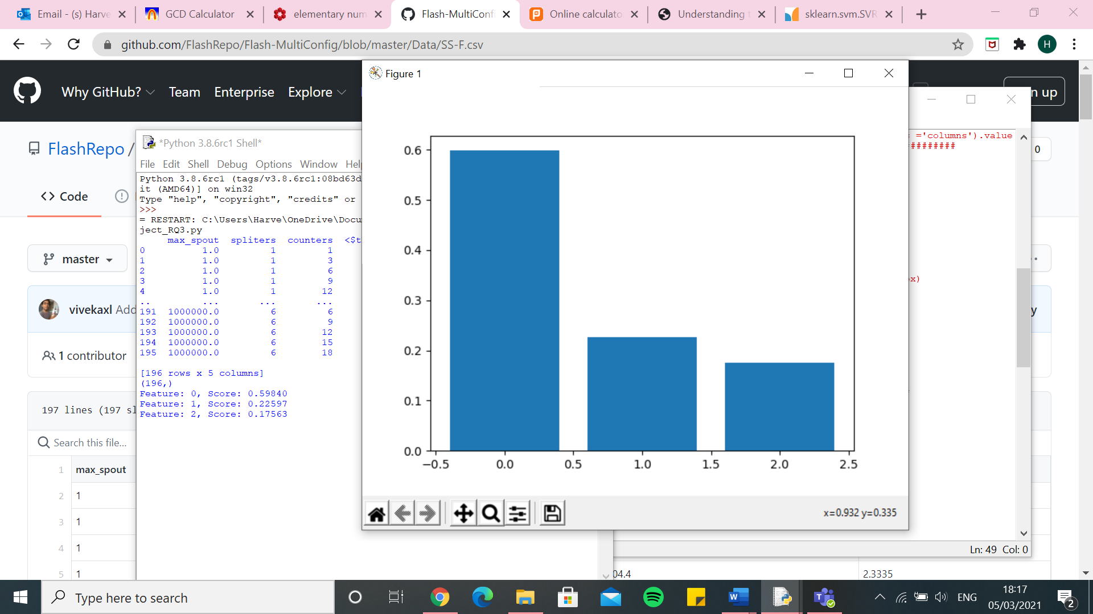

Random forest $latency

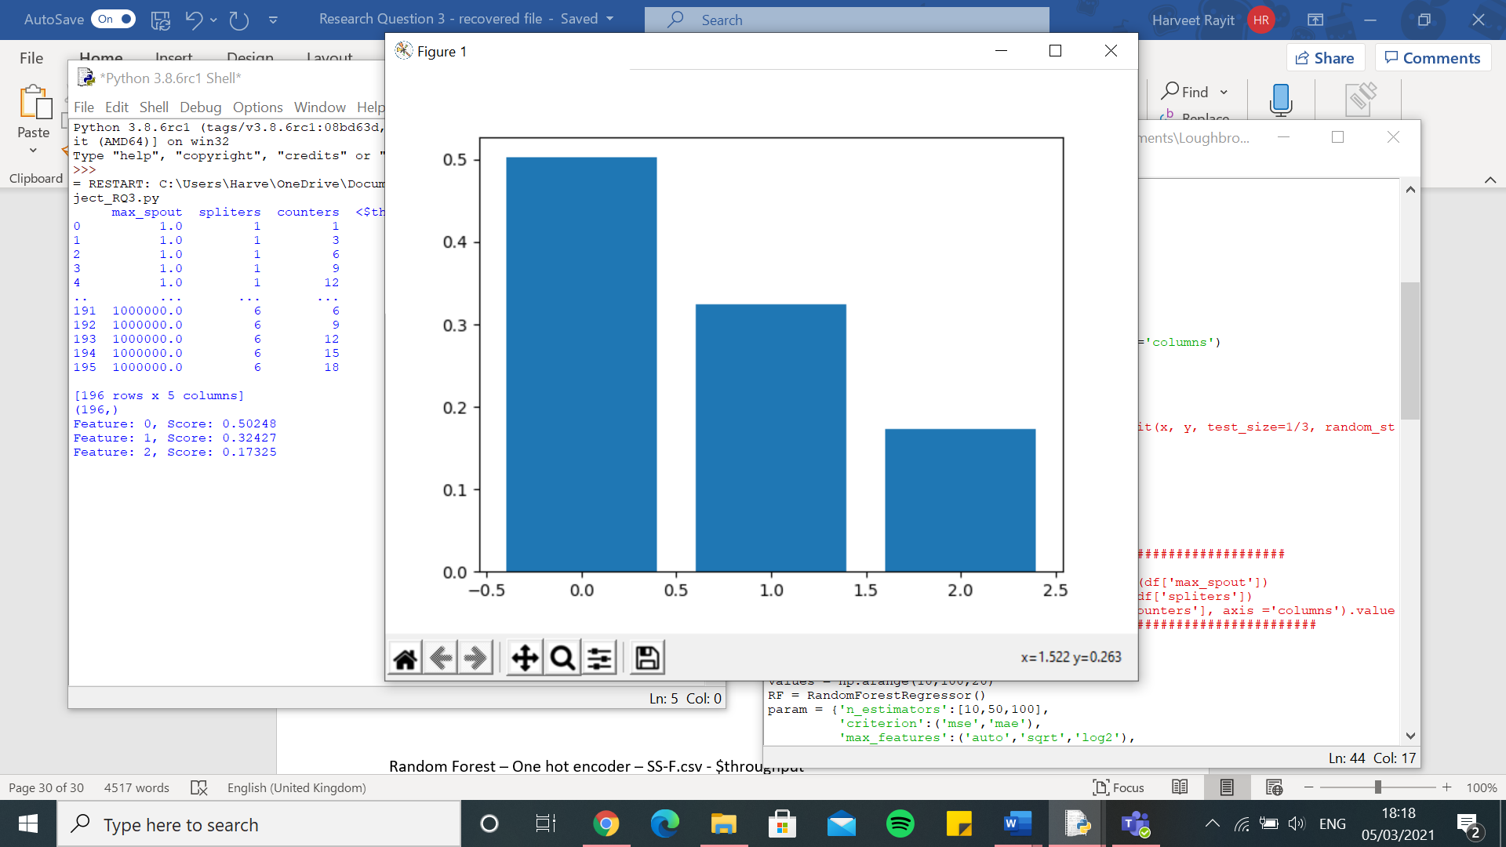

Random Forest – One hot encoder – SS-F.csv - $throughput

[15639.686007231836, 15281.799227906218, 11988.289917544682, 10824.729144826719, 16748.68159635955, 14815.755693024454, 14439.672661141229, 9442.224886275066, 13002.289340222149, 13650.777993535847, 16772.728825777445, 11844.97035202596, 14930.875355094196, 9126.966569409411, 11969.975700346266, 7707.916701849058, 13750.394533913483, 11539.472467612883, 17001.477321172413, 11752.711783231262, 15813.38536834816, 4549.167630444315, 12550.847604460165, 7168.78151229256, 13818.78251406589, 15670.760858615575, 14112.273008450851, 13280.853165069375, 15350.420092788769, 13442.750801129443, 7614.433484664371, 12593.620468040723, 11211.49614925685, 10231.035430104368, 11299.566241516763, 15041.656397339188, 18622.529983645578, 14225.713636688806, 11497.578617603987, 13140.319675703846, 4114.206883636493, 11178.709452782936, 13684.059925311263, 16175.548723178255, 13971.739783581621, 14942.539152989944, 14484.143181827367, 12675.045947188155, 14075.359389560857, 9835.962071575761]

0.0 7.556929455863566e-10

Execution time: 27.664886713027954 seconds

knn – One hot encoder – SS-F.csv - $throughput

[16393.19326312845, 21360.01523854747, 13103.709191980719, 11903.358030487028, 15172.902990613891, 21397.83519395969, 17021.359151459335, 10906.193452201464, 16901.33783814325, 13689.783574646191, 25735.52941864612, 14762.24989300276, 21706.81162629602, 8831.45685408472, 12342.340779224174, 8100.660466961937, 16876.90574130971, 27151.630116706085, 23028.667722850416, 13241.763539317562, 20415.88430777957, 6592.076060689836, 14774.211549317955, 7527.311889795719, 26275.2574633932, 15849.341064572369, 15302.328647397704, 15690.743667190336, 15135.735790926612, 17179.783264502003, 8658.41956978524, 12438.653593415967, 11836.72504161265, 9075.754898988846, 25472.189919779572, 15389.811454547453, 19922.467264553354, 15823.433973499059, 21721.735929090886, 18287.956923816513, 7010.728582662432, 10988.942768888188, 15291.805665733527, 28374.866093234694, 13039.421746142732, 20210.369337310487, 15969.83047207584, 13038.690894888265, 14809.52103836547, 10470.87305344839]

0.0 7.556929455863566e-10

Execution time: 1.2936367988586426 seconds

SVR – One hot encoder – SS-F.csv - $throughput

[15595.119154428434, 17834.618236027756, 12461.810751259301, 10587.24404130107, 13867.477227688516, 14689.77364496576, 15386.755479050033, 9175.215306768987, 13408.701679046577, 13600.167572183916, 17091.200546008567, 11011.175756767294, 15748.918200652917, 8993.19970426942, 11239.021914121044, 7701.129462111892, 12923.689679221357, 24329.656606863606, 17259.198665213287, 12235.670159151177, 15961.367515868265, 11868.039983835095, 12145.448076742143, 7652.923887211797, 20148.826618770723, 14093.397762140423, 14589.31494667437, 12769.410734460018, 14332.550358177486, 14274.006053415682, 7843.803174429872, 12724.157139769279, 13097.615324664284, 9465.264202699855, 16814.299847821545, 15225.817382405517, 15802.95717876962, 13950.080179388753, 16962.866027458414, 15372.379534861238, 10296.6578846723, 11195.95124262612, 14309.49090817893, 19378.211659010343, 14281.563892412965, 16093.611779553183, 14848.57828377979, 12027.780552416474, 13460.04101392773, 9454.350849513043]

0.0 7.556929455863566e-10

Execution time: 1.4617459774017334 seconds

Decision Tree – One hot encoder – SS-F.csv - $throughput

[16741.884433251584, 16242.019987181397, 11161.52832404187, 11281.45473917014, 19830.69517518549, 14627.119888143565, 14340.87277211007, 9116.152313162807, 11087.896007581963, 13802.130488125737, 16194.593723342523, 12520.024609605405, 14339.64372693757, 9275.684326320918, 11334.630633853443, 8040.858803246703, 13916.554988445694, 11215.268320714134, 16271.106886829537, 12149.783370830693, 16669.216981293524, 4836.979657515858, 12472.61273973846, 6697.084212293851, 13645.574548338516, 16308.005728502218, 14724.202461804132, 13845.32874941636, 16324.46639962197, 12502.809849174699, 7162.913157441988, 12456.22082851688, 10949.564401084639, 10751.9108448666, 14344.516157673286, 16549.253911801516, 19942.1476658877, 15065.43655801863, 12261.969438838358, 13960.527434248237, 4146.393875881118, 12014.153497037036, 13637.070360446842, 15828.82349688334, 14488.596217700166, 15268.441425784009, 14581.437048444957, 13458.648806701209, 13745.5350569362, 10708.974103190605]

0.0 7.556929455863566e-10

Execution time: 1.2546031475067139 seconds

Linear Regression – One hot encoder – SS-F.csv - $throughput

[17218.19406913308, 15402.9803512373, 12445.896987032354, 11702.583688866736, 20065.41244512936, 15972.96927339833, 16334.089437101278, 9043.390573501514, 14600.484841859103, 16018.679512544322, 19121.48972207576, 12136.215306376655, 16766.31925062624, 10019.734408697546, 12051.7456580365, 8395.751929876304, 14124.933300433755, 12780.186326217225, 18314.67083261289, 13338.878875261533, 16642.557960864367, 4778.083257381175, 13437.4863469909, 7187.024334344461, 15097.099563475384, 16940.636888956695, 14724.522079339215, 15594.616452997123, 17939.669924002315, 15828.315509143955, 7917.359347999742, 14409.218122705845, 12069.320375845304, 10971.244964371217, 13536.127157469484, 16814.152378353225, 20173.94459351076, 16394.193109309104, 13384.54762732026, 14592.191023955049, 4210.8837526686575, 11481.845644732777, 14831.120376118708, 16749.195582962493, 15488.345066531476, 15808.92711460273, 16060.022921546028, 13342.527091723234, 14032.449799562848, 10543.896671092747]

0.0 7.556929455863566e-10

Execution time: 1.3939650058746338 seconds

Kernel Ridge – One hot encoder – SS-F.csv - $throughput

[24223.050879972205, 18057.248508250705, 22337.479406048456, 15254.288175257656, 19144.45761281839, 26322.806920890864, 22014.56375357735, 16497.96624643235, 20590.35445166013, 20092.797079044714, 27831.584536385995, 16696.89819228129, 23769.370500720037, 15853.867229792073, 16012.373457496775, 17576.048237160707, 19930.762752668496, 17006.67021232177, 23978.586028611455, 19290.424326206954, 21574.30933959038, 14249.920113197128, 21332.11723633725, 14820.456759985267, 16569.30558010638, 17137.567706913826, 21647.294281739552, 21269.465772531497, 23405.006151548456, 21244.739632205194, 17072.206802854165, 20235.32946546227, 18558.518108819462, 13053.092595498974, 18132.159555397393, 22480.28703272325, 21821.221061607423, 20430.353919494137, 19554.870534180292, 22903.6978329345, 12216.282122737352, 16291.303094187095, 20772.683162366448, 19333.435407723715, 19508.655290713457, 17614.803874596506, 25486.75628394811, 14518.347700284356, 18591.872450981173, 17837.525030370074]

0.0 7.556929455863566e-10

Execution time: 1.4952197074890137 seconds

Random Forest – One hot encoder – SS-F.csv - $latency

[30298.28405911354, 29351.806998341843, 25677.49986846517, 11243.0076744422, 28871.36148367215, 28947.666739819844, 24345.32463280354, 7397.948161551265, 23706.29399526952, 33617.73376777825, 35980.06222786161, 19936.67346602595, 35070.13744828462, 15345.518425079717, 6482.974169713728, 12299.616972003423, 21110.448823499966, 13744.33768862883, 35324.10867305608, 20354.742576170192, 28339.716078341706, 1050.4556431873757, 20922.144758074584, 19078.8417145225, 32174.220623317928, 17999.75454382345, 35335.11103035272, 24271.005259572783, 30336.06949720501, 31971.779345105904, 2431.1045111771596, 24228.412314383586, 18731.307618390147, 7903.6242515502945, 21776.300023917986, 31304.56275065613, 29179.095475323822, 24266.599650289823, 17519.029020369915, 33491.903681705444, 1360.835802235607, 16564.973205401235, 29130.691064395338, 30803.086809694367, 32064.461342108363, 40628.338138341656, 33905.285103304, 6632.695089743293, 32906.874570625856, 20187.396051878357]

0.0 7.556929455863566e-10

Execution time: 26.118167400360107 seconds

knn – One hot encoder – SS-F.csv - $latency

[32711.292934813137, 46285.471198094725, 45508.18636207804, 15207.743136420022, 33432.236113142215, 34247.45331811979, 23697.000497705478, 8983.075793383941, 31434.845790187177, 36938.02296301481, 47291.908360122856, 23184.212251922578, 49871.949682606755, 30615.95620166586, 7750.851373457746, 17525.49384633476, 26362.391112333826, 47482.44917971212, 39090.68706404671, 23117.086967011328, 34086.96622130225, 1536.2243751206793, 25913.237089974325, 23267.303817527652, 49352.93506408835, 15550.58802204986, 35759.75206670481, 29486.490381343574, 41451.1533209456, 33033.222507939885, 2432.827702585867, 22992.221705724103, 22510.204563621846, 9801.534713463432, 55613.582527676015, 51947.47870750731, 29954.43563961791, 35194.5079897688, 41375.47937927874, 49925.722427825334, 1584.8418526184007, 17196.439053872033, 26670.886668318315, 48871.57678415678, 36649.02121944101, 47765.46834281511, 46220.48280171796, 6597.812535929086, 30770.171651558398, 23074.483201184503]

0.0 7.556929455863566e-10

Execution time: 1.2219254970550537 seconds

SVR – One hot encoder – SS-F.csv - $latency

[28835.2090093914, 39648.46993211756, 32651.845174822218, 12447.044445208046, 26608.24380224344, 28804.1934646906, 23815.60877832206, 6950.579569521706, 23702.686617889707, 28949.141502398175, 35653.901961109965, 19797.977506789837, 35086.08868290123, 24622.408390252007, 6477.174386938057, 12299.396443987926, 20809.34531642796, 39408.39837793938, 34952.78546465737, 20351.563527730177, 27787.44633214502, 1372.1976920672184, 22058.314606450756, 18995.52183537714, 37604.041995593914, 13257.539728754924, 33369.73988455717, 23195.962282834993, 37678.951482425, 31840.652783979454, 2480.137850422017, 22905.41562662919, 18664.05376158618, 7897.520184703888, 39549.587817300875, 39929.25562680487, 20796.506190881482, 26776.407864314704, 30638.847016616808, 32290.022185000907, 1539.3482417467321, 16694.353486580763, 27320.557738341384, 39968.037595514856, 30471.068708196086, 36479.88148561224, 33897.09551750305, 6636.547015017188, 26246.434073861583, 20207.097579332843]

0.0 7.556929455863566e-10

Execution time: 1.3698289394378662 seconds

Decision Tree – One hot encoder – SS-F.csv - $latency

[32513.21133597807, 34062.500941923616, 24776.31812859719, 16830.680096448374, 38303.26826728021, 28916.85128389224, 24350.570712666246, 7560.581798029414, 23715.55323114715, 33482.598242396394, 38418.836880697425, 19895.246069301884, 35094.51754829057, 23753.073195024448, 6493.385534980869, 12299.521471019156, 21653.189979648636, 14129.620431509036, 35120.8651404508, 20359.391434723228, 28323.737193274115, 927.0840443388771, 20901.06008945721, 19075.646531635066, 32229.730206343233, 18421.18128364275, 35905.3828854629, 24471.508030045607, 32223.325770644817, 32027.08061742341, 2502.396680959132, 24942.73667601224, 18716.74744996985, 7901.696691445736, 28234.850759491535, 31378.291850402067, 32296.85530645391, 29333.10227033243, 23406.963069829224, 36357.238197330655, 1480.3768796257114, 16523.15611529741, 29584.437928624007, 31632.18460915622, 32234.38119164269, 42575.11844886664, 33906.22021829706, 6666.392494840787, 33465.80806221493, 20261.681799742077]

0.0 7.556929455863566e-10

Execution time: 1.1852800846099854 seconds

Linear Regression – One hot encoder – SS-F.csv - $latency

[32693.965504309497, 34892.52401395439, 23658.716566708514, 17029.084603810705, 38420.28406238177, 27638.82766352182, 24038.845538741894, 7764.7081120926, 25637.52606947464, 33783.324767976315, 37877.41197711559, 19746.813887090764, 34726.815492351554, 24209.1365865636, 6539.18935607029, 12162.712391130824, 21604.94551881575, 15000.958520430617, 31355.33594002678, 20396.18766519323, 28065.41158625919, 826.3109031644836, 20736.772507208232, 19489.595422483944, 32718.44237784347, 18458.05864932479, 34702.47364391282, 24476.24727630007, 32596.877564681825, 34558.18480857183, 2364.7293351496946, 27267.91557731769, 19241.56400219634, 8005.015156070963, 28406.394020115025, 34050.05961930183, 32403.52523622637, 29987.16568760715, 23768.7166528934, 37077.661566322604, 1484.8367438628043, 16661.140545690927, 28244.436672558222, 33101.81766707683, 33749.640438902934, 43338.7573068485, 42498.51293725469, 7404.862995954919, 33601.833645690516, 20306.797586409393]

0.0 7.556929455863566e-10

Execution time: 1.3995659351348877 seconds

Kernel Ridge – One hot encoder – SS-F.csv - $latency

[29756.368856568934, 28186.64008888939, 26948.021984578038, 11280.048330268302, 25366.813885716878, 28918.653814154935, 24199.546033319595, 7192.138400706133, 23717.75735848855, 32003.98085821329, 35392.62961426326, 19920.543857087123, 35097.053553803125, 16353.160239819654, 6482.156942114542, 12301.743776787374, 20999.692797622814, 16876.724389606607, 35123.67100385006, 20360.932229822378, 28214.449127047432, 1069.0847226234253, 19955.48336067499, 19080.604058569883, 28762.938385416808, 15638.781056449126, 34505.56225786917, 23740.216488090988, 30774.65016238613, 31972.446029949453, 2446.6860010300884, 22558.69524078926, 18722.764962517245, 7903.9380850227235, 23363.310561577593, 31867.269838085325, 26371.21533236374, 24363.74363258534, 18781.060737009324, 30728.762226237748, 1205.0790859583165, 16588.524710331818, 28291.82104758757, 29419.476480764108, 30918.69483805875, 36971.64845134631, 33907.08636992549, 6631.873107128366, 30426.75736435954, 20197.30046396075]

0.0 7.556929455863566e-10

Execution time: 1.3784029483795166 seconds

Random Forest – Integer encoder – SS-F.csv - $throughput

[14423.080178940128, 14843.855193790328, 13068.542982193581, 10376.34998123994, 16078.683697844896, 14991.242889380017, 12962.651814355202, 8602.433998996228, 11657.562282385983, 14604.813568747055, 17605.287542293958, 10064.224731295486, 12545.239895084811, 8451.603751074956, 10757.198340786397, 8101.785066487319, 11191.573299482803, 10308.684104758971, 18377.15634003117, 11347.383983961265, 12913.124803792258, 5574.660965513851, 12756.548780724903, 7382.26199411241, 13308.580675097464, 16372.2257647367, 14728.16340188745, 12068.443827496349, 15698.019272271591, 12976.109150266768, 7426.239574107484, 11646.456986888375, 13302.454425007007, 10698.08811561654, 9753.737621750035, 13687.072407603135, 18763.229830242206, 13000.893116360769, 10761.182143017786, 12600.104647060794, 6219.989116346555, 8684.113137692775, 12585.147876490802, 16428.40171267998, 14369.609112165404, 15223.554188671578, 15195.744910070385, 11047.888846017362, 13575.715888350745, 9287.291203803337]

0.0 7.556929455863566e-10

Execution time: 26.60990333557129 seconds

knn – Integer encoder – SS-F.csv - $throughput

[13552.998587959788, 14838.01100178457, 12643.474144914442, 10171.392232863698, 13643.821632872512, 14498.8310328033, 13637.307903254528, 8180.549644458654, 11868.397107667244, 14411.879671405592, 17347.55101583621, 10787.689247178007, 15087.56671956946, 9519.822792889583, 10735.561445042362, 8747.554229147709, 10499.316610563907, 14095.004056341157, 20526.358981925758, 11921.057028738773, 14615.501280426204, 6366.832224709554, 12421.534934457979, 7521.13752995516, 12425.913787285022, 15229.248829571996, 14523.621772084553, 12153.388725156368, 15645.878374010737, 13611.70625148268, 7902.021728764102, 11462.234048334556, 11764.808688175935, 9503.858352489267, 11300.158972975558, 14103.549033534786, 15080.446136552915, 13539.079281082284, 14060.080925087166, 13826.47163651096, 6794.360174680173, 10454.372210293643, 14099.153867480842, 18135.77781951687, 14039.673369040322, 14971.239297215845, 14179.360000625817, 10561.901474418626, 13434.259378975046, 9576.77039090011]

0.0 7.556929455863566e-10

Execution time: 1.4498684406280518 seconds

SVR - Integer encoder – SS-F.csv - $throughput

[15593.355094648765, 17835.68947124743, 12462.098983448663, 10586.262884401795, 13866.863704179477, 14689.741740415819, 15386.174266110476, 9173.903272109144, 13408.572261460316, 13600.68904575949, 17091.80076496282, 11009.900215773829, 15748.206442343173, 8992.720572047556, 11238.135930518949, 7701.290581259567, 12921.437567672147, 24328.64526686555, 17259.836141992993, 12235.59167367698, 15961.363230474459, 11867.241371614205, 12145.572812700364, 7653.545713850522, 20147.698974227078, 14093.352341443351, 14589.758658587114, 12768.718076096267, 14332.5239159574, 14270.930430296874, 7844.092734231981, 12723.829310125233, 13095.967776726677, 9464.736770695241, 16813.951269310113, 15225.289335169415, 15802.224241436925, 13950.307644666773, 16962.925573276832, 15372.583612505068, 10295.310619373155, 11195.435592227268, 14310.105708713789, 19378.811012747265, 14280.856304280978, 16093.604517636988, 14847.029545091955, 12027.45312779636, 13460.339693954944, 9454.075688193318]

0.0 7.556929455863566e-10

Execution time: 1.2383418083190918 seconds

Decision Tree – Integer encoder – SS-F.csv - $throughput

[14912.52334228472, 15589.272416601103, 14333.652788870284, 11357.791682516652, 19198.62140423434, 15617.54104034947, 12444.05121564996, 8732.888863181395, 11624.655352310765, 14569.820064216694, 17584.84910320529, 10778.476468644583, 11325.845445401637, 9118.608207204648, 10788.441748736881, 7743.2063054905675, 11428.205511577651, 12354.97277018874, 17889.51176011417, 11370.665642084414, 11756.49035515891, 5722.958068099243, 13120.002434732582, 7181.018443902416, 13344.19152681285, 16641.22864910371, 14558.138669825996, 12851.61881369937, 16006.610302107056, 13031.793277446372, 7239.693388694948, 11538.08131821655, 14260.72046460136, 10832.562749597162, 12702.182789273858, 13629.519790971584, 19907.204494351827, 13910.862280564832, 12118.059131901817, 13074.059387151794, 6183.440115214544, 8837.61046056694, 12744.77094125273, 16301.430707478903, 14487.945147897957, 15038.661840157098, 15459.273129398487, 11105.661082292736, 13730.978167634617, 10507.634464254357]

0.0 7.556929455863566e-10

Execution time: 1.1518731117248535 seconds

Linear Regression – Integer encoder – SS-F.csv - $throughput

[11290.95099958481, 13118.972848501486, 11939.507464562428, 9376.973252273405, 12138.998783358522, 11717.970640704734, 11821.117594810084, 9242.296871286442, 9512.584706612377, 14274.495330589227, 16548.38190857245, 8931.035455217041, 11250.590335301385, 11476.727114851168, 12665.012209902312, 7635.93902175449, 8452.176164073308, 13493.938609476427, 18655.12407196625, 8495.344421464482, 11179.842577427518, 12297.15037642096, 11234.873192418188, 10956.155913468529, 11471.114481503537, 14369.569459093376, 14274.262540162916, 10289.888002714823, 14026.872778995014, 10634.24281895305, 6568.580083101636, 9173.912023111316, 11900.721281303475, 9210.529028675928, 9892.719587030659, 11904.191157316407, 15313.82402834065, 11806.741308736768, 12672.437282773486, 11491.428370385518, 6100.332417982217, 12094.977124257648, 12478.330296416585, 14291.911265456307, 12022.263968812937, 13067.929572904626, 10516.49023076213, 8109.903806849109, 12027.844323482435, 9297.355359053969]

0.0 7.556929455863566e-10

Execution time: 1.0751338005065918 seconds

Kernel Ridge – Integer encoder – SS-F.csv - $throughput

[10099.302784566882, 12926.252013589025, 13782.57685821483, 9343.05406676869, 13310.042295899371, 12399.542566477303, 11290.881628635123, 11554.070433208217, 10974.269452542892, 14317.861231607314, 14929.099529487941, 9782.54167603851, 11425.189400786621, 13955.616639200409, 15086.867142838146, 8812.350483804383, 9803.646742864497, 12447.830241198253, 18007.20698091655, 9803.243068293154, 11073.176265332075, 14901.968094502332, 11815.073738078425, 12898.906974507649, 11832.072955018632, 15682.652450463105, 14944.988866654034, 10812.428320328305, 12999.145503477173, 10749.35662335997, 9802.440205429642, 9137.261055628454, 12366.377473105402, 13198.423554023337, 9822.266985273154, 12553.122279458195, 15712.09733460125, 12435.801640213025, 12373.423626252246, 12520.715107350004, 7821.418388236979, 12546.305643738839, 11833.273816060126, 14204.67829463816, 12020.664547863347, 13988.617794372369, 11023.044974407825, 9096.256186982579, 12668.96596378209, 11691.072418765832]

0.0 7.556929455863566e-10

Execution time: 1.2712314128875732 seconds

Random Forest – Integer encoder – SS-F.csv - $latency

[21113.482713874033, 31977.783935572083, 15225.748662117017, 14779.866282201026, 30310.16392652552, 19625.7987087067, 17921.874862275854, 8688.03158363295, 22739.031258708397, 30620.008705585024, 29842.391390028784, 17636.746878189926, 30990.279438759684, 21623.13462320485, 5970.713636318195, 11150.195519209543, 17746.48107020335, 9538.186158899663, 26594.669841581806, 19718.5242507139, 22283.156941034376, 1066.5597941294757, 18065.798627309385, 17655.873007521808, 30362.34969418339, 17245.824964035102, 18938.596788965297, 19081.377374750882, 20973.733084688614, 27125.650696132867, 2269.018575512475, 18669.5020231822, 17300.285523619856, 7693.413073916143, 21968.63923561123, 22557.76915625711, 30384.256439107652, 23011.972832480078, 17750.465787955167, 34151.27494579684, 1505.8176528182662, 14839.814938970349, 20960.189681169482, 29932.21682910981, 27867.588090385605, 40844.57300937963, 35554.01133829464, 6151.807670511477, 32807.8017860942, 24315.017235557007]

0.0 7.556929455863566e-10

Execution time: 26.417683601379395 seconds

knn – Integer encoder – SS-F.csv - $latency

[23736.73232021394, 26130.82434236926, 23515.852731189436, 10958.500038118795, 22416.72814834446, 19957.289347152935, 18542.23798292364, 7055.873332677658, 23128.713097040858, 32391.039624759585, 29218.50928387986, 16588.25221117232, 35895.75915537916, 19519.58409084608, 6216.571933121207, 12490.34824752493, 18355.38205359752, 15136.567875554385, 24201.367861920895, 19968.037833442006, 22950.872894085594, 990.8888492165087, 15715.885866180068, 18356.568402411256, 26872.50275673687, 14061.79432426031, 21480.77832968948, 18044.340449648837, 24476.16824203913, 29646.238957453468, 2472.4616591545123, 16335.350084450067, 17708.066265066274, 7768.6980140631695, 23338.94167209136, 29999.8322340915, 22965.1020062705, 22609.596388549864, 21075.831395560737, 28546.295454575415, 1320.493346500105, 15016.885399253011, 21012.55919455598, 30792.103509265526, 28577.346094431283, 32665.56356843582, 33425.34657560753, 6391.299528300917, 30185.0341370002, 21548.257427162087]

0.0 7.556929455863566e-10

Execution time: 1.1533164978027344 seconds

SVR – Integer encoder – SS-F.csv - $latency

[28833.96098277962, 39647.40039375913, 32650.60703267927, 12445.99653986392, 26606.844862610862, 28802.771747556682, 23814.545549692604, 6949.672413491784, 23702.24878903131, 28947.794522502194, 35653.04164137043, 19796.226257185615, 35084.23066383048, 24620.961374284867, 6477.171504450242, 12297.777920406063, 20808.69726645776, 39405.784036161014, 34951.1134356734, 20351.30054454817, 27786.76650208684, 1370.5237422778334, 22056.745351912145, 18995.181390326354, 37602.73138322636, 13257.219871489004, 33367.6800602753, 23195.03734119605, 37676.65962601437, 31838.85364675908, 2478.660746451602, 22904.244910267793, 18663.162163192897, 7897.412401990645, 39548.536898952036, 39927.03292649564, 20795.565893047024, 26774.142880266845, 30638.17909808971, 32289.386055754247, 1536.7416526178558, 16693.285386419328, 27319.746172612377, 39966.65225359129, 30470.91710776157, 36478.583073599126, 33896.6307651238, 6636.702570419044, 26244.727751783284, 20205.11949670437]

0.0 7.556929455863566e-10

Execution time: 1.2046828269958496 seconds

Decision Tree – Integer encoder – SS-F.csv - $latency

[21735.267309775263, 34062.470009913195, 16237.269423458345, 19537.573344097214, 38154.024456006526, 19936.347014986342, 18425.22769537305, 8869.405744825874, 22649.846804621087, 30690.53732241641, 32730.89067010087, 19119.70780509815, 30631.190018638776, 29797.590014055124, 5768.895620986196, 11194.966647001478, 17124.643266928466, 12715.099102977598, 28239.82022997569, 19629.60233516591, 22653.810835996246, 1188.7591684101908, 18610.96740962058, 17495.99475546917, 32227.583037249617, 18495.23825279011, 25137.276844498134, 20026.515799045672, 22985.348746456362, 27173.73965788796, 2225.109351017648, 19738.135080769538, 17323.19425083237, 7685.941049215726, 27836.105178169862, 19075.999645455788, 32296.247589602983, 26759.94228972611, 23185.93704368357, 36174.81372393583, 1664.4933093495592, 14687.79149219183, 21090.75269735564, 31632.8054264013, 28041.205888309385, 42575.077709857665, 39122.54555404339, 5923.230547447266, 33451.761791443234, 22600.87408781019]

0.0 7.556929455863566e-10

Execution time: 1.0869474411010742 seconds

Linear Regression – Integer encoder – SS-F.csv - $latency

[26124.48483198616, 31757.021916389367, 25780.484632812957, 11870.3017053164, 24632.64160165979, 23372.459328009136, 22028.70921726477, 7833.80275424143, 26448.31827978468, 30475.704688561593, 37833.68655711014, 17257.38822638343, 37354.160808557805, 20643.72177955938, 6352.58922392788, 12489.110391848028, 20853.690316329335, 20431.173373813323, 27731.641737613543, 21376.70043705088, 27780.89059056424, 1229.051796818009, 17455.057511841318, 22723.177332348096, 31222.465248616307, 14565.522631178243, 22463.303764551343, 20864.94642179826, 30332.3598223631, 33189.134631708635, 2573.035838792651, 19525.660198031233, 18677.425916845157, 8065.147586685566, 30193.752670034813, 33338.0950043932, 25167.68176055321, 24251.000268066626, 27302.20572888595, 34312.81136984991, 1301.8090232216941, 17646.523695849468, 22361.44567483637, 32214.568897301284, 30762.535696348445, 35075.75003937206, 40442.531537339666, 8406.230199423331, 29522.93797345771, 22798.7354663187]

0.0 7.556929455863566e-10

Execution time: 1.1657919883728027 seconds

Kernel Ridge – Integer encoder – SS-F.csv - $latency

[25833.2574509063, 30464.106737130518, 26764.37773285792, 11394.906751872462, 23606.887368615866, 22885.290012609777, 20492.541411945094, 7500.970353470861, 25447.033724026754, 27079.539004398288, 32646.040024828617, 17252.104277134487, 36055.16965067979, 20266.759722996965, 6391.791298114154, 12242.817215721907, 19738.64277759285, 19868.006816995192, 26658.645995046594, 21169.010386103095, 24748.401820337756, 1128.8654572476066, 17555.93538755806, 19832.612347633316, 29860.82061488515, 14002.530035599379, 23445.62947456762, 19496.663361127317, 29521.404249150815, 31933.674798813223, 2417.930665491112, 17929.237508378854, 18146.87450533937, 8041.965717013208, 28997.149709251342, 32584.12000719038, 23694.35541516222, 23753.79764598761, 24950.67534564693, 30606.913508865175, 1269.7697516521778, 16401.967666150624, 22407.197595361282, 29111.563608128374, 25541.877848074862, 33219.32242976801, 39180.73139554006, 6856.285888656343, 28697.808405684413, 22067.700308029707]

0.0 7.556929455863566e-10

Execution time: 1.3326852321624756 seconds

Random forest $energy

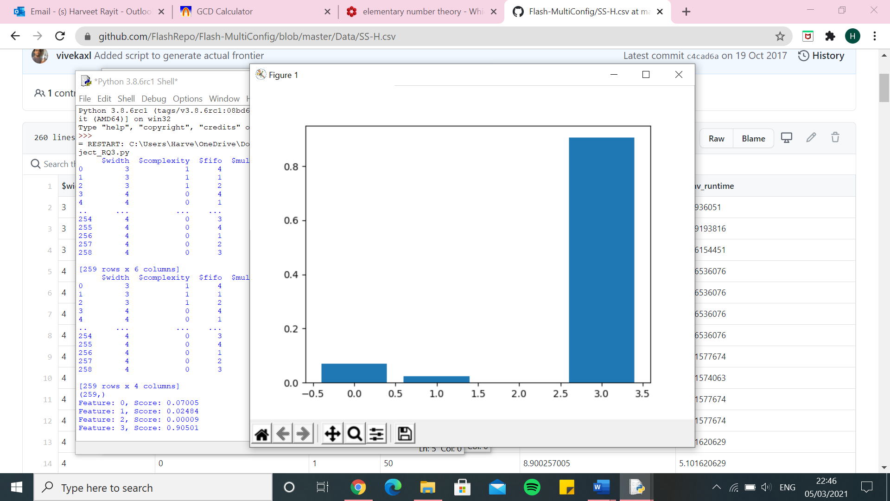

Random forest $inv_runtime

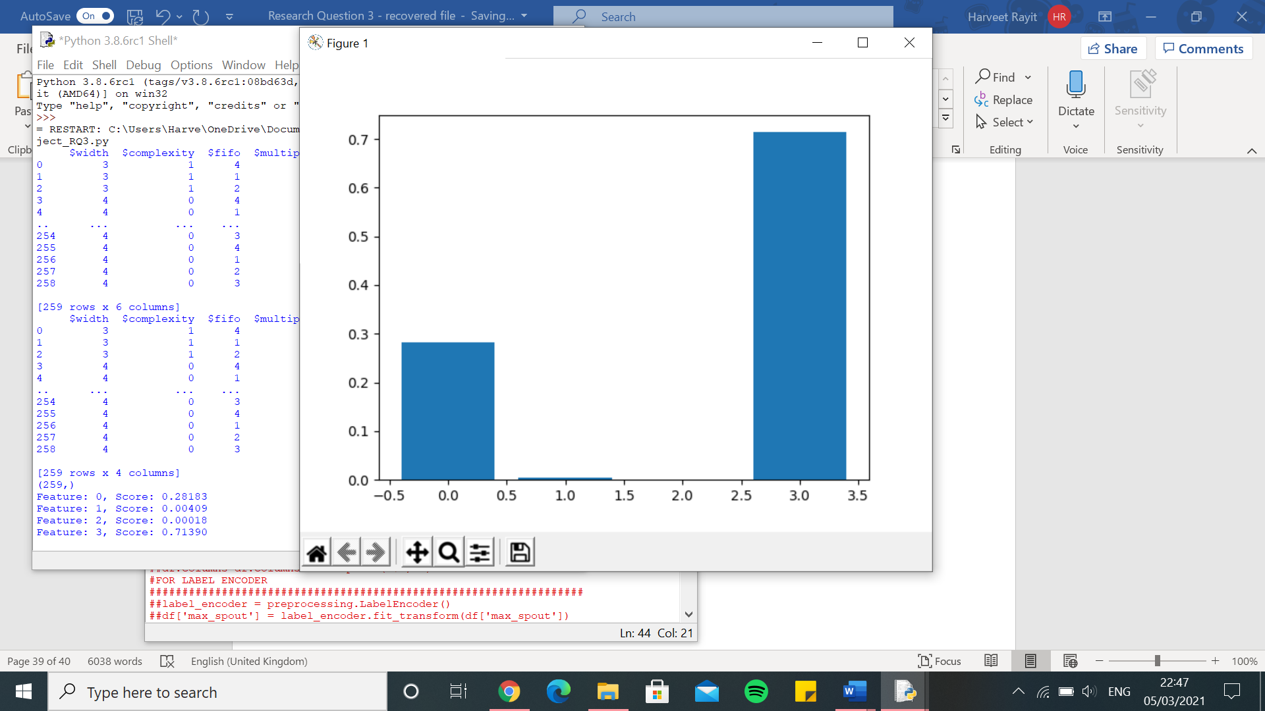

Random Forest – One hot encoder – SS-H.csv - $energy

[0.3382711310596754, 0.2720499514687057, 0.6485748045072827, 0.4910058480117183, 0.4560370227509774, 0.344795487744706, 0.640716718078411, 0.3191643823443163, 0.6000941004768563, 0.5595909395581066, 0.4975340988843881, 0.41980016742256426, 0.5276961412986552, 0.4699164470444313, 0.42375555045569646, 0.9556801794322114, 0.40182609084055143, 0.3491986503983341, 0.41852847534750803, 0.46011168719797524, 0.40218351742176833, 0.36096425544478444, 0.6564642694574447, 0.36829659283952265, 0.6367391342802371, 0.33091568095529394, 0.3388216455276388, 0.4178419796061804, 0.4382488025017697, 0.47887117550136754, 0.612162457521213, 0.4129891004928517, 0.48199702112680015, 0.4533770876542131, 0.5208569075548257, 0.3315378114525092, 0.4173655510410133, 0.44723070645191026, 0.2787145450985387, 0.46543630784357165, 0.6936086300622871, 0.4271117572782864, 0.5137773587787215, 0.34146255972948303, 0.579645915072877, 0.32108012725547797, 0.6574068019570842, 0.8165850765781523, 0.3403184522128246, 0.32220308322251706]

0.0 7.556929455863566e-10

Execution time: 26.556360244750977 seconds

knn – One hot encoder – SS-H.csv - $energy

[0.5670145087784291, 0.5141173740896543, 0.8243767127645224, 0.6966048189600428, 0.8185460514550461, 0.6299413210268466, 0.6887547518044544, 0.7453005609762834, 1.000896826562716, 0.7288963217787013, 0.8436504642800212, 0.672313581560489, 0.9185301302594808, 0.647965477970674, 0.8597924035331191, 0.7492638953012063, 0.7148490686621767, 0.7083500985412025, 0.8793815347238653, 0.7393999114824598, 0.7872583402211887, 0.49954852713085685, 0.6858012592166673, 0.6305452965080268, 0.8702432919553421, 0.6609570792649341, 0.7147208929369601, 0.5642995340788421, 1.0385765248574441, 0.7784184915824471, 1.042853530183091, 0.6515778819857467, 0.712690574545912, 0.7499686915570457, 0.7795149382526586, 0.6453647122830225, 0.760554907976213, 0.716260934541971, 0.5373207470826525, 0.9297521380517145, 0.9532942578795623, 0.9414606837079617, 0.771315600375492, 0.783746105753407, 0.7698131880174275, 0.5327891107773676, 0.7755108435431913, 0.7254842005989249, 0.7572811680914392, 0.6205019102632542]

0.0 7.556929455863566e-10

Execution time: 1.2551326751708984 seconds

SVR – One hot encoder – SS-H.csv - $energy

[0.2965083754807515, 0.27729755155069163, 0.545544779218684, 0.4332343709543751, 0.49927569575794223, 0.42071883510429425, 0.6103432689061538, 0.3658847819829102, 0.6692563840191765, 0.5752830402391844, 0.4651884926288757, 0.4969852966199797, 0.5266533335710298, 0.4578474335261329, 0.4482100216325663, 0.8517138604635556, 0.4180588383417625, 0.35210959371394046, 0.4829100346997473, 0.4747078618724642, 0.5145971642525067, 0.39250337635825694, 0.6184036402987805, 0.3893745426564278, 0.7173686506875155, 0.45424703454046733, 0.3551963284373389, 0.438641797677906, 0.4178615745392274, 0.45890424234631977, 0.681134744176712, 0.44865452374439146, 0.41109398935177466, 0.5266558903966694, 0.5688647339617164, 0.38400065815089995, 0.47147216666115926, 0.4254264434395249, 0.2735463009056445, 0.5271963228348069, 0.7361814110189822, 0.44166160487384, 0.6694509969808801, 0.3467001569658018, 0.45609187652749283, 0.40800891912694603, 0.6922834314492373, 0.7396942117251097, 0.35727545601604405, 0.3900408041635929]

0.0 7.556929455863566e-10

Execution time: 1.3888375759124756 seconds

Decision Tree – One hot encoder – SS-H.csv - $energy

[0.28991295286356555, 0.2542737911412065, 0.6154825502681863, 0.4482585748147499, 0.3325426521222016, 0.31181548343750626, 0.631621981372005, 0.320425442679608, 0.6282909579742545, 0.5207961903046188, 0.44055745048112993, 0.3973261389692081, 0.4111066899864619, 0.4449564444534626, 0.4072013425326558, 1.0354374187753763, 0.43217861794266893, 0.3393032851524161, 0.40488468909301845, 0.368154621043492, 0.4097075332031257, 0.35753311768236534, 0.6285723841214529, 0.388737005855832, 0.8030751582438217, 0.3444315849407853, 0.34834811675164856, 0.42376389756688837, 0.39325586146421054, 0.34431646713888053, 0.654005667603085, 0.39415361343628647, 0.5359766749247601, 0.3650751682268366, 0.4678054173129552, 0.3688083653451261, 0.404168683238481, 0.3979183383223853, 0.24786751832113188, 0.389198117372609, 0.654988633965528, 0.31633825548252437, 0.4221096940420873, 0.3496387633144542, 0.5461349056017188, 0.3242841043584417, 0.6385818149961098, 0.8990144209262245, 0.3086051333385598, 0.28383992891201365]

0.0 7.556929455863566e-10

Execution time: 4.00211238861084 seconds

Linear Regression – One hot encoder – SS-H.csv - $energy

[0.28991295286356517, 0.2688499974780332, 0.48433914054004396, 0.44825857481475023, 0.3325426521222013, 0.39948640979840383, 0.6377448007946163, 0.3204254426796082, 0.5961582224749675, 0.5481046832866635, 0.4405574504811297, 0.5127700845757148, 0.41110668998646177, 0.44495644445346205, 0.4436244654745339, 0.820042109904784, 0.432178617942669, 0.339303285152416, 0.40488468909301867, 0.36815462104349206, 0.4342037346175983, 0.3645742544169749, 0.6210947319392284, 0.38873700585583193, 0.6758501978433211, 0.3947171078938463, 0.34834811675164845, 0.42376389756688854, 0.39325586146421077, 0.3443164671388804, 0.6540056676030856, 0.3941536134362864, 0.4104487065847004, 0.3995015801988827, 0.4678054173129553, 0.3688083653451265, 0.4041686832384809, 0.41085670496642096, 0.25547089681600366, 0.4024395964849315, 0.730962550823626, 0.3275163114269171, 0.5221017208562194, 0.3496387633144541, 0.4690033985200941, 0.35462198382818566, 0.5982709527635858, 0.7266447453589151, 0.35011794753097075, 0.2838399289120136]

0.0 7.556929455863566e-10

Execution time: 1.390204906463623 seconds

Kernel Ridge – One hot encoder – SS-H.csv - $energy

[2.3976631037530267, 2.647077917768044, 3.1478170433604977, 2.4560677473428143, 2.69603033606348, 2.8097829190381156, 2.8417438158409642, 2.4685703603469955, 3.422571781219232, 3.093568971128052, 2.6945535343062703, 3.014135593509657, 2.66673383997295, 2.598245738775626, 2.76538547720633, 3.512681733319875, 2.722734442004676, 2.4092852588421096, 2.578087328266952, 2.606853863419516, 2.6598631481948334, 2.704723468914839, 3.186870196203437, 2.6092134499505844, 3.5218955443303006, 2.6879246459618176, 2.48601558860177, 2.36383320646334, 2.6333713081274492, 2.646274318485723, 2.6872769498503297, 2.6333571423821502, 2.873702869115032, 2.7578298561633865, 2.636324653230982, 2.433265299709718, 2.464773885034149, 2.9242923553838556, 2.624796531433469, 2.8161339058928707, 2.9701190968042535, 3.219506552431035, 2.596617222577122, 2.482840396296422, 2.8602097380363736, 2.450389625630754, 2.9606033357746147, 3.653261808518461, 3.049619259686294, 2.7351180799891015]

0.0 7.556929455863566e-10

Execution time: 1.4767663478851318 seconds

Random Forest – One hot encoder – SS-H.csv - $inv_runtime

[0.0767614405853863, 0.07724355138272576, 0.14736933581637404, 0.17202967610723574, 0.05767642060861541, 0.09794399339506046, 0.08401986054104475, 0.06388072429551561, 0.15230364692626103, 0.10138600576832935, 0.06597396936534979, 0.14866785500541171, 0.07250553173027, 0.11668322626092774, 0.05292835059232931, 0.11269506111643487, 0.14866461128058547, 0.05078730294552278, 0.13902751352876314, 0.09161454434665157, 0.07453312844138849, 0.06452633348190759, 0.130663069180869, 0.11505222682227126, 0.1456141087517767, 0.08269551231378412, 0.051440581436067445, 0.18519284216381854, 0.07773391101787815, 0.07888683598496456, 0.09727340182273013, 0.07861496598896613, 0.11848568122565453, 0.08335693055080116, 0.11659167275412695, 0.09080979074915495, 0.12219903228798962, 0.1538809992045922, 0.14060155469687416, 0.08486260263572475, 0.13844473827254028, 0.16698504935949698, 0.12771999968428832, 0.09502119667140027, 0.0842340997669013, 0.06805135569521766, 0.16039261091765578, 0.0939373783723531, 0.14358463442889885, 0.07003066320728367]

0.0 7.556929455863566e-10

Execution time: 26.355082035064697 seconds

knn – One hot encoder – SS-H.csv - $inv_runtime

[0.12726664248609623, 0.12536114025264858, 0.17205484354281134, 0.19515887734048584, 0.07367619048807984, 0.11146692847870596, 0.0931656324698174, 0.10649388232102198, 0.15358836424308128, 0.12263365471911128, 0.0983225162295371, 0.191608430526226, 0.12785003171832401, 0.19964381114586788, 0.07132379859725879, 0.11818250728878492, 0.1495285890445787, 0.08973817536239038, 0.15231304378643748, 0.1035696442772533, 0.0992006456392199, 0.07620528584946225, 0.1656344253958281, 0.1374554635121389, 0.21122914074621638, 0.08074772835146658, 0.07459408858724711, 0.19527184068623107, 0.1045941017733541, 0.09380797030129435, 0.10152232934272967, 0.12074105604471255, 0.18642159076544612, 0.09841620492141308, 0.18656317654639984, 0.09263301913722867, 0.15732366234105852, 0.15057136673372576, 0.16171325747247042, 0.11094161285065826, 0.16404472968586598, 0.1642353611627865, 0.13010586925379028, 0.12130469423179534, 0.08956641782924618, 0.09870274422640148, 0.1710650576808961, 0.13830181121867385, 0.2549580911157864, 0.13246719938354662]

0.0 7.556929455863566e-10

Execution time: 1.282322645187378 seconds

SVR – One hot encoder – SS-H.csv - $inv_runtime

[0.11210071700666974, 0.10731293518744144, 0.16990159250801506, 0.19609014365337016, 0.09894150775762152, 0.11698827239492751, 0.10795637058946322, 0.09329569801129971, 0.1660129260136798, 0.10809714191688057, 0.10617245850759299, 0.16488495869896966, 0.09784359828650968, 0.12069215937521174, 0.0822768854679655, 0.12654426707057717, 0.18885593848940788, 0.08639610336558247, 0.1761508747774703, 0.10385119744552225, 0.10082406540709461, 0.09191290566219544, 0.14270697067169755, 0.13128222514254212, 0.1945997835713521, 0.09547053244651302, 0.08479749711517864, 0.19922527684231647, 0.11112094590012857, 0.11026522071767118, 0.12680320941324397, 0.10491486039720618, 0.14022048764490705, 0.12446331881224287, 0.1383663875228928, 0.11945823689849483, 0.14010240832608725, 0.16036025134117965, 0.14808486286778413, 0.1118423388322349, 0.20528831479874238, 0.17530194065002147, 0.1449336449591875, 0.11961495298650225, 0.11583174023606753, 0.10533669942551196, 0.18961689284728725, 0.12057146482104616, 0.1503084068389804, 0.09671984156171295]

0.0 7.556929455863566e-10

Execution time: 1.26318359375 seconds

Decision Tree – One hot encoder – SS-H.csv - $inv_runtime

[0.08078532409080014, 0.07266577196347745, 0.14773960447352408, 0.16573662186036411, 0.05740426505714818, 0.0962939898863971, 0.08160046696973892, 0.05106785532558377, 0.1522509333500326, 0.10083499633536908, 0.07025784167107489, 0.12800695327564754, 0.06825403882746636, 0.12141521653000857, 0.055419043140146285, 0.11240794897356311, 0.16941811546980504, 0.030083432389643887, 0.1388131873006436, 0.08947297196140533, 0.06704771461340998, 0.06647207631773701, 0.12226328487548913, 0.10961901305045443, 0.14311596402899424, 0.08027197881862147, 0.05502109766591569, 0.1633936806663546, 0.08059572667025153, 0.08592830938895805, 0.13669099738221183, 0.0767920189847666, 0.11626131402071894, 0.08477284290301047, 0.11439310583372536, 0.09634213168636185, 0.12601539624625033, 0.15559512122428976, 0.13916768833321153, 0.08725090462695716, 0.21035614776538902, 0.16693804128324766, 0.12943058607936989, 0.09872307011957895, 0.08446940717282525, 0.07261826599548261, 0.16560184528013067, 0.09361859164529027, 0.1167805722945855, 0.05233556156750483]

0.0 7.556929455863566e-10

Execution time: 1.1439809799194336 seconds

Linear Regression – One hot encoder – SS-H.csv - $inv_runtime

[0.08078532409080037, 0.07515694181730699, 0.14860717644997856, 0.16573662186036411, 0.057404265057147984, 0.09119436936613487, 0.08360932409364112, 0.05106785532558394, 0.15341534028365447, 0.09972442977644452, 0.07025784167107497, 0.13168884051833663, 0.0682540388274663, 0.1214152165300083, 0.05287409362256664, 0.11305412518595803, 0.16941811546980537, 0.03008343238964413, 0.13881318730064382, 0.08947297196140527, 0.06713110007316636, 0.05899727288582705, 0.1271727353525964, 0.10961901305045459, 0.14857437971032464, 0.07075340743268603, 0.055021097665915626, 0.16339368066635454, 0.0805957266702517, 0.08592830938895822, 0.13669099738221202, 0.07679201898476662, 0.11933942490821431, 0.0865024057399931, 0.11439310583372533, 0.09634213168636177, 0.1260153962462504, 0.14618055771514465, 0.13331059828270933, 0.08974499779613175, 0.2096273915613215, 0.16244709932601772, 0.12873597073556228, 0.0987230701195788, 0.08470693973986719, 0.0722113706383743, 0.16804163011553183, 0.10072636828926704, 0.11853336852915866, 0.052335561567505]

0.0 7.556929455863566e-10

Execution time: 1.4179723262786865 seconds

Kernel Ridge – One hot encoder – SS-H.csv - $inv_runtime

[1.5021200861425172, 1.6806371882052136, 1.8535884571992352, 1.5365399677541693, 1.6733385619435486, 1.7972623522305895, 1.7165569728704637, 1.5449712320918523, 2.188913431918369, 1.931485118367781, 1.6520780747947255, 1.9835656170587175, 1.6272249465246738, 1.6151127388300885, 1.8349152528303234, 1.9681736914870411, 1.7271485263713833, 1.5268168920176928, 1.6075219249050632, 1.5935073417235526, 1.7755961747590596, 1.6976838087325061, 1.871337852550112, 1.6119550442838306, 2.341240110620424, 1.7375564638804475, 1.5512274583891996, 1.4193718919268072, 1.7191930864604001, 1.6704043391070063, 1.7688870853115064, 1.5882880912678072, 1.7373965665790319, 1.7761247131302746, 1.6084210134672547, 1.5649457031246534, 1.5210807886887627, 1.7906321588478211, 1.6485450071957815, 1.7745887770605981, 2.0050153229374255, 1.9850611898938721, 1.680659113281275, 1.560498017779701, 1.723890028629926, 1.6297579955031094, 1.7752039276460978, 2.074524269698257, 1.9293563593348964, 1.6469313940364525]

0.0 7.556929455863566e-10

Execution time: 1.3740625381469727 seconds

Random Forest – Integer encoder – SS-H.csv - $energy

[0.2922323446566824, 0.2565065967086952, 0.5371808340824547, 0.47159782437933456, 0.3611151483708519, 0.29287555368247203, 0.47525274291877023, 0.3291475323724623, 0.5001945028524448, 0.4137008490272812, 0.43306567069307345, 0.395644377030462, 0.44144109767395245, 0.41834064781417807, 0.33762179913882484, 0.5541009457407784, 0.3889584169962576, 0.32681863897915947, 0.4041680116076724, 0.376517803049861, 0.38501812763668164, 0.36582091748177037, 0.5068729851938708, 0.3809712620220704, 0.4778081693611677, 0.3195744082768172, 0.32794167815888, 0.4211352775727134, 0.38798207581863764, 0.35463511370494505, 0.560883421372684, 0.3852455941079852, 0.36716975410876435, 0.3585092900618091, 0.47231331043878444, 0.34554496051539, 0.39167421120799195, 0.38308424192947627, 0.24464315080499974, 0.3706091590644209, 0.5552095544946208, 0.36245724717628974, 0.41225864615969054, 0.3227302958325687, 0.46785012479978294, 0.31860275725098497, 0.5941635005012066, 0.48343630944265276, 0.3024022702983002, 0.2905333333802591]

0.0 7.556929455863566e-10

Execution time: 26.46149444580078 seconds

knn – Integer encoder – SS-H.csv - $energy

[0.26834601322375634, 0.3376397292905395, 0.5516364132044022, 0.5032581533135444, 0.4721922640590842, 0.36904197226997604, 0.4870211764699279, 0.47056455053604646, 0.5433765656015809, 0.4788775587690626, 0.4546573371690203, 0.39818446007053976, 0.5579728594446213, 0.41677564479130264, 0.4228207671274143, 0.5832424869985489, 0.367051181117998, 0.35816722791598066, 0.4788155352898858, 0.44836035796333734, 0.4146483890766049, 0.39328641308815765, 0.47373731215706866, 0.4261045054247986, 0.47315113844953566, 0.39584266444037425, 0.3708804479291526, 0.45059170159135076, 0.4563702199975873, 0.4403871197563716, 0.5046172221732557, 0.41192123253893886, 0.45485554023057134, 0.4403388039797522, 0.5389169103519762, 0.42835057451376923, 0.4099941048959171, 0.4657386257792477, 0.28600942274402097, 0.42441614759909174, 0.49732692995801675, 0.39439812964700605, 0.43615119689666576, 0.30900554339575265, 0.46748267950918604, 0.32439301707183, 0.6198472688690594, 0.512829427226567, 0.4023795004369347, 0.37722532203668896]

0.0 7.556929455863566e-10

Execution time: 1.234255313873291 seconds

SVR – Integer encoder – SS-H.csv - $energy

[0.2790638560275971, 0.24692867166348859, 0.5017007811705162, 0.4071946141487845, 0.34392834855188537, 0.3682462830415074, 0.4473601491463669, 0.3716277564601481, 0.48424218822876636, 0.49890921019245305, 0.38315288367416306, 0.36868861292284855, 0.4396378247402288, 0.4191433447950951, 0.3211442452521712, 0.5270258842913699, 0.4023961565065713, 0.32887244739334925, 0.43541188887984555, 0.3607380198730748, 0.3852941539425036, 0.3928197785444341, 0.5108211109238275, 0.35647120129876264, 0.49420675530249913, 0.32026299183321133, 0.3197925640652943, 0.44481556203676315, 0.4097561587506186, 0.3504147297917968, 0.4357965585900526, 0.3897121673726031, 0.3407781358237265, 0.4212109216897161, 0.4389785433227579, 0.347886966247086, 0.39026401638962804, 0.4230486881344817, 0.239065522512931, 0.41164245383175246, 0.6112706983886729, 0.3153081637826696, 0.489126013522143, 0.2920908458165465, 0.4238175237314312, 0.3145562963536536, 0.5895540558868007, 0.5456870805741465, 0.278641038348325, 0.289008127786447]

0.0 7.556929455863566e-10

Execution time: 1.2591006755828857 seconds

Decision Tree – Integer encoder – SS-H.csv - $energy

[0.28991295286356544, 0.25018846500512015, 0.536807514934554, 0.44825857481474973, 0.3325426521222016, 0.29556057863305907, 0.48321347481061566, 0.320425442679608, 0.5058243966862388, 0.4096963070502656, 0.44055745048112993, 0.397731737196767, 0.41110668998646177, 0.4449564444534623, 0.33615398318234085, 0.5590090801990091, 0.4321786179426689, 0.3393032851524161, 0.40488468909301834, 0.3681546210434919, 0.4008578285228665, 0.3658254862593099, 0.5084007409852367, 0.3887370058558321, 0.46633570117960715, 0.33372994436354103, 0.3483481167516485, 0.42376389756688837, 0.39325586146421054, 0.3443164671388805, 0.654005667603085, 0.3941536134362864, 0.38325755799093014, 0.3670730396808429, 0.4678054173129552, 0.3688083653451262, 0.40416868323848093, 0.3884348570316033, 0.24786751832113194, 0.3777388442777217, 0.6518649044015448, 0.33311170090325304, 0.42210969404208726, 0.3496387633144542, 0.4743505997854907, 0.32250531620554845, 0.5988373158462359, 0.43365599243612585, 0.3075689175838613, 0.28383992891201365]

0.0 7.556929455863566e-10

Execution time: 1.045872449874878 seconds

Linear Regression – Integer encoder – SS-H.csv - $energy

[0.4449655439386055, 0.428570969957553, 0.620144909890655, 0.641829400320736, 0.43535002257949273, 0.36813097124379845, 0.404633785346203, 0.4167716234062272, 0.5238187159239653, 0.5127774733284379, 0.4249146096990121, 0.5153713133430761, 0.5501219646389207, 0.40862751740821307, 0.39108473014444467, 0.48299768897906903, 0.5437052758227876, 0.4418348866769784, 0.6032051889394909, 0.3475328546797, 0.43750317816349515, 0.39680009074005185, 0.4867830985074262, 0.5393562393372541, 0.7028531840968135, 0.44161842414176045, 0.3674008973681897, 0.45912088795016515, 0.46635764693063353, 0.39595113982404845, 0.510108676182477, 0.5049272118255225, 0.4564384716980975, 0.4486595451671764, 0.5908094151684615, 0.41509833962222986, 0.46534370059426355, 0.4539586610336903, 0.43299382301866873, 0.4062408794495003, 0.5195534672541741, 0.6289963687976802, 0.48710628398086014, 0.3377270392739261, 0.44299028892836523, 0.524303376113579, 0.5325591384731516, 0.4806071283144707, 0.5040908823378089, 0.4286440534431361]

0.0 7.556929455863566e-10

Execution time: 1.0866684913635254 seconds

Kernel Ridge – Integer encoder – SS-H.csv - $energy

[3.326542426676434, 3.8925796200412686, 4.851951772179594, 3.4297154395175906, 3.4574345865665475, 3.125806223972112, 3.4854519913850477, 3.5897478796409215, 3.9618132827715242, 2.8087187580483377, 3.5591805158337357, 3.6974829957999282, 3.481003756453388, 4.263598187702504, 3.4598953551288343, 3.8376042095669116, 3.3348268978046156, 2.8633184836029812, 4.315415656132522, 3.2000813296734476, 2.8601747097595704, 3.9616685822612654, 3.672968135272393, 4.169058500765495, 4.070191452169462, 2.860153099287484, 3.4299385420319863, 3.8336901590194183, 3.5006857295383424, 3.5368901794985774, 3.553135232750533, 3.572054736842214, 4.18267841708918, 3.517519933920972, 4.01650096538581, 3.3115562390168103, 3.7353877476839483, 4.290479084470402, 2.6732529909099667, 3.3199551870129524, 3.371502020100215, 2.920736335194764, 2.985844276767631, 3.5992898826203645, 3.8737802066262352, 3.844769631984061, 4.022371012256923, 3.8337788462903992, 4.042807882173441, 3.5691468367621053]

0.0 7.556929455863566e-10

Execution time: 1.2535264492034912 seconds

Random Forest – Integer encoder – SS-H.csv - $inv_runtime

[0.08104402992953189, 0.07240573598830313, 0.14583770538781485, 0.17458394755648665, 0.05953286079407673, 0.08522221421706995, 0.07965116181062953, 0.05626731504341594, 0.15161196725936765, 0.08954278589279588, 0.06934880231637786, 0.14512821976713763, 0.07075552619139477, 0.11817913028405333, 0.051110932223515294, 0.10995353089589624, 0.14487321290666186, 0.04971088517532215, 0.14692482483512828, 0.08597950268004495, 0.06773044547539225, 0.0522447364869328, 0.1208788140913323, 0.10867461804670368, 0.14376641135367424, 0.04999313582709593, 0.05186383562705372, 0.17055472161443017, 0.07815360030368988, 0.08072499538402914, 0.12417643913388507, 0.07365881096720804, 0.11973915751105302, 0.08514023258042372, 0.11320586887903002, 0.0826766253208894, 0.12035735159867042, 0.13454721752151647, 0.11831778755691266, 0.08630741078905803, 0.1487249222146394, 0.1533511018916378, 0.142299185204135, 0.08942088142312164, 0.08401285354983858, 0.07931228937512007, 0.16394482643422545, 0.09214471025870824, 0.13741408527786872, 0.05219863054645341]

0.0 7.556929455863566e-10

Execution time: 26.32974886894226 seconds

knn – Integer encoder – SS-H.csv - $inv_runtime

[0.10344491358319678, 0.06861918387612682, 0.15243175057681327, 0.18746685553060438, 0.06485823364492503, 0.08143654737306812, 0.07081777280162818, 0.07252628541620607, 0.13535147668089378, 0.09345864480383392, 0.06821619212456485, 0.14878392295764734, 0.07963258595464708, 0.1084134986764028, 0.05658425899679039, 0.10709729687973522, 0.1370875197584353, 0.0826161143655112, 0.1482609865505883, 0.08634283672545648, 0.06285653302386249, 0.04877031225635229, 0.1142865902709264, 0.1129458600936597, 0.16999552727394632, 0.05675771930778455, 0.05033670342670477, 0.17383134484835916, 0.0737459815950431, 0.08251974360565331, 0.09076886577513381, 0.08606596974558262, 0.13783693591496224, 0.07718082979184751, 0.13304741481923082, 0.06636627855744814, 0.11872145924586296, 0.13832316544621262, 0.12524767861631958, 0.08481656134918392, 0.1232926221712347, 0.15977592639861246, 0.12964996112177715, 0.08690811518731846, 0.08913005748741909, 0.0650682991519087, 0.15183482367882137, 0.10078164532965561, 0.15094737896055033, 0.07089530536509103]

0.0 7.556929455863566e-10

Execution time: 1.1112873554229736 seconds

SVR – Integer encoder – SS-H.csv - $inv_runtime

[0.10975801590248344, 0.09456525092958004, 0.16559919448370847, 0.18895461040157652, 0.09858899431514874, 0.10194659055268522, 0.10024952982642177, 0.07878661204956637, 0.14871032138716336, 0.10590224440740188, 0.09771835555534364, 0.15607126661770293, 0.09658416295033374, 0.11744583069219856, 0.0833402351996608, 0.11221573383041517, 0.1702981322142981, 0.08684946109151129, 0.16738436951881386, 0.09096789093485881, 0.0905618467015117, 0.08859822385780618, 0.12601871225296418, 0.12671615264116587, 0.17280768392263904, 0.09109068707466354, 0.08373262475888872, 0.19892651413052448, 0.09640195367017541, 0.10047487029865791, 0.11651841228209078, 0.09021881537175587, 0.13442217008988117, 0.11840933652405776, 0.13553548842353066, 0.10029121622439201, 0.1384428049056379, 0.1512025807770263, 0.1435986549204518, 0.10278749773049668, 0.19274443635809957, 0.1724767664787933, 0.14400720140524545, 0.08875346828735296, 0.10253321144847517, 0.09590508428752616, 0.18333327134396296, 0.1155811020625299, 0.1470558794372172, 0.0832377293723963]

0.0 7.556929455863566e-10

Execution time: 1.0345139503479004 seconds

Decision Tree – Integer encoder – SS-H.csv - $inv_runtime

[0.08078532409080014, 0.07385259580308225, 0.14780200506151556, 0.16573662186036406, 0.05740426505714795, 0.08565582310002633, 0.08160046696973888, 0.05106785532558386, 0.15724519711886487, 0.08961506764923638, 0.07025784167107489, 0.13713040647639058, 0.06825403882746636, 0.12141521653000846, 0.05350373354643435, 0.11238432989272029, 0.16941811546980504, 0.030083432389643807, 0.13881318730064357, 0.08947297196140536, 0.07204396765179315, 0.052501788553596065, 0.12268539177073831, 0.10961901305045452, 0.1459982714284213, 0.05482629250685168, 0.05502109766591569, 0.1633936806663546, 0.08059572667025153, 0.08592830938895805, 0.13669099738221185, 0.07679201898476656, 0.11597732610832741, 0.08541688267875741, 0.11439310583372536, 0.09634213168636191, 0.12601539624625033, 0.1339400118520642, 0.1091827066690339, 0.09038419287659158, 0.21654146843311864, 0.14300823245763045, 0.15276217846286932, 0.09872307011957888, 0.08446940717282542, 0.07871480812373408, 0.16560184528013067, 0.09322901592871195, 0.11771710414156414, 0.05233556156750491]

0.0 7.556929455863566e-10

Execution time: 1.0228004455566406 seconds

Linear Regression – Integer encoder – SS-H.csv - $inv_runtime

[0.12120843292597015, 0.08810712800404465, 0.19603207707471412, 0.19174457426579697, 0.08737570235783658, 0.0853173245944362, 0.07228796724814018, 0.08564714597259472, 0.1352152871166784, 0.08774811236319016, 0.08153929545653825, 0.16273006831194523, 0.09698227234631322, 0.11782507030735496, 0.05487583887618461, 0.09936295163809886, 0.15118973294785812, 0.08441819491986856, 0.18693042039263316, 0.07990059563809697, 0.07138155103191066, 0.07230540145615345, 0.13550722983784041, 0.15056464762480956, 0.21013879442386893, 0.05785021803226409, 0.061437983963627534, 0.17901197181344652, 0.09198690530724983, 0.08109398947403457, 0.09341018791733388, 0.10316773907517168, 0.1579644401506691, 0.08695969585581385, 0.16028501712450868, 0.08226876767653137, 0.13135655923996245, 0.1439813999798533, 0.13370077340045206, 0.08893132116595498, 0.13510250323861134, 0.16798223241680524, 0.13847307333739894, 0.08554130275151077, 0.10045485395728192, 0.08808632104072367, 0.15921555540071608, 0.1282313574313905, 0.1737644293839011, 0.09730942880409134]

0.0 7.556929455863566e-10

Execution time: 0.9567334651947021 seconds

Kernel Ridge – Integer encoder – SS-H.csv - $inv_runtime

[2.453084681757389, 2.867084414193082, 3.399680710607174, 2.57033425802289, 2.7176409869559506, 2.344830403082394, 2.6957749555344876, 2.679468840167752, 2.92425804507074, 2.2016605044869517, 2.702778223803255, 2.650516409184955, 2.671679026505151, 3.1106330454776927, 2.6948608960990805, 2.847593883340148, 2.5709852400405557, 2.241860550637668, 2.9582124986410254, 2.4578011405150346, 2.2804471076990622, 2.9926545092577626, 2.5285437422536923, 2.9048098512067906, 3.0422979043681178, 2.236723052933503, 2.6396699390349228, 2.695588087939186, 2.7616794919179948, 2.715753229535794, 2.7538457349694125, 2.637406015988175, 3.058302862928587, 2.6811472368643297, 2.8600692789037963, 2.556260917701591, 2.8387805861441895, 2.9643003888122275, 2.200026661202585, 2.551503868585446, 2.5771969340705922, 2.2428748339439806, 2.273026356197889, 2.7671101058825966, 2.960266131214268, 2.845596592174515, 2.8363738546344774, 2.8803225672810395, 2.963555307674823, 2.5325557413639985]

0.0 7.556929455863566e-10

Execution time: 1.246945858001709 seconds

Random forest $throughput

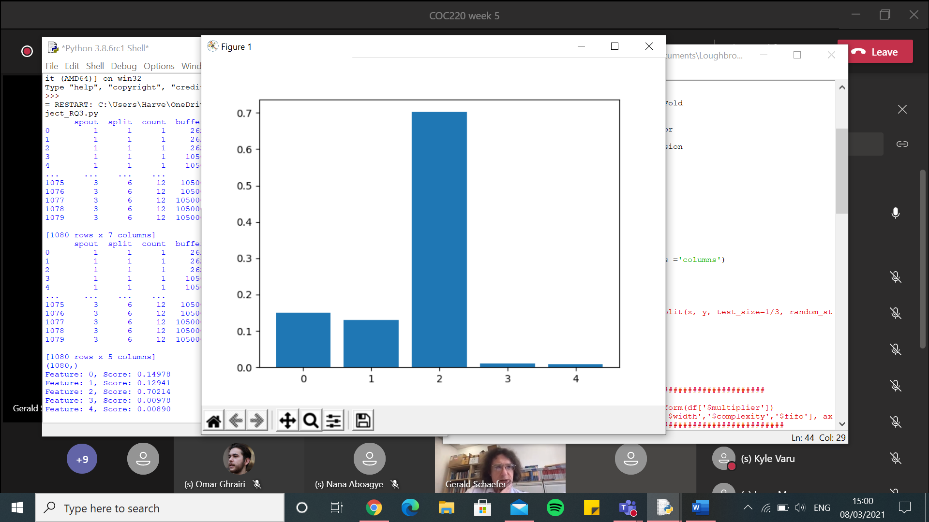

Random forest $latency

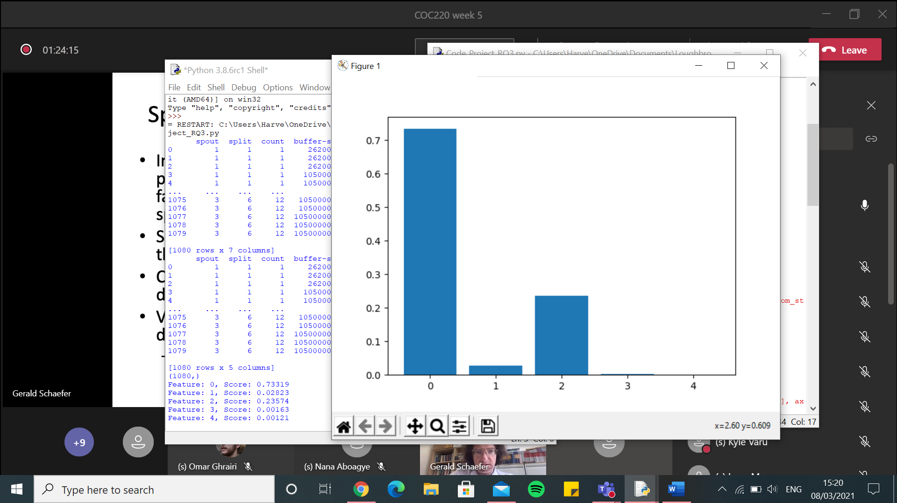

Random Forest – One hot encoder – SS-I.csv - $throughput

[1967.223938938804, 1487.4351202181942, 1830.116653626521, 1363.5220667575015, 1755.5413398284632, 1818.7626766170056, 1692.796370557004, 2153.465026406201, 1590.1830147963562, 1687.5866252944422, 1696.0839258723536, 1262.681074335012, 1826.3721924787533, 1796.8937878179415, 1747.1964416675146, 1643.1791631629528, 2193.5020470598356, 1816.1879927908092, 1492.6980437986695, 1789.5821919944524, 1725.7788034174966, 1519.8188954169182, 1699.0734643319488, 1686.5516251336976, 1955.838667188452, 2105.810392220347, 1793.0088731875744, 1735.6778163697156, 1465.8536164300242, 1585.4437172841074, 1760.0650231352054, 1461.0386423071132, 2074.7081401776422, 1719.8818950625757, 1641.4652903409947, 1621.8706164884895, 1690.818624146041, 1662.7602712468556, 1869.1614119215635, 1944.0717440687822, 1588.867277921759, 1923.2008976918733, 1992.192152919826, 1682.6661404772658, 1597.24530444969, 1935.1819865758953, 1604.6590324523117, 1212.9091721456955, 1799.9888367799165, 1861.1389456911747]

0.0 7.556929455863566e-10

Execution time: 30.085773468017578 seconds

knn – One hot encoder – SS-I.csv - $throughput

[2040.9400957011799, 1462.881540480219, 1852.2298840726685, 1536.6385286252441, 1900.217494548687, 1968.476529282744, 1985.1623336877497, 2344.1796085727196, 1592.21913076617, 1761.123168072643, 1965.311974359099, 1255.732784711779, 2056.3299476251373, 2002.2545657092915, 1884.3095681540856, 1851.0042536407893, 2323.682008599475, 1928.4093311539125, 1496.5786877507073, 1883.1112012325261, 1878.6867634087935, 1727.5893641912323, 2179.1759833325377, 1945.5040280929582, 2161.188382383208, 2264.980323288745, 1618.1989504956384, 1817.822980474375, 1585.750463009024, 1564.6501023184655, 1886.8510681036018, 1558.7171597645433, 2078.6767031642457, 1955.6925846283639, 1700.7513789999907, 1665.133364366328, 1909.2541651892743, 1815.5781071093625, 1945.7973328118674, 2256.4085187716305, 1680.5508074493075, 2002.7289001463685, 2121.7304484111114, 1609.1215193413477, 1758.8827564773421, 2076.2228807139177, 1717.7082706467208, 1274.083829581084, 1854.3127105590204, 2053.294517307175]

0.0 7.556929455863566e-10

Execution time: 4.239320516586304 seconds

SVR – One hot encoder – SS-I.csv - $ throughput

[3084.960137595644, 2477.9240952282967, 2723.8149022764724, 2514.2090289523753, 2557.553807074769, 2796.2642307014735, 2820.6198445414147, 3054.7910831798995, 2815.1593616398286, 2817.2975200183223, 2809.5621249601045, 1972.5208470184143, 3077.950489027593, 2856.60399097941, 2887.450763247047, 2507.8284319620357, 3233.8552374325363, 2846.810992757625, 2786.1142184578293, 2542.894251394831, 2867.617423729889, 2634.156250836002, 2921.731162394432, 2837.0012018001567, 2806.2487808921783, 3293.815401874843, 2734.086819141243, 2431.787539874461, 2484.248511751085, 2745.7279312568176, 2935.7678372458986, 2564.2020490130976, 2995.8474811894007, 2885.6291357402647, 2714.3751201623177, 2597.0533808806836, 2728.0702592933967, 2592.004406990493, 2799.0307188315946, 2931.2224830230894, 2621.5616833726185, 3061.306661931219, 2759.023213202229, 2695.0742114226387, 2730.605046025622, 3045.3756929645447, 2877.900161835274, 2440.295729739285, 2780.114193880569, 2745.4759834702186]

0.0 7.556929455863566e-10

Execution time: 5.373232841491699 seconds

Decision Tree – One hot encoder – SS-I.csv - $ throughput

[1964.6077452108611, 1487.7616908836208, 1821.5743580595151, 1355.7109164270416, 1737.5977278088262, 1814.1019055718457, 1686.3368386351544, 2157.0960944364997, 1598.9582966251041, 1684.8425688033205, 1689.2368233694322, 1258.078486963726, 1826.0546984302568, 1800.6046159582745, 1751.0470090758022, 1656.3409930295797, 2201.7260068141486, 1822.1889628242307, 1504.9583671903158, 1795.3594739649166, 1718.9452202498217, 1524.1657017967082, 1701.303782219851, 1676.3762459770421, 1948.473379501663, 2109.127105896011, 1789.611637554057, 1740.1249922868567, 1470.0162366250404, 1578.7342558040014, 1754.909024590047, 1452.9209362453644, 2072.185138636067, 1732.0565195278273, 1625.298215972508, 1612.5054025706952, 1690.87249313707, 1684.248136583984, 1873.5504355263438, 1955.320692345789, 1574.368793392057, 1928.7662824230842, 1977.339870665244, 1668.6150486482227, 1602.1020894824364, 1933.660706414473, 1603.7459120487513, 1202.4815109433262, 1792.7301140995296, 1868.6081272378756]

0.0 7.556929455863566e-10

Execution time: 4.141820907592773 seconds

Linear Regression – One hot encoder – SS-I.csv - $throughput

[1964.6077452108611, 1487.7616908836208, 1821.5743580595156, 1355.7109164270414, 1737.5977278088262, 1814.101905571845, 1686.3368386351538, 2157.0960944365006, 1598.9582966251041, 1684.8425688033196, 1689.2368233694328, 1258.0784869637262, 1826.0546984302568, 1800.604615958275, 1751.047009075802, 1656.3409930295797, 2201.726006814149, 1822.1889628242313, 1504.9583671903158, 1795.3594739649166, 1718.9452202498214, 1524.1657017967077, 1701.3037822198505, 1676.3762459770421, 1948.4733795016625, 2109.127105896011, 1789.6116375540573, 1740.1249922868567, 1470.01623662504, 1578.7342558040025, 1754.909024590047, 1452.9209362453648, 2072.185138636067, 1732.0565195278275, 1625.2982159725077, 1612.5054025706952, 1690.8724931370698, 1684.2481365839838, 1873.5504355263438, 1955.3206923457888, 1574.3687933920576, 1928.7662824230836, 1977.3398706652436, 1668.6150486482231, 1602.102089482437, 1933.6607064144725, 1603.7459120487515, 1202.481510943326, 1792.73011409953, 1868.6081272378751]

0.0 7.556929455863566e-10

Execution time: 4.340673923492432 seconds

Kernel Ridge – One hot encoder – SS-I.csv - $ throughput

[2111.983823836824, 1685.9842889105048, 2017.4736905462803, 1641.9187041462842, 1914.7182023575085, 2012.5975237161892, 1868.4337689777685, 2286.443081939564, 1820.538020200578, 1907.4471629518114, 1884.9682580345202, 1558.4995289363687, 1995.2288947446332, 2040.8971029322681, 2011.3922158383255, 1860.2349798094338, 2389.199431374434, 2058.916574822365, 1825.2351087430884, 1938.9031006235325, 1938.3643567934707, 1750.8707078176171, 1904.7300169789476, 1924.195688742004, 2115.899575359949, 2265.447978264895, 1970.9120633310145, 1884.8007208043837, 1699.4739073502212, 1807.808401108736, 2018.811487575267, 1638.4908519054147, 2221.8791657369243, 1918.9814231622327, 1838.1589848617396, 1781.2925310779926, 1893.4708168288244, 1845.6338293205306, 2096.569008271979, 2146.898763861705, 1854.2995520754039, 2108.0837996342166, 2117.92902298668, 1896.2098832802951, 1786.2382149046703, 2095.022607592238, 1860.0456791155523, 1497.232133299689, 1997.6705110089533, 2029.450701187523]

0.0 7.556929455863566e-10

Execution time: 5.6012043952941895 seconds

Random Forest – One hot encoder – SS-I.csv - $latency

[46.36962904855298, 50.24026851190411, 47.14366542893991, 41.84736218673909, 40.491559714232245, 52.60312866311086, 46.1109812290245, 53.8324836261601, 53.0775595850029, 49.345439264240845, 47.486680440628, 40.257064500846305, 55.17970541632094, 48.63620229020625, 72.71864064849161, 41.051432355344325, 54.481868004146826, 41.581506160455355, 56.73734989506858, 43.138918553991246, 45.15659784080015, 45.931682861025834, 49.87184713715996, 66.16683422905767, 50.743284185111534, 47.93378408635703, 41.73696432458461, 52.37017476509911, 43.750092194891046, 54.21682897373115, 47.83304533567445, 48.5228835392972, 46.78084364276612, 45.18290962032246, 42.74889952956273, 56.41463587785685, 45.34107673346569, 50.24243569872162, 43.0557698426499, 50.49116815847187, 54.37802983199753, 65.0837712909939, 41.27554284313589, 45.89866906318901, 53.31350595157826, 54.042060034166454, 46.26364550684314, 57.047654563507095, 48.07841276561855, 38.44222347841094]

0.0 7.556929455863566e-10

Execution time: 29.243280172348022 seconds

knn – One hot encoder – SS-I.csv - $latency

[44.980117110217584, 65.5368458887936, 69.5182878749182, 43.19678659723043, 44.711713053955556, 74.64440999856639, 60.27278075383, 76.84568707629211, 52.74833458837737, 57.13712402446449, 56.655514010013974, 47.539814283569676, 72.0923006507681, 56.43594954452217, 60.543126477064064, 41.991167173175306, 72.57744934153929, 44.6537777175766, 70.38624530611234, 51.62204366346407, 48.50116970402001, 53.18698814403137, 63.28059917151486, 72.46961132406032, 61.127762465247955, 65.77862853685275, 52.928446994171445, 51.268276081839375, 51.61285183541804, 66.44052142724682, 52.246796762048625, 60.394205052698624, 48.81473073312026, 49.018105036774884, 42.80260151425984, 76.38218756074005, 54.11646253975806, 65.58558026579271, 41.8312809571887, 58.22107687901223, 53.022478574828504, 76.57403817724628, 47.1285887027145, 57.91328190784718, 78.01397095999798, 55.566632490221444, 54.39384051871982, 71.28448045875894, 50.0697176502406, 43.924381875606116]

0.0 7.556929455863566e-10

Execution time: 4.290594100952148 seconds

SVR – One hot encoder – SS-I.csv - $latency

[73.1556426416838, 78.93383529890536, 76.02358753502563, 72.47877952547742, 80.77104187604107, 83.39711890555336, 79.76182364271266, 76.83833543909418, 90.37723828205579, 85.79153218026386, 82.57728958710135, 72.19706236812678, 77.1015544412426, 80.64806790965464, 89.93081992288796, 72.09417681415793, 89.55850534091068, 66.51492953963893, 91.73765921830743, 75.56948768742598, 72.86060581339993, 81.36790142302472, 87.2629258750272, 85.65905257682299, 88.03633129605751, 76.9171032806776, 68.49698859221873, 72.24329415538479, 86.38152461995077, 79.03171242575937, 75.126199367232, 90.21945195140269, 72.71833188843225, 78.03805334279691, 69.82978751127492, 89.36874814375612, 77.43178232774392, 84.23977374426602, 75.11668588577209, 89.90641893409337, 76.69241342529708, 94.21189536253382, 76.84941428341071, 79.02474425970614, 90.62486281263709, 78.01364159644409, 78.11985226076663, 77.53930984330385, 72.86078533005985, 74.65880482362311]

0.0 7.556929455863566e-10

Execution time: 5.174536943435669 seconds

Decision Tree – One hot encoder – SS-I.csv - $latency

[46.71240216896892, 50.22250523657862, 47.239899534318084, 41.623719556940145, 40.12611491459297, 52.3890433987886, 46.44712482522003, 53.62147643693768, 52.48104100524329, 49.526371033280874, 47.914610726503106, 40.38235920908886, 55.33360587126574, 48.556835849667266, 73.42371837347433, 41.288868477619495, 53.670754583096944, 41.674864933150864, 56.863294728716646, 43.00700107073696, 44.41074495393615, 45.94421756672941, 49.62280160560487, 64.80715947729963, 50.70494225396201, 47.72050268097368, 42.0215840817684, 52.008843864290185, 43.510245124689746, 54.476949186038695, 48.70011615105819, 48.53557477310451, 46.77792538829585, 44.72035115857151, 42.64358221804663, 55.40158344384904, 45.38150895725076, 50.77767895662187, 45.826693990232144, 49.934459315089846, 54.318874429495054, 65.0814223171825, 41.18131758290927, 45.82203757277203, 52.73781515286679, 54.29113254526584, 46.214273437010476, 55.93004596376976, 47.89728140396582, 38.22495272353619]

0.0 7.556929455863566e-10

Execution time: 4.547952651977539 seconds

Linear Regression – One hot encoder – SS-I.csv - $latency

[47.018390082805105, 50.09910669881221, 47.33504677900623, 41.55643721608991, 41.52287233706505, 51.761934677258814, 46.373645197355486, 53.47546173316385, 52.58084440079041, 49.400195514291724, 47.99869222748597, 40.03560549731996, 54.824388590433124, 48.55179188839539, 74.38308906148114, 41.3688681995424, 53.784778556451606, 41.67507363333805, 56.516809612797104, 43.0990299338727, 44.37114809668995, 45.951509887717165, 49.706224597441135, 64.9121535893206, 50.810770801564054, 47.67842994522117, 41.86258294561848, 52.01361431266582, 43.312085523690335, 54.479190940956336, 49.02145596328267, 49.289293561952135, 47.009380593045144, 44.8450249849274, 42.156686124004324, 55.45629999688292, 45.75902414053196, 50.75954155788513, 46.92791736116985, 49.834327700235406, 54.003589277170235, 64.94928568613277, 41.119257449325865, 45.67499108233611, 53.16298518251642, 53.72353287497229, 46.50594931722372, 55.745659741572496, 48.05132372489958, 38.48616685331911]

0.0 7.556929455863566e-10

Execution time: 4.369502782821655 seconds

Kernel Ridge – One hot encoder – SS-I.csv - $latency

[41.43069457139363, 49.82702600571394, 47.0333034164136, 41.27352749092263, 39.14871169257594, 51.6247032455992, 45.63238839719251, 52.74158756024544, 51.94333642061081, 49.99510437257178, 47.71403549298708, 41.09354463778065, 53.59134335906485, 48.318246591625055, 50.93339711034931, 40.33090605153043, 52.17788816258908, 39.19273295553935, 55.89524738764496, 43.86731151450475, 41.51949298673199, 46.050619032446626, 49.57534137291403, 57.12314153429013, 51.127706594933635, 46.9409076676393, 40.24556868767513, 46.65915761960607, 41.87568260128164, 54.117221442051154, 47.37102459946809, 49.315070956428364, 45.2731285846338, 44.91438832956228, 42.815139782222445, 54.159325534081574, 44.71887055395287, 49.683769349136924, 37.6295586606389, 48.11317292818676, 52.90829331525708, 62.78941755220967, 41.730916831417325, 45.931673915319344, 53.22208243586638, 49.6822381418149, 45.390548067062284, 47.30534053554809, 46.9185312954975, 38.26968338733741]

0.0 7.556929455863566e-10

Execution time: 5.379665851593018 seconds

Random Forest – Integer encoder – SS-I.csv - $throughput

[1961.1997799027097, 1487.395529605185, 1814.6664792495428, 1355.7141378791755, 1745.1768628103332, 1834.5562566191547, 1682.8484434540478, 2172.958717878018, 1603.1814083634838, 1689.777284334442, 1689.229857690614, 1258.039488045587, 1815.8706682057011, 1793.4844060462842, 1758.9160769324749, 1653.2645672972587, 2221.1054203805706, 1825.9234264094714, 1480.4663496375276, 1792.7497006349536, 1713.9067195631765, 1517.8634729427563, 1692.5970933830724, 1681.4091362733857, 1948.1006468498465, 2115.920341592551, 1775.2208515238835, 1724.4518333116187, 1459.5668797860294, 1575.985002376523, 1747.652874063795, 1451.7184208592992, 2077.669200177755, 1724.5591808116903, 1630.5630543717277, 1605.9132768284442, 1698.6213888161703, 1692.269562063014, 1877.4898856068955, 1956.290513957635, 1577.713653120194, 1917.3316870926271, 1972.7666170576679, 1673.6733098352322, 1599.0064891759318, 1933.4580384575124, 1602.8694699112227, 1207.116202409734, 1785.791236887782, 1867.3506551566275]

0.0 7.556929455863566e-10

Execution time: 30.465447902679443 seconds

knn – Integer encoder – SS-I.csv - $throughput

[2104.860691542317, 1373.1323270699168, 1804.8439372083612, 1362.7025432043324, 1848.227493767615, 1834.4304180488732, 1534.0766430319889, 2008.5783692083944, 1545.0397316957642, 1695.8454138865368, 1861.9763221462658, 1304.5624686886829, 2209.1981049911064, 2086.6054043749305, 1925.4576253615562, 1764.9027831688175, 2209.2763838650208, 1887.1215008598165, 1490.5899795159412, 1729.9428137283528, 1691.2830675588016, 1656.759183585924, 1721.6382908493058, 1805.6184771388405, 2032.2154927329195, 2165.0054174912975, 2011.345913487708, 1958.8850080679401, 1518.5267884208865, 1635.364239687339, 2059.367883333064, 1638.423076970093, 2008.1626522603526, 1725.9050500094577, 1750.6950333954671, 1523.6434026493987, 1447.7691243068753, 1572.6514012176542, 1990.5292648392488, 2017.9978909800675, 1360.7581125689542, 2014.5587931126279, 2027.4935409213463, 1753.703707973288, 1512.5646449546105, 2092.966357945725, 1621.5678065721183, 1150.0814937034936, 1731.5682725345102, 1911.158594691441]

0.0 7.556929455863566e-10

Execution time: 3.845916986465454 seconds

SVR – Integer encoder – SS-I.csv - $ throughput

[3075.8890316705265, 2471.4684506590024, 2717.3561565509654, 2504.5156829539324, 2548.1982930549116, 2788.145639207515, 2813.089601051549, 3048.416087322413, 2805.7318495227846, 2809.732786472418, 2799.6050574085907, 1967.4205897111835, 3069.1994074730537, 2851.1747052036344, 2878.220564347483, 2502.1119832655804, 3225.601035381393, 2841.120024455945, 2779.1878626409098, 2537.36604973196, 2861.5819173526056, 2627.67926300589, 2912.717734818273, 2825.727576602006, 2799.466478500116, 3284.7237997975512, 2729.3298153305273, 2423.477445279982, 2477.646110441293, 2738.711402359907, 2927.124114191158, 2553.8734397290773, 2989.168649565834, 2877.033160012919, 2705.239130343152, 2588.391262322533, 2722.5385818210825, 2587.1139168030663, 2791.801919387429, 2923.2951168967184, 2612.2891146637426, 3051.923194346995, 2754.7125594663307, 2684.059651152135, 2721.813473932495, 3038.2491001147146, 2869.245003185271, 2434.8298354865765, 2774.2441571901986, 2738.3770913805733]

0.0 7.556929455863566e-10

Execution time: 5.017645597457886 seconds

Decision Tree – Integer encoder – SS-I.csv - $ throughput

[1964.6077452108611, 1487.7616908836208, 1821.5743580595151, 1355.7109164270416, 1737.5977278088262, 1814.1019055718457, 1686.3368386351544, 2157.0960944364997, 1598.9582966251041, 1684.8425688033205, 1689.2368233694322, 1258.078486963726, 1826.0546984302568, 1800.6046159582745, 1751.0470090758022, 1656.3409930295797, 2201.7260068141486, 1822.1889628242307, 1504.9583671903158, 1795.3594739649166, 1718.9452202498217, 1524.1657017967082, 1701.303782219851, 1676.3762459770421, 1948.473379501663, 2109.127105896011, 1789.611637554057, 1740.1249922868567, 1470.0162366250404, 1578.7342558040014, 1754.909024590047, 1452.9209362453644, 2072.185138636067, 1732.0565195278273, 1625.298215972508, 1612.5054025706952, 1690.8724931370698, 1684.248136583984, 1873.5504355263438, 1955.320692345789, 1574.368793392057, 1928.7662824230845, 1977.339870665244, 1668.6150486482227, 1602.1020894824364, 1933.660706414473, 1603.7459120487513, 1202.4815109433262, 1792.7301140995296, 1868.6081272378754]

0.0 7.556929455863566e-10

Execution time: 3.7401726245880127 seconds

Linear Regression – Integer encoder – SS-I.csv - $ throughput

[2036.4498546648508, 1666.9450791726745, 1851.028830028368, 1447.0716599600687, 1771.4570783215518, 1861.8889012923282, 1748.8568834102023, 2178.6991182643187, 1642.4547803647204, 1734.9524523494301, 1694.1050131566783, 1355.1272619296417, 1887.4856876002218, 1843.230037984667, 1796.9316933141984, 1776.4184114913096, 2196.8150131177704, 1825.3704812375822, 1553.0965670349342, 1821.2908397912533, 1740.5426580116596, 1609.983344190054, 1772.1197419729306, 1779.484134997722, 1905.8196590428547, 2141.5104332875108, 1899.7621372191295, 1833.6378153379499, 1562.0686618283091, 1739.5840490563169, 1752.9396780676852, 1569.282778259847, 2120.1405713720246, 1763.5685661553707, 1706.3813406988356, 1749.3267339878191, 1756.4415155766915, 1780.181081615079, 1873.2659571297318, 1978.380138036676, 1636.2808520700746, 1991.4192802322084, 2112.4450576108798, 1668.0086653648814, 1722.8267661994425, 2078.5363813899057, 1554.1625477652626, 1426.232003935443, 1887.2376823391253, 1946.9434537034667]

0.0 7.556929455863566e-10

Execution time: 3.932053565979004 seconds

Kernel Ridge – Integer encoder – SS-I.csv - $ throughput

[5856.275133994592, 5715.074888317421, 5384.198833128679, 6121.537125286902, 5514.5706275584, 5627.798552247046, 5930.171409055323, 5344.239759439973, 5690.980590648923, 5545.197754936755, 5604.427381683778, 5597.225693990787, 5719.786409196036, 5642.893184050291, 5984.085911260881, 5366.624029798836, 5953.860077080999, 5439.166512162079, 5762.824597754858, 5815.598849591728, 5633.651638749289, 5697.980469405197, 5716.855968925595, 5867.742917826403, 5704.963859238869, 5475.756979947402, 5653.180288852972, 5779.489744268165, 5752.650175597243, 5749.63430225619, 5380.492539545782, 5822.813697391081, 5630.973772739966, 5857.857497676543, 5594.319780168552, 5768.236906609272, 5289.996754016479, 5874.363922307656, 6079.026327871016, 5594.1645314458, 6088.726031663523, 5678.063154715353, 5663.435693229164, 5600.57968774049, 5788.855733544454, 5846.972243264837, 5460.343495909717, 5784.061449530869, 5718.124251865342, 5331.134402037647]

0.0 7.556929455863566e-10

Execution time: 5.3135762214660645 seconds

Random Forest – Integer encoder – SS-I.csv - $latency

[46.60984481354961, 50.76142482374002, 47.16422239416858, 41.56552500587524, 39.92018734753386, 52.72247241968053, 46.61211102862195, 54.46360794071433, 52.35360902940792, 49.55916827023311, 47.68088282867863, 40.637645102177295, 55.327288855660925, 48.342289905611246, 73.25328768638526, 41.4469418602693, 53.41283209074963, 41.68738801569081, 56.99244405742346, 42.8871527393455, 44.00667429528877, 45.9851120754514, 49.63371065980952, 65.58295274266325, 50.63595992570893, 47.8146616315771, 41.97461346947723, 51.80568606860231, 43.934549353674576, 54.87068074075535, 48.849152827416184, 48.61880640890607, 46.334287857699586, 44.54657641804579, 43.03139313584051, 55.17860330281486, 45.22020221289638, 51.103104105385775, 45.13741154878777, 49.705370712130076, 53.92828150376508, 65.31775367325307, 41.14152221132376, 45.257489322590466, 52.93206308618801, 54.365517772972495, 46.033273517386974, 55.33773361249903, 47.3396728789401, 38.111222078450986]

0.0 7.556929455863566e-10

Execution time: 29.0560200214386 seconds

knn – Integer encoder – SS-I.csv - $latency

[45.36605785947528, 57.335993437372046, 57.26753194445575, 45.1930578601773, 46.52541961363901, 68.66568353868485, 55.61299392239059, 56.068586138129845, 60.191121817267295, 52.41411154499083, 53.03841184355256, 43.739558015083034, 69.61723059843946, 59.085093120578286, 59.805569480448405, 41.402853929445044, 63.96394407731535, 42.34052819076497, 60.44094957578813, 55.28272931738165, 48.45835725948391, 54.47565651826102, 62.653377064546326, 58.52278166775929, 52.608426393975805, 57.44905183022799, 50.32977637262576, 45.4418824622176, 46.538274430595386, 60.607635310400596, 52.07074674616932, 58.01032409370479, 40.02002139724472, 47.93177747267077, 43.261247810761006, 80.79012593432489, 49.44880734349115, 68.43506608186793, 38.106939423776964, 53.23359607278444, 52.99714319098997, 62.291393588993394, 49.22156868597118, 46.880081500573034, 66.97545915251071, 54.44262631059586, 53.149662180812065, 61.71805457815584, 42.936751781471585, 43.252917256296136]

0.0 7.556929455863566e-10

Execution time: 4.21213436126709 seconds

SVR – Integer encoder – SS-I.csv - $latency

[72.68603410046701, 77.38272298166774, 73.92700822548059, 70.53196984183118, 78.23476494608529, 81.26281895532128, 78.27748727231685, 74.63465278402418, 88.06983967362984, 83.93288224296407, 80.8377755188463, 69.41397887497298, 75.82351336743876, 78.8811849356275, 88.61835513469157, 70.59932724161172, 87.70817676428612, 64.25766161028685, 89.74748054527161, 73.19727314245075, 71.65312426689236, 79.81538807827373, 86.05069488844228, 83.9473553511608, 86.45134721522905, 74.99444225896694, 66.19372771076246, 70.60110641166328, 84.55793309171678, 77.87483300072053, 73.49538504793111, 88.65645340492993, 70.83578232739077, 76.39467902619914, 68.48814092985602, 87.36506326644181, 75.26831717723249, 82.52618260428763, 74.77955390440967, 88.08136170860169, 75.26075566754496, 91.66521058393515, 75.53039035964714, 77.70487854068585, 88.76143396766543, 76.56244451155702, 76.09841627923379, 75.96237544403657, 71.1448915233778, 72.7804938163089]

0.0 7.556929455863566e-10

Execution time: 4.854858875274658 seconds

Decision Tree – Integer encoder – SS-I.csv - $latency

[46.71240216896892, 50.222505236578634, 47.23989953431808, 41.62371955694014, 40.126114914592975, 52.389043398788594, 46.44712482522003, 53.621476436937684, 52.48104100524329, 49.52637103328088, 47.9146107265031, 40.3823592090889, 55.33360587126574, 48.55683584966726, 73.42371837347436, 41.288868477619495, 53.670754583096944, 41.674864933150864, 56.863294728716646, 43.00700107073696, 44.41074495393615, 45.94421756672941, 49.62280160560487, 64.80715947729963, 50.70494225396201, 47.72050268097369, 42.0215840817684, 52.00884386429019, 43.510245124689746, 54.47694918603869, 48.700116151058175, 48.5355747731045, 46.77792538829585, 44.72035115857151, 42.643582218046625, 55.40158344384905, 45.38150895725077, 50.77767895662187, 45.82669399023215, 49.93445931508985, 54.31887442949503, 65.08142231718253, 41.18131758290927, 45.82203757277204, 52.73781515286679, 54.29113254526584, 46.214273437010476, 55.93004596376975, 47.89728140396582, 38.22495272353619]

0.0 7.556929455863566e-10

Execution time: 3.916646957397461 seconds

Linear Regression – Integer encoder – SS-I.csv - $latency

[40.78186406778441, 46.498970292703234, 44.37919691461824, 41.253100717893304, 38.32652073890358, 49.46584412682549, 45.04694895125556, 49.392500967957496, 50.55340006338296, 48.52773902418268, 46.12838179907883, 37.38510330578012, 51.039110687417676, 48.085063846627136, 45.22823476050548, 39.7219845172796, 50.89344572687816, 39.271158209744165, 53.82402584264825, 41.44412629516639, 41.54613369119767, 45.37817795034746, 48.20549575429599, 54.036604078107956, 48.629554308410476, 46.05179028479717, 39.60115949828107, 43.33919946345542, 41.69275952468888, 50.098237816641245, 45.982484881506345, 47.953661196485285, 43.89941470555401, 43.79140087070851, 41.828273326923984, 50.4967970192448, 43.16462669811815, 47.135856726718785, 39.3139604259133, 46.65179586129603, 50.21256797719387, 57.64451535072724, 40.95726235871466, 43.87683690107059, 52.032560859426795, 49.88645987122469, 44.86401217638953, 45.67647074838806, 43.60442416468397, 37.354165121276196]

0.0 7.556929455863566e-10

Execution time: 3.9827935695648193 seconds

Kernel Ridge – Integer encoder – SS-I.csv - $latency

[78.88051445244434, 70.63368554625313, 66.21940848056433, 72.24796131105425, 63.686348201358584, 72.04420760244527, 70.27676080869945, 71.26460673713825, 71.59875604376293, 68.21156301422717, 67.45509203438485, 66.19066897330903, 77.6423501203131, 71.69698062199818, 73.91297776145794, 68.3422089598957, 74.3952391679468, 70.69116580446752, 72.91809469258912, 65.60787051857086, 73.31370356587186, 66.97888620743862, 68.61295962942678, 82.02133564694066, 68.3495885072241, 71.06717477103466, 71.40842157994851, 71.369241600997, 68.28030437995939, 71.01244383574145, 70.22517122382149, 65.46838586533889, 74.28746022920186, 72.21509031484825, 72.40719476890479, 69.27164079605178, 66.71957091052958, 69.93181769619729, 75.56653167578632, 68.56877851005774, 74.94928745480186, 77.39330995940209, 66.24303549423703, 67.14553176603877, 69.05680828075721, 77.63585825716338, 73.52794383820073, 77.30721346247913, 73.36840220248455, 61.42947545967429]

0.0 7.556929455863566e-10

Execution time: 5.2013514041900635 seconds

Random forest $throughput

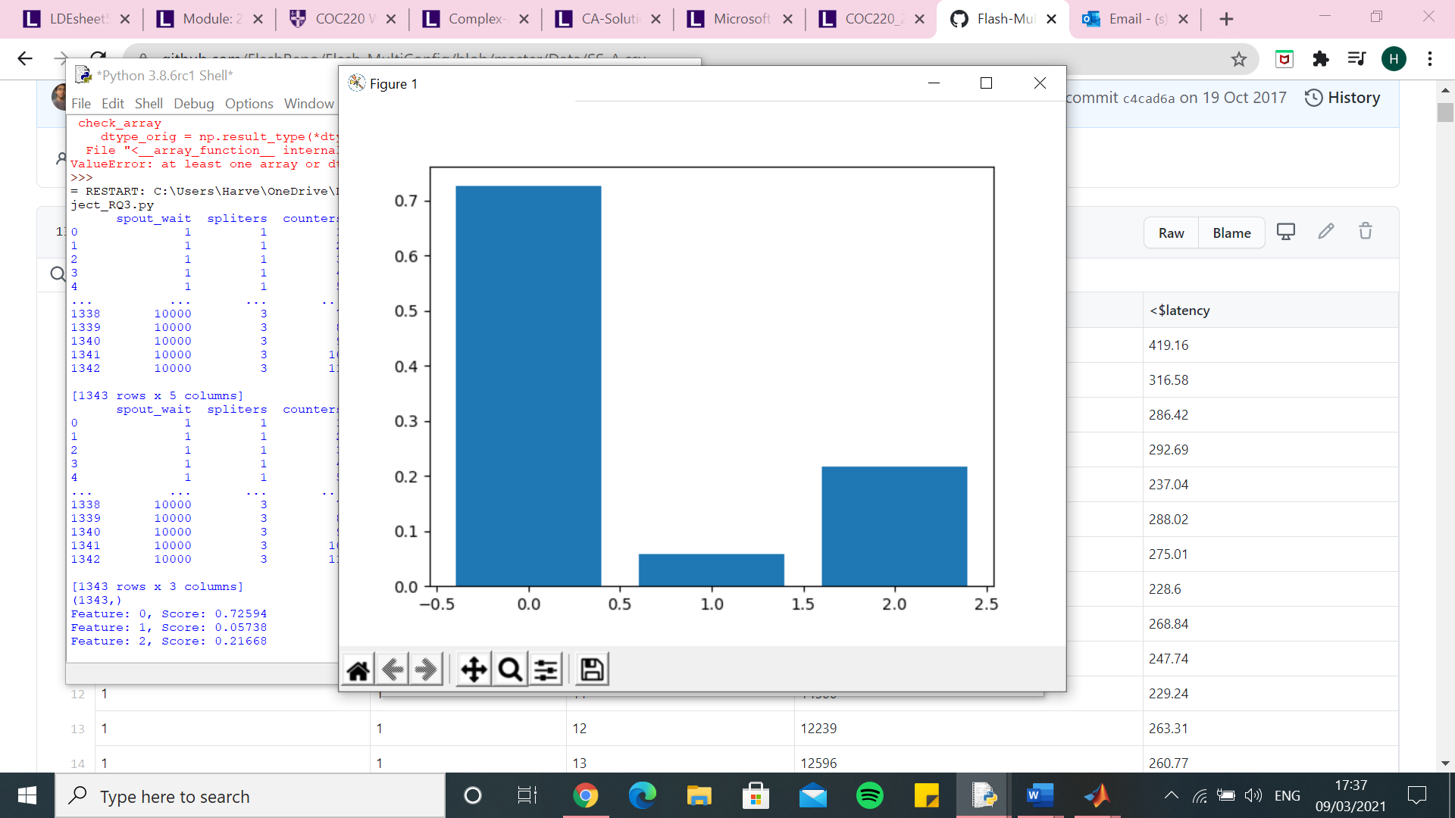

Random forest $latency

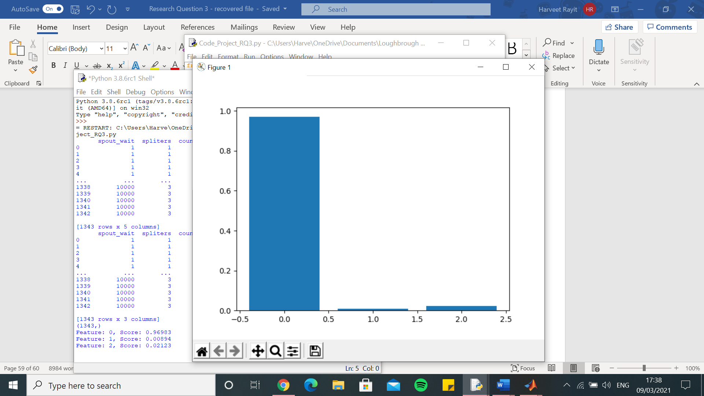

Random Forest – One hot encoder – SS-A.csv - $throughput

[4362.71430897858, 5568.462767811676, 5671.785870912944, 5749.905255214988, 6361.977883226684, 5932.42715163329, 6112.035295803535, 6403.4463912422425, 6319.032569923208, 6493.223242552168, 5967.3577354958015, 5868.5175052793675, 6321.714267838347, 5417.876251648263, 5863.129691086491, 5381.726168935558, 6349.208607892005, 5853.491940253083, 5691.919124236052, 6730.967045500577, 6199.447701655347, 6017.303988097351, 5896.77278823384, 5826.411971965585, 5188.587445597503, 5655.908286100144, 6076.130557731647, 6397.758026502925, 5766.82914687791, 6170.342445789646, 5277.547850504612, 5929.457196896659, 6066.519260397458, 5427.523529564556, 5531.191856535925, 5884.182710512031, 6481.716386380057, 6900.51780646638, 5564.010904673667, 6429.579254098429, 5560.665992063008, 6834.75540820059, 5695.064819910416, 6026.842932151147, 5910.564715839508, 5164.453360449724, 5462.358764196098, 6140.945919578136, 6476.4780098943875, 5947.666519498152]

0.0 7.556929455863566e-10

Execution time: 27.357125520706177 seconds

knn – One hot encoder – SS-A.csv - $throughput

[4348.008138798305, 5642.384189391797, 5776.901091973549, 5266.571018456603, 7501.844188706027, 5609.2524730865525, 6237.448370702666, 6708.351588617205, 6741.439128483842, 6691.585920451524, 6272.260783947105, 5942.220201449897, 6636.504891186994, 5351.678269058891, 5361.362897436941, 5509.6283415467, 6591.837197927891, 6406.849085317666, 5594.724716202515, 7451.029520960836, 6725.895718892433, 6329.22126123252, 6107.387320803358, 5887.78080801507, 5577.011673682916, 6231.578506698285, 5598.236789553848, 6184.0611315825445, 5848.523381099022, 5977.461122838111, 5478.570159993221, 5919.708131043974, 6408.334017907491, 5426.025053178377, 6123.126502094212, 6543.53217223193, 6503.174269086173, 6622.839791310779, 5948.7707029404555, 6040.256924063868, 6001.666128152896, 6906.783832793992, 6055.94864180581, 5496.2656294516055, 6363.831549953091, 5458.211846103245, 6239.025927936403, 6691.660677726686, 6490.695307068074, 6321.550156264279]

0.0 7.556929455863566e-10

Execution time: 1.7868683338165283 seconds

SVR – One hot encoder – SS-A.csv - $ throughput

[4264.273278793678, 5588.809322358621, 5606.993764205031, 5516.829616495308, 6613.611897123127, 5659.152814600749, 6026.538885767742, 6372.280434778865, 6309.127906566539, 6410.459370278508, 5888.200386680932, 5793.404166672007, 6077.109252847392, 5260.731528369467, 5659.080627008697, 5189.271479035787, 6438.9950780553145, 5867.871747217129, 5649.832577314067, 6777.681376670099, 6187.005668238223, 6059.26072019486, 5802.594584670265, 5761.940442817083, 5139.140611027311, 5669.722948230191, 5974.544493212223, 6199.414313771933, 5725.005493962682, 6248.563174975052, 5311.236600735371, 5869.2147238037405, 6189.253583081228, 5308.693149031754, 5538.582002128326, 5565.192679738557, 6199.548835841213, 6910.814079328819, 5578.256751463974, 6382.171980513421, 5338.379124146076, 7015.412388060176, 5368.903248631363, 5947.975891147297, 5760.178626710374, 5145.312674942136, 5373.337501986952, 6102.855604420764, 6294.542477089003, 5903.091785713698]

0.0 7.556929455863566e-10

Execution time: 2.8856043815612793 seconds

Decision Tree – One hot encoder – SS-A.csv - $ throughput

[4417.514397602841, 5708.697641513341, 5937.556818233012, 6035.368205086742, 6587.5403392101, 5909.010916165266, 6238.958156186879, 6510.769645675883, 6789.329024212033, 6752.4055711969695, 6346.330445295197, 5735.44282799997, 6225.167647596455, 5387.395654966122, 6074.109117904963, 5348.3583681853925, 6276.5001237049955, 5688.66290229302, 5658.917389442623, 6665.630260161527, 6430.170925397245, 5649.821584022647, 5959.83171109494, 5776.312312964087, 5349.549191716488, 5503.301341417006, 6126.759825154687, 6605.282559816329, 5883.7041704660005, 6242.285616244396, 5091.735159349583, 5899.292968546074, 5940.910657851218, 5537.6693496327825, 5538.119708773942, 5801.886978977659, 6539.707605368858, 7105.172674206459, 5556.346051689617, 6637.781667998251, 5850.563414135912, 6739.267800135603, 5809.855236794357, 6290.161082904102, 6231.15668295033, 5250.821597123075, 5511.770271633602, 5951.599568999904, 6403.144624579032, 5833.239353437672]

0.0 7.556929455863566e-10

Execution time: 1.0910098552703857 seconds

Linear Regression – One hot encoder – SS-A.csv - $throughput

[4446.852815913581, 5787.782777855919, 6165.1707482207175, 6024.173778972143, 6619.330699840382, 6280.886554173063, 6244.594569629294, 6678.042203935963, 6637.790531209851, 6582.5388524867685, 6175.379451096732, 6106.583547699276, 6637.509506980981, 5721.958209363616, 6323.650515748365, 5800.82808088571, 6651.630422374066, 6177.7569337193745, 6127.28660734222, 7068.46825265802, 6266.796303140213, 6255.7367315453685, 6180.376732471376, 5853.81820958008, 5636.329046342192, 5916.945438368053, 6352.552979527474, 6870.265777361034, 6129.601010971024, 6479.817391606211, 5734.4944335168075, 6236.094996757663, 6455.977684005628, 5728.587899490818, 5832.696709118815, 6000.553468456317, 6541.237446435483, 7202.497562719535, 5826.601235393847, 6642.273478992585, 5843.007581550758, 7195.140108526225, 5928.875450724803, 6257.527522933571, 6059.9380822968515, 5538.525461696215, 5751.311371163162, 6420.786312237841, 6694.837921803474, 6040.626844985466]

0.0 7.556929455863566e-10

Execution time: 1.3375048637390137 seconds

Kernel Ridge – One hot encoder – SS-A.csv - $ throughput

[13202.007403644811, 12834.965975559637, 14447.077003429487, 12307.682447677438, 12652.924945259512, 12886.736450744507, 13558.683816720953, 11820.149300295, 13651.599866122577, 12555.21144698809, 12530.697487584943, 12634.344553500241, 13775.910699163616, 14908.384556609422, 14746.434571436348, 14450.004963058818, 13620.872054478312, 13357.898601316814, 12542.48295105728, 13597.562166691443, 12653.375416728763, 14246.076010021898, 13158.526311786654, 13396.316717944965, 14950.523416853459, 12767.176366634098, 13044.019771866402, 13955.722502414357, 13758.893900768948, 13953.677992812038, 14012.101759146368, 13865.98126153012, 14155.49749465197, 13575.155099267035, 13417.677368655193, 12812.948122347685, 12923.32990548812, 13080.427992145886, 13484.86071489998, 13020.400577692599, 13013.528078739639, 13302.759426236687, 12594.41774293793, 13665.605225344632, 12846.391050183, 13696.969199252564, 13597.975269065913, 12591.730725482676, 11828.585781515108, 12118.45772388246]

0.0 7.556929455863566e-10

Execution time: 6.02026891708374 seconds

Random Forest – One hot encoder – SS-A.csv - $latency

[846.1025757542443, 1198.8807673467481, 1426.7588258536405, 1259.7591075390624, 1571.4642434083826, 1017.0670981487372, 1168.1294404789455, 1358.007490065466, 1385.4304904121084, 1333.5272512102574, 1248.9184029917856, 845.3665724647823, 1269.2488075567442, 549.1151579350261, 1234.0615329902803, 1153.401573748688, 1225.1278280697638, 1821.1742434072614, 1362.4054109882024, 1575.1988553872216, 1474.6264250880276, 1061.3667323772895, 1668.8606853218414, 453.89028539421116, 1011.4920061931699, 1131.6911790646502, 1146.990532386394, 1309.409309820126, 1527.7051302310897, 1488.443835743548, 682.912012390315, 1387.8769766726568, 1319.198277262422, 830.0258622102316, 734.8434712607428, 1068.5527411325245, 1750.3965994943624, 1632.6346232032447, 1372.218179142439, 1445.1909664372777, 1202.575362384127, 1733.6785455883532, 935.1171665592111, 1050.3008992124635, 1248.476807886, 1365.0825413645562, 458.53033332157094, 1444.858763913307, 1621.726189151823, 1180.447112249079]

0.0 7.556929455863566e-10

Execution time: 26.545127391815186 seconds

knn – One hot encoder – SS-A.csv - $latency

[846.4792245382307, 1198.5067825986605, 1426.9125244105242, 1256.1199220788606, 1578.8850205884428, 1013.5798143940931, 1165.8550554609867, 1358.8933628274212, 1389.724815400001, 1336.7687137304856, 1250.6637596772066, 843.9211977360077, 1271.806749382008, 548.1333311170673, 1229.216579617023, 1151.8194050183415, 1228.0260004209035, 1827.3420447223339, 1359.9997662193389, 1579.0644149121122, 1477.6946070411066, 1062.545820210268, 1671.2404391278908, 455.18734788190363, 1014.3581540876867, 1137.6376569821302, 1145.3070344191162, 1304.3983736020837, 1527.9076608726436, 1482.23896009282, 684.5062184437177, 1389.1867071914814, 1321.991948176578, 828.203679791751, 734.986985247023, 1072.1668594699713, 1752.2306476625472, 1630.2642190194522, 1374.7376509156265, 1440.4164517255977, 1207.169121239605, 1736.1813183377155, 937.7656442177233, 1043.6979660148584, 1252.534211425482, 1366.468845537143, 461.82051471304396, 1447.3129669346758, 1614.815845560679, 1182.9331916717765]

0.0 7.556929455863566e-10

Execution time: 1.1806004047393799 seconds

SVR – One hot encoder – SS-A.csv - $latency

[847.0133899423923, 1199.3012521135288, 1427.6133116397957, 1262.1701231633024, 1572.7866297690027, 1017.9235984749056, 1170.247316113434, 1358.1320588425835, 1386.943569360206, 1335.777683835349, 1248.8451000944785, 846.6840876492001, 1271.7025201082413, 549.5204532412364, 1234.2222094971721, 1153.5400266795561, 1227.3584599267265, 1823.0147610505421, 1362.3765517187653, 1575.4296159706917, 1476.0956202094308, 1060.7236335583132, 1669.1513242296328, 453.90335610238185, 1012.1845414235543, 1133.8884979537922, 1148.2811345957887, 1310.0171020840564, 1527.6252890662693, 1491.6413130102617, 684.1948270070056, 1387.735586357448, 1320.448319010676, 830.3260021886455, 735.6727970513303, 1068.4663392218117, 1751.68202070881, 1631.9869269380927, 1373.6264994537667, 1447.2249330651568, 1203.0225874803796, 1736.9841448635734, 934.871886895044, 1052.6740225428066, 1248.7539151111355, 1365.3980437141063, 459.9628681206213, 1446.0615475830743, 1623.0625156745189, 1181.2537598096583]

0.0 7.556929455863566e-10

Execution time: 2.8944990634918213 seconds

Decision Tree – One hot encoder – SS-A.csv - $latency

[846.2962649073552, 1198.7827581521562, 1424.2370396745673, 1258.1258634207556, 1572.2365999983895, 1018.3935036166239, 1167.6614941297955, 1355.628580645141, 1383.8593644440155, 1332.4647111496206, 1249.5091528196913, 841.4433164229216, 1269.230817777932, 548.1692690942253, 1233.117078519083, 1153.627097709959, 1226.1464775716674, 1819.5395596583294, 1358.055122909974, 1572.5539158712656, 1473.5026104089568, 1062.3687852222183, 1669.234088799141, 455.1065161203953, 1012.0821087389635, 1132.5541267235858, 1147.5280303344352, 1308.5670832300657, 1526.1080765991744, 1488.572905435968, 680.8878366046408, 1389.080422289973, 1317.975382661246, 830.7102433386168, 735.0358485978294, 1066.2367219654416, 1750.6363801427033, 1634.0047379128048, 1374.17958620466, 1447.4833529924922, 1203.1985064771786, 1727.8741728786686, 936.1297698556796, 1051.5206645867079, 1250.9719364345988, 1364.4923504716858, 457.5648258573124, 1444.153126579844, 1619.0694374669645, 1179.070536541731]

0.0 7.556929455863566e-10

Execution time: 1.040686845779419 seconds

Linear Regression – One hot encoder – SS-A.csv - $latency

[947.4327432609181, 1282.628376169456, 1522.7109748492035, 1351.0370043876565, 1630.918321579723, 1109.5484234439375, 1251.8960689068983, 1413.5987484372988, 1468.0931161418982, 1405.3242432427496, 1308.6961994941985, 934.0505474388348, 1373.792883830938, 721.548124508505, 1326.5414761650786, 1253.6189577901007, 1304.865394252655, 1880.9320491131966, 1440.0834354064655, 1657.9360985269188, 1545.6658712627652, 1175.526391366475, 1734.6020249752005, 565.2631521079913, 1190.7964594537273, 1203.490929181029, 1210.4727429991647, 1395.7669116002228, 1626.394595500205, 1570.2910938802981, 903.7237347996302, 1466.311582171746, 1405.0878477883787, 943.349551641333, 864.5708668768219, 1159.525567146194, 1802.9682030108763, 1702.4723568656223, 1457.0166122510898, 1514.316149946733, 1271.097920197808, 1813.6191176573523, 1028.8587080859352, 1137.089940716654, 1315.5234884516613, 1446.2351701142554, 571.1124300407016, 1517.964139554073, 1678.7103425314442, 1249.6609248494103]

0.0 7.556929455863566e-10

Execution time: 1.2999253273010254 seconds

Kernel Ridge – One hot encoder – SS-A.csv - $latency

[890.3444304664391, 1255.6445285662799, 1481.4431042313076, 1313.861995311854, 1633.604346175153, 1073.1900943299402, 1224.5546067686305, 1420.3993500199017, 1451.1777197670026, 1391.874074396904, 1304.3157545367542, 909.5974417776172, 1328.5022664051187, 613.3771593546738, 1293.924743583188, 1207.9196452539684, 1285.1838141724681, 1883.6572293643687, 1413.8214640687224, 1637.2545102156664, 1531.9471929709778, 1114.5798228695655, 1727.2299969386654, 531.3049104872339, 1061.0904563012184, 1191.66399522111, 1207.4214099750363, 1373.9540398846418, 1588.5057783107957, 1548.3160634414735, 736.4918422845891, 1447.8528850797766, 1376.774812215956, 886.0096444275367, 798.4353959428556, 1118.5498139756721, 1812.2803158167917, 1692.81683806362, 1429.0628020979907, 1509.4191537375812, 1255.6574889973979, 1798.9067699228196, 988.8437463850042, 1110.9039888846155, 1306.8485116818583, 1417.2255402607607, 527.6330005369192, 1503.8170189218538, 1686.4962854617652, 1234.9850229320273]

0.0 7.556929455863566e-10

Execution time: 6.08661150932312 seconds

Random Forest – Integer encoder – SS-A.csv - $throughput

[4434.027661623269, 5707.960592488502, 6019.828722601953, 5437.804353740035, 6981.8555665108515, 5775.003291784707, 5908.973433524765, 6531.377657822058, 6751.833024262889, 6292.802025714158, 6266.155947634441, 5545.822523142506, 6792.9512146364295, 5671.201041780184, 5505.7239926322345, 5366.030932923858, 5825.005998168267, 5676.30323018841, 5736.02032474236, 6456.902513515179, 5174.124700241197, 6297.523744476221, 5667.091341212936, 6327.618959405138, 5359.618814253297, 5821.587235810534, 6142.406736570355, 5842.354380508913, 5434.550790537301, 6322.993857928112, 5119.227835728488, 6098.017620594491, 6074.416451021495, 5435.59644155065, 4902.89633445101, 5863.940823170361, 6600.401466731566, 6880.539649917682, 5801.468114366942, 5519.6185264313635, 5445.43103113945, 6520.379173965016, 5485.950685373901, 5752.909318617132, 6009.9703801943715, 5430.150906387593, 5592.510334850533, 6030.122802074148, 6060.751125602613, 6460.842787529425]

0.0 7.556929455863566e-10

Execution time: 26.001912355422974 seconds

knn – Integer encoder – SS-A.csv - $throughput

[4641.684077356375, 6156.893787653533, 6212.2849842309615, 4951.954902694656, 6638.973869708116, 5225.149182148602, 6031.131158289611, 6423.415277421384, 6626.841092315121, 6292.922568913215, 5823.821652278205, 5622.40158033011, 6863.227785263367, 5850.789403129877, 5386.412055055689, 5019.934279608604, 6397.431712823713, 5627.50710779503, 5457.364844472498, 5980.494430233234, 5687.515383903459, 6173.2567194451, 5477.481113693559, 6421.857004239448, 5513.493551526733, 5735.011544824943, 6274.330548674306, 5911.56533053874, 5355.223227579335, 6460.9280821117445, 5158.583140733366, 6673.582186783392, 6123.586052635607, 4988.623841250165, 5250.804947081285, 6000.618424878103, 6447.527282250011, 6871.548824814837, 5643.951174470018, 5454.044767752166, 5347.230710128998, 7255.815934697464, 5519.591764890401, 5385.113987939622, 5744.320611490386, 5022.8973948914645, 5469.336124577277, 6252.19118365027, 6038.659251148808, 6572.985272848353]

0.0 7.556929455863566e-10

Execution time: 0.9153096675872803 seconds

SVR – Integer encoder – SS-A.csv - $ throughput

[4263.909223727374, 5588.897657397126, 5606.501503608726, 5515.221664158487, 6617.458735224704, 5660.405267872948, 6024.4386706904115, 6372.942128047012, 6309.94786798231, 6412.323576580762, 5890.2091642465275, 5793.008735722462, 6076.491592056693, 5261.283426364523, 5658.805071146932, 5187.535522676871, 6441.258323813294, 5867.247383093902, 5650.711311690616, 6776.726490230364, 6188.0978616203465, 6059.533013962568, 5801.459434044897, 5759.271677232791, 5138.48771429855, 5669.782826233514, 5975.410069117299, 6199.11611948785, 5725.155771940454, 6249.897777523396, 5310.966196560495, 5870.081959005667, 6191.0767771457795, 5308.268056154572, 5538.30412456488, 5564.567923503209, 6199.51136844496, 6910.8910683814665, 5579.80693622863, 6381.7892093950395, 5338.340328226947, 7016.278093516009, 5368.212911168793, 5946.590748422421, 5760.810773638452, 5145.40431101921, 5373.573026794312, 6102.180939218379, 6293.978401985957, 5905.674707316289]

0.0 7.556929455863566e-10

Execution time: 2.937659502029419 seconds

Decision Tree – Integer encoder – SS-A.csv - $ throughput

[4468.915416435832, 5762.878539511852, 6145.996905597517, 5799.809008680875, 7028.9890506801, 6199.031074872639, 5974.076134711888, 6489.395019420508, 6969.646988894026, 6330.0454430904565, 6477.436266616439, 5598.196832641301, 6814.70699402674, 5703.683696476903, 5630.9153632197795, 5573.984216898487, 5229.264139600711, 5631.17182579311, 5814.639768596664, 6675.300014545731, 5096.80680808078, 6333.279303148655, 5827.391107560267, 6343.242287892599, 5373.332884836114, 5889.784071334142, 6265.420542720243, 6243.020847762415, 5444.563255576943, 6332.96474051033, 5154.869811714709, 6135.596718237012, 6127.219935984619, 5503.111677127794, 4867.447850777909, 5863.367670156858, 6648.267220576477, 7277.675137695421, 5818.148637087971, 5550.204616200159, 5686.899576877844, 6481.451304393925, 5549.114006289868, 5725.193879516293, 6011.755246386874, 5482.15331002839, 5616.50042309943, 6034.31027439663, 6038.760086182161, 6494.540013231508]

0.0 7.556929455863566e-10

Execution time: 0.9581384658813477 seconds

Linear Regression – Integer encoder – SS-A.csv - $ throughput

[4646.069456530281, 6760.5216679685, 6693.823496855569, 6606.621715777135, 8393.73546971727, 6749.878858054164, 7078.931114308274, 8108.790955077601, 7859.075867165937, 7628.969864706648, 7608.579763405657, 6894.478139614417, 7168.389008762776, 6274.306144697134, 6611.028455991026, 6467.9199107549775, 7848.686997885547, 6952.769929504621, 6447.961981063961, 8223.839603325658, 7779.694987048391, 7501.54399240414, 7078.389832647753, 7369.549026998507, 5701.391010464447, 6619.838433849627, 6776.239405158393, 7216.642732741704, 6844.880794815768, 7527.443534031195, 5894.141775355137, 6962.2427652296565, 7695.346122553519, 6399.069898131338, 5941.48184841222, 6838.00180011661, 7772.068062515884, 8514.059392759247, 6520.750609943396, 7296.019504020992, 6054.583011505942, 8668.193627918577, 6429.853952170554, 7322.186608478633, 6931.685666261122, 6149.3849537144615, 6064.390479899828, 7512.548318561092, 7187.050658554924, 7257.596163981726]

0.0 7.556929455863566e-10

Execution time: 1.0049943923950195 seconds

Kernel Ridge – Integer encoder – SS-A.csv - $ throughput

[11773.43753192248, 13993.627974780033, 13703.801136118687, 13001.023979188054, 15083.380110800124, 14494.818117802675, 14137.238426973006, 14308.056508938347, 14632.030196773258, 14356.787722688523, 14006.49622128752, 12685.241820569363, 13806.740148766274, 12662.956808614266, 14274.923387011968, 12814.693314628123, 15415.123906272465, 14502.907246427725, 14615.372910153235, 14679.525662490434, 13541.825276151441, 14375.61185101224, 14536.329983031024, 13235.790693232604, 13202.491611316264, 13364.998363037368, 15225.282237189722, 14385.115087638118, 13312.113228307282, 14443.083862246689, 11975.061873179651, 14119.812843522552, 15003.490502673725, 12923.71110741337, 13190.532954193679, 14017.891519942033, 15064.715888823144, 15695.048941855492, 13306.233456098022, 13798.758786617665, 13908.055308167386, 15547.514630910384, 13050.508159893303, 14162.5763406996, 13565.061774934022, 13047.527213742072, 13223.778909627312, 14890.698098769057, 13249.32303469897, 13881.098338791018]

0.0 7.556929455863566e-10

Execution time: 3.7862353324890137 seconds

Random Forest – Integer encoder – SS-A.csv - $latency

[845.8838831392748, 1198.5460931296088, 1427.301919274467, 1255.4961181285478, 1574.8096037813955, 1012.0108255325482, 1163.7075415240452, 1360.3950617704431, 1391.9296780670927, 1332.0807275688264, 1250.7669925206733, 837.9089594173576, 1270.595042810374, 552.8274615283437, 1226.787964991773, 1150.7901114049164, 1219.9727872204512, 1818.6703645550383, 1362.7303486144451, 1572.5710391029436, 1465.9930271672943, 1061.7896918154977, 1666.06995946589, 457.2285895325771, 1013.0538726497624, 1133.0735093618077, 1145.8449229825123, 1294.9546695930253, 1525.5669863133294, 1489.7735243841914, 682.3253138075381, 1388.532795394318, 1318.0683853139253, 829.2690559322186, 731.4355703470634, 1068.9201437614056, 1750.5050857676292, 1633.7952973332344, 1372.5851902254271, 1429.3011520519563, 1200.6120922974462, 1730.8951439274185, 934.177495764152, 1048.4211471601518, 1248.396455255469, 1364.4199749622082, 456.70392613429607, 1442.0969778360773, 1620.3455379506747, 1182.9482770442132]

0.0 7.556929455863566e-10

Execution time: 26.282493591308594 seconds

knn – Integer encoder – SS-A.csv - $latency

[848.1683028681583, 1202.086150017482, 1431.0887139434737, 1256.4215941609964, 1574.51934541415, 1007.6375371243372, 1168.2683881533592, 1360.5551037692107, 1388.6846551043755, 1334.5636333651335, 1248.5916341356058, 838.1915380675231, 1274.372903177158, 553.732949770404, 1228.0383448140906, 1146.1261635564372, 1226.035163742149, 1820.7636675639335, 1360.8764133377485, 1568.6689065217236, 1471.0040031955093, 1061.3983147771728, 1666.0695199805195, 456.53483620786625, 1014.3656121129666, 1129.7722324658612, 1149.6777770393662, 1297.1485985949819, 1525.6099641159337, 1491.9109166714754, 680.5613975056726, 1393.009383689327, 1319.5202052563288, 826.4255130085246, 732.2523751668496, 1069.8284283598307, 1751.279613430032, 1633.269625367042, 1373.7464326293339, 1432.2132151188714, 1203.7077440525293, 1738.8790021120228, 934.0901086522571, 1046.759631879586, 1248.4821040560807, 1363.1217958196314, 457.158205274227, 1445.6148497023783, 1620.3817214498308, 1183.7386388197]

0.0 7.556929455863566e-10

Execution time: 0.9215843677520752 seconds

SVR – Integer encoder – SS-A.csv - $latency

[846.8979788251037, 1199.449178648998, 1427.8906832714251, 1261.0662450970292, 1573.2187525270635, 1018.1203992867113, 1170.224689975432, 1359.5164760977214, 1387.126896014308, 1335.9183896419884, 1249.3098515714692, 846.1995279964714, 1272.046251655261, 549.8081323220539, 1234.003187799556, 1153.279385338409, 1227.5909184907266, 1823.007811715944, 1362.325659033497, 1576.0478833769225, 1475.7630481995593, 1061.00825473406, 1668.8982306146388, 454.4628261544718, 1012.3718394564056, 1133.8700048237747, 1147.9916571146164, 1309.9504501086678, 1527.467913261765, 1492.0471265074568, 683.8391498242411, 1387.8879159667067, 1320.676751361044, 829.9674618829499, 735.9791190858381, 1068.2283413948637, 1752.0936905591425, 1632.689638580088, 1373.907923046138, 1447.7176924660082, 1202.7689823575315, 1737.4799091176126, 935.1727107707507, 1052.3575838000515, 1248.9218936241111, 1365.7455852186736, 460.0095742873839, 1445.9743765107514, 1623.0206429291034, 1181.9131569404515]

0.0 7.556929455863566e-10

Execution time: 3.029539108276367 seconds

Decision Tree – Integer encoder – SS-A.csv - $latency

[845.9485215752971, 1198.8655181983145, 1427.3999561718367, 1254.8255255695258, 1574.807689219887, 1012.9485085246461, 1164.5162518765073, 1360.634819891206, 1392.020503246626, 1331.990033148063, 1250.6564288065736, 836.2280716497081, 1269.876339048684, 552.9325949993389, 1226.4354829068668, 1150.4232647041267, 1215.1578576500474, 1818.208492943479, 1362.7552591314402, 1572.4716260986622, 1464.7571661994273, 1062.070398468041, 1666.2187732691234, 457.099313420929, 1013.0956622210041, 1134.3312037667483, 1145.5538310509778, 1295.2373103259258, 1525.4874569635008, 1489.553866261301, 682.1946917709297, 1388.1746657217582, 1318.2544819952964, 829.0419202798023, 731.1862237782834, 1068.8985275880386, 1750.720181998246, 1634.979503334844, 1372.7619699975962, 1428.4849763817779, 1200.4115444281713, 1728.2058096295746, 933.9833179025269, 1048.4262529310865, 1248.1667300944225, 1364.7167111398956, 457.0103214403806, 1442.8706018429798, 1619.6162773683682, 1182.9897789064066]

0.0 7.556929455863566e-10

Execution time: 0.9407227039337158 seconds

Linear Regression – Integer encoder – SS-A.csv - $latency

[888.536415252455, 1315.9347413046685, 1591.6186347751136, 1385.132474296189, 1809.9885073868138, 1101.6674296588656, 1284.775894121527, 1570.4744398834548, 1571.0446434503003, 1494.908450766452, 1390.217670403708, 941.9295598462033, 1410.7603744387316, 591.1180061775734, 1375.9940661145356, 1268.8710377677644, 1359.2060013450475, 2094.9639545028404, 1490.7416901179147, 1800.9869306230637, 1671.115622918522, 1164.8727365466145, 1867.553532430153, 509.9434792664008, 1077.3145229454624, 1266.874868346085, 1269.5653807587462, 1475.5023014072724, 1726.8377542062012, 1685.9394781389087, 721.7759184779045, 1562.2897934976022, 1476.7064075602937, 898.5415549638825, 793.8468239203736, 1160.4468543185235, 2015.3493938252525, 1847.166421897057, 1524.2505657240795, 1656.383960289537, 1312.857983038113, 1968.491777082137, 1018.375410662091, 1161.5988095369407, 1401.8402186328628, 1521.6894889119685, 498.5958816630071, 1615.3556414916952, 1869.9711321708137, 1307.5292291396092]

0.0 7.556929455863566e-10

Execution time: 0.9555766582489014 seconds

Kernel Ridge – Integer encoder – SS-A.csv - $latency

[847.1447614538422, 1233.4054646531274, 1477.570815568036, 1291.3758259218407, 1652.8695605042221, 1038.1388360464523, 1195.6439845694, 1426.7846761265246, 1450.568747695845, 1387.6635033836924, 1294.464533532542, 865.6149943832959, 1299.3233092865635, 553.65992563829, 1256.0769819020863, 1183.6079799386857, 1270.6354695277485, 1931.4439342880942, 1392.1910286267164, 1681.941317475806, 1543.9322241176312, 1081.0772550815586, 1748.069121850079, 459.339097475459, 1021.0148421121967, 1161.5078478803266, 1183.2592211378967, 1357.6800709353213, 1601.5611493871236, 1551.57231951474, 685.8908141882708, 1439.1330024969707, 1356.0953166637323, 840.2418584343328, 742.0183825329281, 1089.2484669021005, 1856.9133063072384, 1729.3484285548573, 1422.958936360946, 1517.0958828412154, 1220.675763309199, 1825.1831477088235, 955.927736763603, 1080.0121042274318, 1294.4990400126358, 1409.8926025810217, 454.84803217101256, 1507.9434978493957, 1727.1372423103346, 1216.318284228897]

0.0 7.556929455863566e-10

Execution time: 3.580030918121338 seconds